protective equipment

Tender documentation model

Public procurement of protective equipment

**PUBLIC**

**CLEAR**

**EFFICIENT**

**Good governance project**

Tender documentation model

**Open procedure**

Reserved public procurement

**Public procurement of protective equipment**

Place and date: Belgrade, December 2023

**INTRODUCTION**

Article 37 of the Law on Public Procurement (“Official Gazette of the Republic of Serbia”, Nos. 91/2019 and 92/2023, hereinafter referred to as: the PPL) provides for **reserved public procurements**, which would enable participation in the procedure only to economic operators whose main goal is professional rehabilitation and employment of persons with disabilities in accordance with the Law on Professional Rehabilitation and Employment of Persons with Disabilities ("Official Gazette of the Republic of Serbia”, Nos. 36/2009 and 32/2013 and 14/2022 – as amended), as well as economic operators whose basic goal is social and professional integration of persons in a disadvantageous position who are organized in accordance with the Law on Social Entrepreneurship. In the specific model of tender documentation, we have decided to determine that only companies for professional rehabilitation and employment of disabled people have the right to participate, bearing in mind that for this subject-matter of public procurement there is competition on the market among those companies.

The following social aspects were used in this competition documentation:

- Through the condition that reserved public procurement is carried out,

- Selection criteria for an economic operator, and

- Special conditions for contract execution.

All those aspects are marked in yellow. During the preparation of the tender documents on the Public Procurement Portal, the Contracting Authorities are obliged to state whether the procurement is being carried out as a reserved public procurement.

**TABLE OF CONTENTS**

1. GENERAL INFORMATION ON THE SUBJECT-MATTER OF PROCUREMENT.................. 5

2. TYPE, TECHNICAL CHARACTERISTICS (SPECIFICATIONS), QUALITY, QUANTITY AND DESCRIPTION OF GOODS, METHOD OF IMPLEMENTING CONTROL AND PROVIDING QUALITY GUARANTEE, PERFORMANCE DEADLINE, PLACE OF DELIVERY OF GOODS.......................................................................................................................................................... 6

3. CRITERIA FOR QUALITATIVE SELECTION OF THE ECONOMIC OPERATOR (GROUNDS FOR EXCLUSION AND CRITERIA FOR SELECTION OF THE ECONOMIC OPERATOR), WITH INSTRUCTIONS ON HOW TO PROVE THE FULFILMENT OF THESE CRITERIA.................................................................................................................................................... 24

4. DATA REGARDING THE CRITERIA FOR AWARDING THE PUBLIC PROCUREMENT CONTRACT................................................................................................................................................ 33

5. DATA ON THE BASIS OF WHICH THE BIDDERS PREPARE THE BID FORM.......................................................................................................................................................... 34

6. DATA ON THE BASIS OF WHICH THE BIDDERS PREPARE THE FORM OF THE STATEMENT ON FULFILMENT OF THE CRITERIA FOR QUALITATIVE SELECTION OF THE ECONOMIC OPERATOR ....................................................................................................................... 35

7. OFFERED PRICE STRUCTURE FORM .......................................................................................... 36

8. FORM OF BID PREPARATION COSTS.......................................................................................... 38

9. CONTRACT MODEL........................................................................................................................... 39

10. INSTRUCTION TO BIDDERS ON HOW TO PREPARE A BID............................................. 48

**1.** **GENERAL INFORMATION ON THE SUBJECT MATTER OF PROCUREMENT**

**Name:** Protective equipment, ORN: 18143000

**Type of procurement subject matter:** Goods

**Type of public procurement procedure:** Open procedure

**Description:** The public procurement is conducted for the purpose of concluding a public procurement contract.

**Other notes:** Public procurement is conducted as a reserved public procurement from Article 37 of the PPL.

*(enter any other remarks relevant to the subject matter of public procurement, for example: data on possible changes to the contract (Article 30, paragraph 1, in connection with Article 156 of the* *PPL), that an e-auction will be conducted (Articles*  *71-73 and Annex 5 of the*  *PPL), information on the address and time of site visit, deadline for making a decision on contract award if longer than prescribed PPL (Article 146 paragraph 3 of the* *PPL), etc.)*

***Note:***

*❖ This part of the tender documentation is created by the Portal based on the data that the customer enters into the system.* *In that case, this part contains only the mandatory data prescribed by the Rulebook on the Content of Tender Documents in Public Procurement Procedures.*

*❖ If the Contracting Authority wants this part of the tender documentation to contain some other data, the Contracting Authority prepares this document on its computer and uploads it to the Portal at the appropriate step.*

**2.** **TYPE, TECHNICAL CHARACTERISTICS (SPECIFICATIONS), QUALITY, QUANTITY AND DESCRIPTION OF GOODS, METHOD OF IMPLEMENTING CONTROL AND PROVIDING QUALITY GUARANTEE, PERFORMANCE DEADLINE, PLACE OF DELIVERY OF GOODS**

This public procurement is conducted by the Contracting Authority as a reserved public procurement in accordance with Article 37, paragraph 1, item 1) of the Law on Public Procurement, which means that only business operators that have a permit issued by the ministry responsible for employment can participate in this procedure (for the company for professional rehabilitation and employment of persons with disabilities).

In accordance with Article 37, paragraph 8 of the Law on Public Procurement, economic operators participating in the public procurement procedure must be manufacturers of the offered equipment.

The offered clothing must be produced in the facilities at the address(es) specified in the permit (decision) of the competent ministry, in the sense of Article 36, paragraph 2, item 3) of the Law on Professional Rehabilitation and Employment of Persons with Disabilities, which stipulates that a professional rehabilitation company and employment of persons with disabilities can perform activities provided that it has appropriate space and appropriate technical and other equipment for work training and work of persons with disabilities.

|  |  |  |  |
| --- | --- | --- | --- |
| **No.** | **Item name** | **Unit of measurement** | **Quantities** |
| 1 | Winter jacket with insole | pcs | 35 |
| 2 | Summer jacket | pcs | 35 |
| 3 | Trousers | pcs | 70 |
| 4 | Vest | pcs | 35 |

## 1. Winter jacket with insole

The jacket is intended as protection against meteorological conditions during the colder part of the year. It is made of fabric 50% cotton, 50% polyester.

The jacket has a straight cut, with a collar, and a removable hood.

At the ends of the sleeves there is a flywheel and Velcro for adjusting the width of the sleeves.

In the upper part of both sleeves there is a pocket of the base fabric, with a zipper (reverse fastening) with a puller (handle).

In the breast area of ​​the front of the jacket both left and right are built-in base fabric pockets with a zipper (reverse fastening) with a puller (handle).

The lower front of the jacket on both the left and right has slanted pockets with zippers (reverse fastening) and a puller (handle). The pockets are made of basic fabric.

The jacket fastens all the way to the top of the collar with a zipper (reverse fastening) with a puller (handle).

The back part is slightly rounded in the lower part and longer than the front part of the jacket.

In the lower part of the back there are two slanted pocket openings with a zipper (reverse fastening), covered with mouldings.

The hem of the jacket is made with a melding on the inside of the jacket from the base fabric.

In the underarm part of the jacket there are ventilation openings, which are fastened with a zipper (reverse fastening), with 2 sliders each. The opening is covered both from the outside and from the inside with mouldings made of basic fabric.

The collar in the front part has a pleat, inside which is sewn a hook Velcro for attaching the hood. In the middle of the neckline, a label is sewn with the size, raw material composition, method of maintenance and the name of the manufacturer and a hanger made of the base fabric.

The collar has a flap at the back with hook-and-loop Velcro (for closing the extension, when the hood is removed), and at the bottom an extension with sewn-in fibre Velcro and a split zipper (reverse fastening) along the edge, for hanging the hood.

The hood is made of polyamide lining with water repellence treatment. In the rear part, the back circumference of the hood is tightened using an elastic cord and a stopper with two openings. The cord passes through the tunnel formed by the 3 upper parts of the hood and exits through the metal rings under the flap of the middle part. The opening of the hood is pulled forward. The cord passes through a lining tunnel, sewn to the inner lining of the hood, exits through a metal ring on the outside of the hood extension, then through a stopper with two openings, then goes through two metal rings on different sides of the hood extension and ends with a plastic end (on both sides of the hood). On the extension of the hood, in the front, on both sides, a fibre Velcro is sewn for attachment to the collar.

The jacket is fitted:

- polyamide lining on the sleeves and in the lower part of the front part of the jacket;

- with an adjustable mesh in the upper part of the front of the jacket and the back.

Between the fabric and the lining, one part of the spiral zipper is sewn for hanging the jacket insert. The zipper goes along the lining mesh and goes to the lining about 1cm from one and the other side.

**Quilted insole**

It is made of two layers of polyamide lining and blocking, with underlining (100% polyester, 150 gr/m² ±10%) in the middle. The quilting pattern is a 5x5 cm diamond. The outer edges of the insole are lined with the same lining. An opening is left on the insole in the armpit area (the edges are treated against pilling and hemmed), fixed at the point of connection with the sleeves. A size label is sewn into the neckline.

The insert is attached to the jacket with a zipper and buttons: one above the sleeve hem on the inside of the sleeve. Buttons are sewn on the lining of the jacket, and holes are opened on the lining.

**Image of the model**

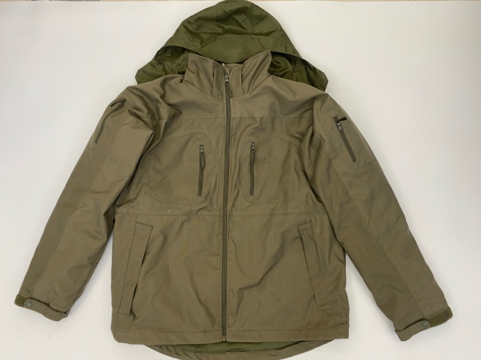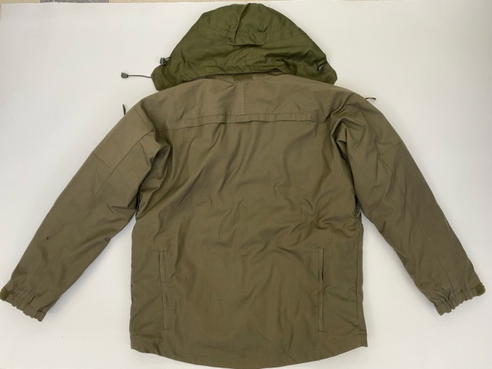

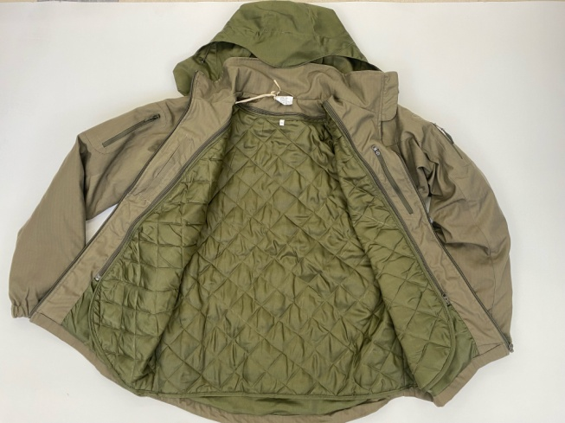

**Technical characteristics of the base fabric for the winter jacket**

|  |  |  |  |  |  |  |  |
| --- | --- | --- | --- | --- | --- | --- | --- |
| Reg.  no. | Testing elements  (Standards) | | Requested values | | | | |
| 1 | Raw material composition (SRPS EN ISO 1833-1:2012 or equivalent) | | 50% cotton – 50% polyester (±3%) | | | | |
| 2 | Surface mass (SRPS F. S2.016:1986 or equivalent) | | 260 gr/m² (±5%) | | | | |
| 3 | Yarn fineness (SRPS ISO 7211-5:2005 or equivalent) | | basis: 25x2 teh (±5%) | | | weft: 25x2 teh (±5%) | |
| 4 | Interweave | | ripstop | | | | |
| 5 | Wire density (SRPS EN 1049-2:2016 or equivalent) | | basis: 31 w/cm (±2) | | | weft: 17 w/cm (±2) | |
| 6 | Colour fastness to: | | | | | | |
|  | Light (SRPS EN ISO 105-B02:2015 or equivalent) | | min. 4 | | | | |
|  | Wash at 40⁰C (SRPS EN ISO 105-C08:2012 or equivalent) | | min. 4/4/4 | | | | |
|  | Sweat-alkaline (SRPS EN ISO 105-E04:2014 or equivalent) | | min. 4/4/4 | | | | |
|  | Sweat-alkaline (SRPS EN ISO 105-E04:2014 or equivalent) | | min. 3-4/3-4/3-4 | | | | |
|  | Mopping dry (SRPS EN ISO 105-X12:2017 or equivalent) | | min. 4/4 | | | | |
|  | Mopping wet (SRPS EN ISO 105-X12:2017 or equivalent) | | min. 3-4/3-4 | | | | |
|  | Dry cleaning (SRPS EN ISO 105-D01:2012 or equivalent) | | min. 4/4/4 | | | | |
| 7 | Water repellence (SRPS EN ISO 4920:2012 or equivalent) min. 4 (90) | | min. 4 (90) | | | | |
| 8 | Oil resistance (SRPS F. A1.019:1981 or equivalent) | | min. 4 (90) | | | | |
| 9 | Colour – SMB (light olive colour) – Colour coordinates according to CIE Lab method SRPS EN ISO 105-J03 or corresponding and standard light source D65/10 | | | | | | |
| L* | | a* | | b* | C | | Ho |
| 34.2 | | 2.1 | | 9.4 | 9.6 | | 77.3 |
| Allowed tolerance ∆cmc ≤ 2.0 | | | | | | | |

**Technical characteristics of the fabric for the tufted insole**

|  |  |  |  |  |  |  |  |
| --- | --- | --- | --- | --- | --- | --- | --- |
| Reg.  no. | Testing elements  (Standards) | | Requested values | | | | |
| 1 | Raw material composition (SRPS EN ISO 1833-1:2012 or equivalent) | | 100% polyamide | | | | |
| 2 | Surface mass (SRPS F. S2.016:1986 or equivalent) | | 90 gr/m² (±5%) | | | | |
| 3 | Yarn fineness (SRPS ISO 7211-5:2005 or equivalent) | | basis: 115 dteh (±10%) | | | weft: 115 dteh (±10%) | |
| 4 | Interweave | | twill 2:2 | | | | |
| 5 | Wire density (SRPS EN 1049-2:2016 or equivalent) | | basis: 44 w/cm (±2) | | | weft: 32 w/cm (±2) | |
| 6 | Colour fastness to: | | | | | | |
|  | Light (SRPS EN ISO 105-B02:2015 or equivalent) | | min. 4 | | | | |
|  | Wash at 40⁰C (SRPS EN ISO 105-C08:2012 or equivalent) | | min. 4/4/4 | | | | |
|  | Sweat-alkaline (SRPS EN ISO 105-E04:2014 or equivalent) | | min. 4/4/4 | | | | |
|  | Sweat-alkaline (SRPS EN ISO 105-E04:2014 or equivalent) | | min. 3-4/3-4/3-4 | | | | |
|  | Mopping dry (SRPS EN ISO 105-X12:2017 or equivalent) | | min. 4/4 | | | | |
|  | Mopping wet (SRPS EN ISO 105-X12:2017 or equivalent) | | min. 3-4/3-4 | | | | |
|  | Dry cleaning (SRPS EN ISO 105-D01:2012 or equivalent) | | min. 4/4/4 | | | | |
| 7 | Colour – SMB (light olive colour) – Colour coordinates according to CIE Lab method SRPS EN ISO 105-J03 or corresponding and standard light source D65/10 | | | | | | |
| L* | | a* | | b* | C | | Ho |
| 29.7 | | 0.0 | | 11.7 | 11.7 | | 89.9 |
| Allowed tolerance ∆cmc ≤ 2.0 | | | | | | | |

## 2.Summer jacket

The jacket has a straight cut. Buckle along the entire length and along the collar, with a waterproof, split zipper, with one slide (a puller is placed on the guide). A "soft shell" trim is stitched under the zipper with cut tape. The placket goes over the top of the collar onto the face to protect the wearer's neck and chin and is stitched so that the soft-shell fabric is visible on the face.

The jacket has a raised, stand-up collar to protect the neck. The outer and inner part of the collar is soft shell, placed so that the soft-shell fabric is visible on both sides. The collar part, in the middle of the back part, has a trapezoidal "soft shell" reinforcement, which holds the collar in an upright position. In the upper part of the reinforcement there are two metal rings, through which the cord for tightening the collar passes. The cord is fixed in the upper corners of the collar, and the tension is done using a small, plastic stopper with two holes. In the middle of the neckline, between the collar and the back, a soft-shell hanger and a printed label are sewn on.

The front of the jacket and the back are cut horizontally in the shoulder-chest area. The back is flat. In the waist area, a tunnel is made, by sewing a strip of rip stop summer fabric, on the back of the jacket, through which the cord for tightening the waist of the jacket passes.

On the right front part of the jacket, closer to the middle of the jacket, there is a vertically open pocket, which is fastened with a zipper (reverse fastening).

In the lower part of the front part of the jacket there are open oblique pockets, which are fastened with zippers (reverse fastening).

On the left part of the front part of the jacket there is an internal pocket made of mesh, with a horizontal opening in the upper part that is fastened with zippers (reverse fastening), and it is located on the entire front part of the jacket from the chest cut to the waist.

The back part of the jacket is slightly rounded and slightly longer than the front part of the jacket. Front and back hems are done by sewing soft shell tape on the back, leaving the soft-shell fabric visible.

The side part of the jacket has openings:

- from the hem up – fastens with a zipper (reverse fastening), with one slide and a spangle made of folded "soft shell" with a snap button, which fastens on the back, over the hem (2 lower snap buttons for width adjustment).

- in the armpit area – fasten with a zipper (reverse fastening), with two sliders.

The sleeves are multi-part and have: a narrow lower part (a continuation of the side part of the jacket), the upper part of the sleeve up to the elbow and the upper part of the sleeve from the elbow to the hem.

In the upper shoulder part of the sleeve there is a vertically open pocket that closes with a zipper (reverse closure) with a single slider.

In the area of ​​the elbow, the greater part of the forearm, Cordura reinforcement is sewn, so that it goes above the cut of the sleeve at the elbow and occupies the entire back side and enters the seam of the sleeve.

The hem of the sleeves is made to imitate a cuff. A strip of summer fabric rip stop is sewn on the inside. On the outside, a fibre Velcro band is sewn on the front, which is fastened with a spangle and thus adjusts the circumference of the sleeve. The spangle is sewn into the bottom seam of the sleeve; the outside is made of "soft shell", and on the bottom side there is a hook-and-loop fastener sewn on. It is reinforced in the middle with a staple, and at the free end it has a puller made of folded synthetic tape.

All internal seams are treated against shedding.

**Image of the model**

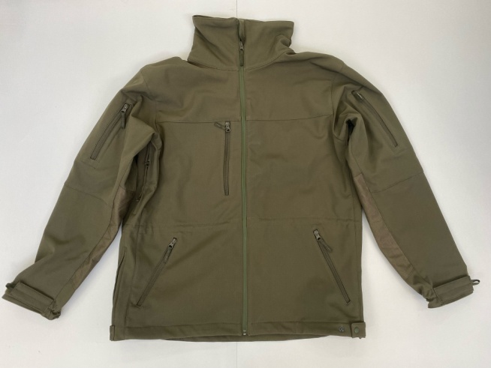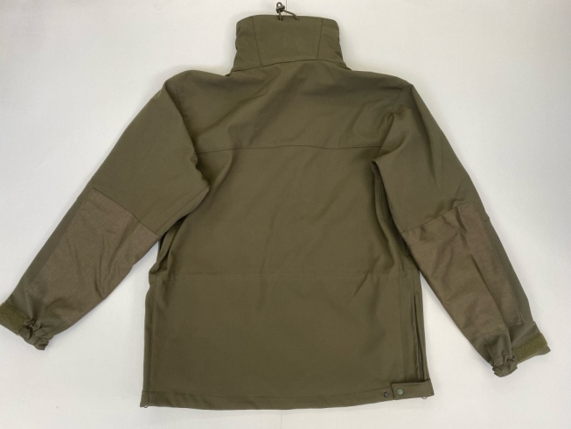

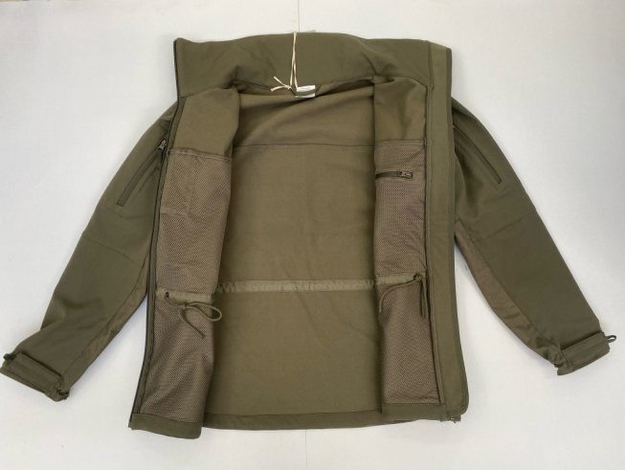

**Technical characteristics of the basic fabric for the summer jacket**

|  |  |  |  |  |  |  |  |
| --- | --- | --- | --- | --- | --- | --- | --- |
| Reg.  no. | Testing elements  (Standards) | | Requested values | | | | |
| 1 | Raw material composition (SRPS EN ISO 1833-1:2012 or equivalent) | | 1st layer (face) – fabric | | | 97% cotton – 7% polyester (±3%) | |
| 1st layer (face) – membrane | | | breathable membrane | |
| 3rd layer (back side) – knitted polar 100% polyester | | | 100% polyester | |
| 2 | Surface mass (SRPS F. S2.016:1986 or equivalent) | | 360 gr/m² (±10%) | | | | |
| 3 | Material type: | | softshell | | | | |
| 4 | Colour fastness to: | | | | | | |
|  | Wash at 40⁰C (SRPS EN ISO 105-C08:2012 or equivalent) | | min. 4 | | | | |
|  | Mopping dry (SRPS EN ISO 105-X12:2017 or equivalent) | | min. 3 | | | | |
|  | Mopping wet (SRPS EN ISO 105-X12:2017 or equivalent) | | min. 3 | | | | |
| 5 | Water repellence (SRPS EN ISO 4920:2012 or equivalent) min. 4 (90) | | min. 4 (90) | | | | |
| 6 | Colour – SMB (light olive colour) – Colour coordinates according to CIE Lab method SRPS EN ISO 105-J03 or corresponding and standard light source D65/10 | | | | | | |
| L* | | a* | | b* | C | | ho |
| 32.8 | | 0.7 | | 7.5 | 7.5 | | 84.4 |
| Allowed tolerance ∆cmc ≤ 2.0 | | | | | | | |

**Technical characteristics of the reinforcing fabric (Cordura)**

|  |  |  |  |  |  |  |  |
| --- | --- | --- | --- | --- | --- | --- | --- |
| Reg.  no. | Testing elements  (Standards) | | Requested values | | | | |
| 1 | Raw material composition (SRPS EN ISO 1833-1:2012 or equivalent) | | 100% polyamide 6.6 | | | | |
| 2 | Surface mass (SRPS F. S2.016:1986 or equivalent) | | 260 gr/m² (±10%) | | | | |
| 3 | Yarn fineness (SRPS ISO 7211-5:2005 or equivalent) | | basis: 560 dteh (±10%) | | | weft: 560 dteh (±10%) | |
| 4 | Interweave | | canvas | | | | |
| 5 | Wire density (SRPS EN 1049-2:2016 or equivalent) | | basis: 21 w/cm (±2) | | | weft: 15 w/cm (±2) | |
| 6 | Colour – SMB (light olive colour) | | | | | | |
| L* | | a* | | b* | C | | ho |
| 31.8 | | 1.5 | | 8.6 | 8.7 | | 79.9 |
| Allowed tolerance ∆cmc ≤ 2.0 | | | | | | | |

## 3.Trousers

The trousers are straight cut. They are fastened with a zipper (reverse fastening) in the slit and a button in the waistband, above the slit.

The belt, about 5 cm wide, is formed by sewing a strip of base fabric on the inside. 10 belt loops, 1 cm wide, 4 from the front and 6 from the back, are sewn onto the belt. The belt loops are secured in the lower part with padded rings. An elastic band is inserted into the side parts of the belt to tighten the belt. In the middle of the back part of the belt, on the inside, a printed label is sewn.

Under the belt, on the front, there are two pockets with slanted openings. The edge of the pocket is reinforced with a stitched Cordura strip. Pocket bags are made of basic fabric.

Beneath the slanted pockets, side pockets are sewn on. The side pocket has two flaps in the middle, facing the back of the pants. On the front side of the side pocket is a vertical opening, which is closed with a zipper (reverse fastening), covered with a piped trim of the base fabric. On the upper side, the pocket closes with a flap with Velcro strap. On the cover of the pocket, four stitched, vertical circles are made, which form two openings. The ends of the lid are secured with stapled, horizontal rings.

Under the side pockets, the leg is cut in an arc, and the composition is double-stitched. Beneath this composition, Cordura knee reinforcement is sewn.

On the back of the pants, there are two eyelets, below which are two horizontal welt pockets, covered with flaps, which are fastened with Velcro.

On the seat part of the pants, reinforcement is sewn, made of the basic fabric.

The rear parts of the legs are also cut in an arch, so that the arch follows the bend of the knee, and the composition is double top-stiched.

Under the slits, between the legs, there are open vents (on the front and back, four in total). The sole between the legs is reinforced with the base fabric on the inside.

The hem of the legs is reinforced with corduroy. On the inside of the hem, there are two holes for a cord that regulates the circumference of the leg.

**Image of the model**

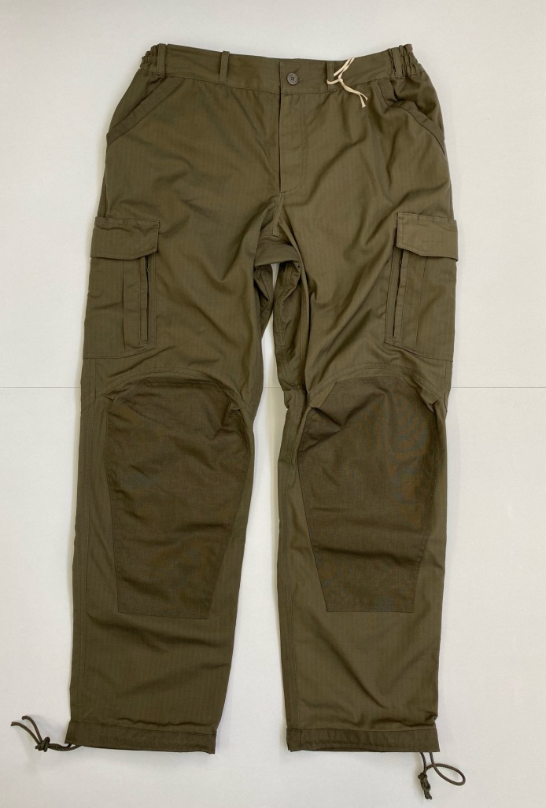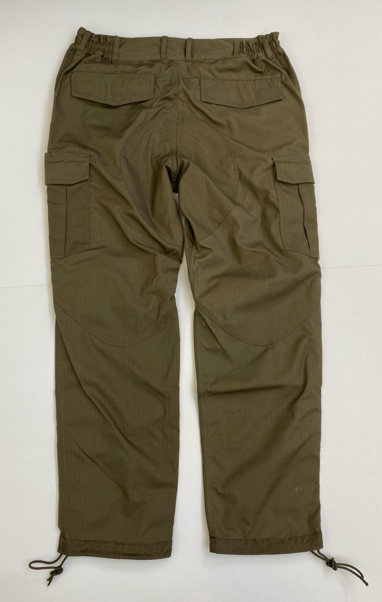

**Technical characteristics of fabric for trousers**

|  |  |  |  |  |  |  |  |
| --- | --- | --- | --- | --- | --- | --- | --- |
| Reg.  no. | Testing elements  (Standards) | | Requested values | | | | |
| 1 | Raw material composition (SRPS EN ISO 1833-1:2012 or equivalent) | | 50% cotton – 50% polyester (±3%) | | | | |
| 2 | Surface mass (SRPS F. S2.016:1986 or equivalent) | | 260 gr/m² (±5%) | | | | |
| 3 | Yarn fineness (SRPS ISO 7211-5:2005 or equivalent) | | basis: 25x2 teh (±5%) | | | weft: 25x2 teh (±5%) | |
| 4 | Interweave | | ripstop | | | | |
| 5 | Wire density (SRPS EN 1049-2:2016 or equivalent) | | basis: 31 w/cm (±2) | | | weft: 17 w/cm (±2) | |
| 6 | Colour fastness to: | | | | | | |
|  | Light (SRPS EN ISO 105-B02:2015 or equivalent) | | min. 4 | | | | |
|  | Wash at 40⁰C (SRPS EN ISO 105-C08:2012 or equivalent) | | min. 4/4/4 | | | | |
|  | Sweat-alkaline (SRPS EN ISO 105-E04:2014 or equivalent) | | min. 4/4/4 | | | | |
|  | Sweat-alkaline (SRPS EN ISO 105-E04:2014 or equivalent) | | min. 3-4/3-4/3-4 | | | | |
|  | Mopping dry (SRPS EN ISO 105-X12:2017 or equivalent) | | min. 4/4 | | | | |
|  | Mopping wet (SRPS EN ISO 105-X12:2017 or equivalent) | | min. 3-4/3-4 | | | | |
|  | Dry cleaning (SRPS EN ISO 105-D01:2012 or equivalent) | | min. 4/4/4 | | | | |
| 7 | Water repellence (SRPS EN ISO 4920:2012 or equivalent) min. 4 (90) | | min. 4 (90) | | | | |
| 8 | Oil resistance (SRPS F. A1.019:1981 or equivalent) | | min. 4 (90) | | | | |
| 9 | Colour – SMB (light olive colour) – Colour coordinates according to CIE Lab method SRPS EN ISO 105-J03 or corresponding and standard light source D65/10 | | | | | | |
| L* | | a* | | b* | C | | ho |
| 34.2 | | 2.1 | | 9.4 | 9.6 | | 77.3 |
| Allowed tolerance ∆cmc ≤ 2.0 | | | | | | | |

**Technical characteristics of the reinforcing fabric (Cordura)**

|  |  |  |  |  |  |  |  |
| --- | --- | --- | --- | --- | --- | --- | --- |
| Reg.  no. | Testing elements  (Standards) | | Requested values | | | | |
| 1 | Raw material composition (SRPS EN ISO 1833-1:2012 or equivalent) | | 100% polyamide 6.6 | | | | |
| 2 | Surface mass (SRPS F. S2.016:1986 or equivalent) | | 260 gr/m² (±10%) | | | | |
| 3 | Yarn fineness (SRPS ISO 7211-5:2005 or equivalent) | | basis: 560 dteh (±10%) | | | weft: 560 dteh (±10%) | |
| 4 | Interweave | | canvas | | | | |
| 5 | Wire density (SRPS EN 1049-2:2016 or equivalent) | | basis: 21 w/cm (±2) | | | weft: 15 w/cm (±2) | |
| 6 | Colour – SMB (light olive colour) | | | | | | |
| L* | | a* | | b* | C | | ho |
| 31.8 | | 1.5 | | 8.6 | 8.7 | | 79.9 |
| Allowed tolerance ∆cmc ≤ 2.0 | | | | | | | |

## 4. Vest

The vest is intended for clothing, as the upper part of the uniform and, at the same time, as protection from meteorological conditions. The vest has a Russian collar, two patched chest pockets with flaps, two slash pockets with flaps and a patched lining inside. The collar is made of two layers of base fabric. A hanger made of the base fabric and a label with the size number and raw material composition are sewn into the neckline. The vest is fastened with a zipper (reverse fastening) along the entire length of the vest and collar. In the chest area, on the front part of the vest, there are flat chest pockets with patches, which are fastened with two fasteners, under which there is a zipper (reverse fastening). There are two folds in the middle of the pocket. On the left side at chest level between the zipper and the pocket is a horizontal pocket that closes with a zipper (reverse fastening) and is covered with a base fabric skirt. In the lower part of the vest, there are two larger flat pockets with flaps that fasten with two fasteners each, under which there is a zipper (reverse fastening). There are two folds in the middle of the pocket. A polyamide lining is sewn into the inside of the vest. The hem is slightly rounded. The vest is sewn with a thread compatible with the fabric.

**Image of the model**

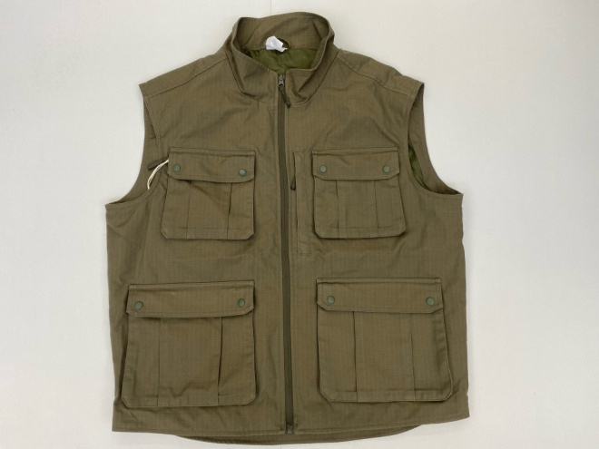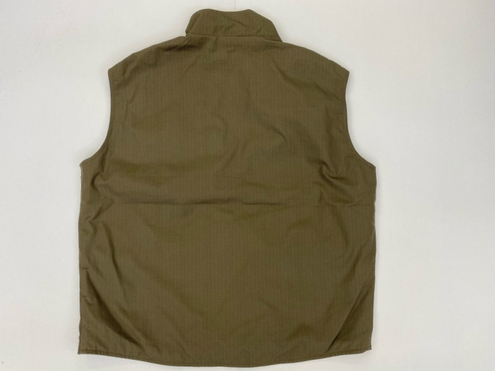

**Technical characteristics of the vest fabric**

|  |  |  |  |  |  |  |  |
| --- | --- | --- | --- | --- | --- | --- | --- |
| Reg.  no. | Testing elements  (Standards) | | Requested values | | | | |
| 1 | Raw material composition (SRPS EN ISO 1833-1:2012 or equivalent) | | 50% cotton – 50% polyester (±3%) | | | | |
| 2 | Surface mass (SRPS F. S2.016:1986 or equivalent) | | 260 gr/m² (±5%) | | | | |
| 3 | Yarn fineness (SRPS ISO 7211-5:2005 or equivalent) | | basis: 25x2 teh (±5%) | | | weft: 25x2 teh (±5%) | |
| 4 | Interweave | | ripstop | | | | |
| 5 | Wire density (SRPS EN 1049-2:2016 or equivalent) | | basis: 31 w/cm (±2) | | | weft: 17 w/cm (±2) | |
| 6 | Colour fastness to: | | | | | | |
|  | Light (SRPS EN ISO 105-B02:2015 or equivalent) | | min. 4 | | | | |
|  | Wash at 40⁰C (SRPS EN ISO 105-C08:2012 or equivalent) | | min. 4/4/4 | | | | |
|  | Sweat-alkaline (SRPS EN ISO 105-E04:2014 or equivalent) | | min. 4/4/4 | | | | |
|  | Sweat-alkaline (SRPS EN ISO 105-E04:2014 or equivalent) | | min. 3-4/3-4/3-4 | | | | |
|  | Mopping dry (SRPS EN ISO 105-X12:2017 or equivalent) | | min. 4/4 | | | | |
|  | Mopping wet (SRPS EN ISO 105-X12:2017 or equivalent) | | min. 3-4/3-4 | | | | |
|  | Dry cleaning (SRPS EN ISO 105-D01:2012 or equivalent) | | min. 4/4/4 | | | | |
| 7 | Water repellence (SRPS EN ISO 4920:2012 or equivalent) min. 4 (90) | | min. 4 (90) | | | | |
| 8 | Oil resistance (SRPS F. A1.019:1981 or equivalent) | | min. 4 (90) | | | | |
| 9 | Colour – SMB (light olive colour) – Colour coordinates according to CIE Lab method SRPS EN ISO 105-J03 or corresponding and standard light source D65/10 | | | | | | |
| L* | | a* | | b* | C | | ho |
| 34.2 | | 2.1 | | 9.4 | 9.6 | | 77.3 |
| Allowed tolerance ∆cmc ≤ 2.0 | | | | | | | |

***Note:*** *This technical documentation is taken from the Public Procurement Portal as an example of a good example.* *The Contracting Authority defines the technical specification in accordance with its needs and in everything in accordance with the provisions of the PPL.*

***See Articles 98-104 of the*** ***LPP***

**Markings –** the Contracting Authority's emblem/logo is made and placed on the winter jacket and summer jacket on the right sleeve at shoulder height and on the front part of the equipment on the left side at chest height, and on the vest on the front part on the left side at chest height.

Approximate dimensions of the emblem/logo: height 90mm, width 80mm

The final appearance of the emblem/logo, the method of production will be submitted in the request for delivery to the selected bidder.

It is not mandatory to make emblems on the samples

**Along with the offer, the bidder is obliged to submit:**

1. Sample of the base fabric for the winter jacket and the test report of that base fabric issued by the accredited laboratory that performed the test,
2. Sample of the base fabric for the winter jacket and the test report of that base fabric issued by the accredited laboratory that performed the test,
3. Sample of the base fabric for the vest and the test report of that base fabric issued by the accredited laboratory that performed the test,
4. Sample of the base fabric for the winter jacket and the test report of that base fabric issued by the accredited laboratory that performed the test,
5. Fabric sample for a quilted lining for a winter jacket and a test report on that fabric issued by an accredited laboratory that performed the test,
6. Sample of the reinforcing fabric (Cordura), in full width, 1 meter long and the test report of that fabric issued by the accredited laboratory that performed the test,
7. Sample of the finished product: winter jackets with an insert and a report on the control of the finished product, which confirms that it has been manufactured in all respects according to the description in the technical specification and according to valid standards, issued by the accredited laboratory that performed the test,
8. Sample of the finished product: winter jackets with an insert and a report on the control of the finished product, which confirms that it has been manufactured in all respects according to the description in the technical specification and according to valid standards, issued by the accredited laboratory that performed the test,
9. Sample of the finished product: one vest with an insert and a report on the control of the finished product, which confirms that it has been manufactured in all respects according to the description in the technical specification and according to valid standards, issued by the accredited laboratory that performed the test,
10. Sample of the finished product: one pair of trousers with an insert and a report on the control of the finished product, which confirms that it has been manufactured in all respects according to the description in the technical specification and according to valid standards, issued by the accredited laboratory that performed the test,

**NOTE:**

At the public opening of bids, the Commission will only note which bidders submitted which samples, while during the review and expert evaluation of the bids, they will check whether the submitted samples correspond in all respects to the requirements of the technical specification. If they determine that they do not meet the stated requirements, the offer will be deemed unacceptable.

The Contracting Authority has the right to send the delivered samples of all finished products and samples of all materials for re-examination to an accredited institution of his choice. In the event that an independent specialized institution determines a deviation from the required quality of the goods, the offer will be assessed as inadequate.

The samples of the selected bidder will be stored in the Contracting Authority's warehouse and will be returned to the selected bidder after the final delivery of the clothing for which the samples were delivered.

The Contracting Authority will keep the samples of the other bidders until the contract is signed with the selected bidder, after which they will be returned to the bidders.

**Delivery term:**

A maximum of 40 days from the date of receipt of a written request for delivery, containing detailed specifications with the correct sizes. The ordering party will deliver the request for delivery to the selected bidder to the e-mail address that the bidder is obliged to specify when concluding the contract. Pursuant to Article 44, paragraph 2 of the Law on Public Procurement, it is considered that the selected bidder received the Contracting Authority's delivery request on the day when the Contracting Authority sent the request by e-mail, and the delivery deadline is calculated from that moment.

**Place of delivery:**

The Contracting Authority’s facility in _________________________________________________ (*Each Contracting Authority enters their place of delivery*)

**METHOD OF DELIVERY**: The selected bidder delivers and unloads the goods to the Contracting Authority's address using his own transport and at his own expense.

**WARRANTY PERIOD** – **at least 12 months from the date of delivery**.

**Quality control**

The Committee for Quantitative and Qualitative Acceptance of Goods, established by the Contracting Authority, will perform a quantitative and qualitative inspection of the delivered goods upon delivery, which will be compiled into a Record of Quantitative and Qualitative Receipt, which will be signed by the members of the Commission and the Supplier's representative. The Commission for Quantitative and Qualitative Acceptance of Goods in question prepares the Minutes of Quantitative and Qualitative Acceptance of Goods, which confirms the receipt of a certain quantity and type of goods, as well as that the delivered goods correspond in all respects to the agreed upon. The committee draws up minutes in two identical copies, which are signed by all members of the committee and the representative of the Bidder, of which one copy is kept by each contracting party. In the event that the Committee for Quantitative and Qualitative Acceptance determines that the quality of the delivered goods does not correspond to the agreed upon, it does not draw up a Record of Quantitative and Qualitative Acceptance, but draws up and signs a Complaint Record, which states why the delivered goods do not conform to the agreed upon. The Bidder is obliged to remedy the defects listed in the Complaint Minutes and to deliver the goods in accordance with the Bidder's Offer and the Contract, no later than the deadline for delivery. After removing the defects and delivering the goods, Minutes of Quantitative and Qualitative Acceptance will be drawn up.

In the event that the Committee for Quantitative and Qualitative Acceptance determines that the quantity of delivered goods does not correspond to the requested quantity, it may draw up the Minutes of Quantitative and Qualitative Acceptance for the delivered goods. In that case, the Bidder is obliged to deliver the remaining requested and undelivered goods in accordance with the Bidder's Offer and the Contract, no later than the deadline for delivery. Upon delivery of the goods, Minutes of Qualitative and Quantitative Receipt will be drawn up for the delivered remaining requested goods.

During the implementation of the contract, the Contracting Authority is authorised to examine whether the delivered goods have the agreed characteristics and quality upon receipt of the goods. The Contracting Authority will examine whether the delivered goods have the agreed characteristics and quality by comparing the technical characteristics specified in the product declaration and accompanying documentation with the agreed characteristics. In the event that the Contracting Authority, during 2 (two) different deliveries of goods, determines that the delivered goods do not have the agreed characteristics, the Contracting Authority is authorised to unilaterally cancel the contract, with a notice period of at least 15 (fifteen) days. In the aforementioned case, the Contracting Authority will activate the means of financial security for the fulfilment of contractual obligations delivered on the basis of the concluded contract.

For all observed defects – hidden defects, which were not visible at the time of receiving the goods, the Contracting Authority shall submit a complaint with a record of defects to the Supplier no later than 8 (eight) days after the defects have been identified. The Bidder undertakes to remove the defects or to replace the defective goods with goods of the agreed quality within 5 (five) days after receiving the complaint at the latest.

**Special note**:

During the delivery of the goods, the supplier **is obliged to submit a statement** of the legal representative of the selected bidder, given under criminal and material responsibility, that the goods delivered were **produced by the selected bidder**.

This is because, according to the provisions of Article 37, paragraph 8 of the PPL, the goods that are delivered **must be produced by the selected bidder**, as an economic operator whose main goal is the professional rehabilitation and employment of persons with disabilities.

In this regard, and in addition to the submitted statement of the selected bidder described above, the ordering party reserves the right to check the production process at the selected bidder. On this occasion, an inspection can be made of the selected bidder's premises where the equipment is manufactured, as well as of the documentation from which it can be undoubtedly determined whether the selected bidder produced the delivered goods (e.g. inspection of incoming invoices for materials/raw materials, work orders from which shows that the employees of the selected bidder were instructed to make the items that are the subject of the public procurement, according to the sizes that the Contracting Authority requested in the request for delivery). If it is determined in such an inspection that the selected bidder is not the manufacturer of the delivered goods, the ordering party will terminate the contract and activate the means of financial security for the fulfilment of contractual obligations delivered on the basis of the concluded contract.

**3.** **CRITERIA FOR QUALITATIVE SELECTION OF THE ECONOMIC OPERATOR (GROUNDS FOR EXCLUSION AND CRITERIA FOR SELECTION OF THE ECONOMIC OPERATOR), WITH INSTRUCTIONS ON HOW TO PROVE THE FULFILMENT OF THESE CRITERIA**

***3.1 GROUNDS FOR EXCLUSION***

**3.1.1.** **Final verdict for one or more criminal offences**

**Legal basis:**

Article 111, paragraph 1, item 1) of the PPL.

The Contracting Authority/entity is obliged to exclude the economic operator from the public procurement procedure if the economic operator does not prove that it and its legal representative in the previous five years from the deadline for submission of bids, i.e., applications is not convicted, unless no other period of ban on participation in the public procurement procedure has been determined, for:

(1) a criminal offence committed as a member of an organised criminal group and a criminal offense of association for the purpose of committing criminal offences;

(2) criminal offence of abuse of office of a responsible person, criminal offence of abuse in connection with public procurement, criminal offence of accepting bribes in performing economic activities, criminal offence of giving bribes in performing economic activities, criminal offence of abuse of official position, criminal offence of trading in influence, criminal offence bribing and the criminal offence of receiving bribe, the criminal offence of fraud, the criminal offence of unjustified obtaining and using credit and other benefits, the criminal offence of fraud in economic activities and the criminal offence of tax evasion, the criminal offence of terrorism, the criminal offence of public incitement to commit terrorist acts, the crime the act of recruiting and training for committing terrorist acts and the crime of terrorist association, the crime of money laundering, the crime of financing terrorism, the crime of trafficking in human beings and the crime of establishing slavery and transporting persons in slavery.

**Method of proving the fulfilment of the criteria:**

The economic operator is obliged to compile and submit an application through the Portal on the fulfilment of the criteria for qualitative selection of the economic operators, which confirms that there is no ground for exclusion.

Prior to making a decision in the public procurement procedure, the Contracting Authority is obliged to request from the bidder who submitted the most economically favourable bid to submit evidence of fulfilment of the criteria for qualitative selection of the economic operator.

It is considered that the economic operator that is entered in the register of bidders has no grounds for exclusion from Article 111, paragraph 1, item 1) of the Law on Public Procurements.

The absence of this ground for exclusion is proved by the following evidence:

Legal entities and entrepreneurs:

1) Certificate of the competent Basic Court in whose territory the seat of the domestic legal entity or entrepreneur is located, i.e., the seat of the representative office or branch of the foreign legal entity confirming that the bidder has not been convicted in the previous five years from the deadline for submission of bids, i.e., applications, that it has not been convicted by an enforceable decision, except if the final period of prohibition of participation in the public procurement procedure has not been determined by a final judgment, for the following criminal offences: criminal offence of tax evasion; the criminal act of fraud; the criminal act of unjustified obtaining and using credit and other benefits; criminal offence of abuse of official position; the criminal act of influence peddling; the crime of bribery; the criminal offense of trafficking in human beings (for forms referred to in Article 388, paragraphs 2, 2,3, 4, 6, 8 and 9 of the Criminal Code) and the criminal offence of establishing slavery and transporting persons in slavery (for forms referred to in Article 390, paragraph 1 and 2 of the Criminal Code).

2) Certificate of the competent High Court in whose territory the seat of the domestic legal entity or entrepreneur is located, i.e., the seat of the representative office or branch of the foreign legal entity confirming that the bidder has not been convicted in the previous five years from the deadline for submission of bids, i.e., applications, that it has not been convicted by an enforceable decision, except if the final period of prohibition of participation in the public procurement procedure has not been determined by a final judgment, for the following criminal offences: criminal offence of tax evasion; the criminal act of fraud; the criminal act of unjustified obtaining and using credit and other benefits; criminal offence of abuse of official position; if the value of the obtained property gain exceeds RSD 1,500,000.00; criminal offence of trafficking in human beings (for forms referred to in Article 388, paragraphs 1, 5 and 7 of the Criminal Code); the criminal offence of establishing a slave relationship and transporting a person in a slave relationship if it was committed against a minor and the criminal offence of accepting bribes.

3) Certificate of the Special Department of the High Court in Belgrade for Organised Crime confirming that the legal entity or entrepreneur has not been convicted of any of the following criminal offences: criminal offences of organised crime; the criminal offence of association for the purpose of committing criminal offences; criminal offense of abuse of official position, trading in influence, accepting bribes and giving bribes if the defendant or the person to whom the bribe is given is an official or responsible person performing a function based on election, appointment or appointment by the National Assembly, President, General Session of the Supreme Court of Cassation, the High Judicial Council or the State Prosecutors’ Council; criminal offenses against the economy, if the value of property exceeds RSD 200,000,000, or if the value of public procurement exceeds RSD 800,000,000 for: criminal offence of abuse in connection with public procurement, criminal offence of accepting bribes in performing economic activities, criminal offence of giving bribery in performing economic activity, criminal offense of fraud in performing economic activity, criminal offence of abuse of position of a responsible person, criminal offense of money laundering – if the property subject to money laundering originates from all the above criminal offences; the criminal offence of public incitement to commit terrorist acts; the criminal act of terrorist financing; the criminal act of terrorism; the criminal act of recruitment and training for terrorist acts and the crime of terrorist association. 4) Certificate of the Special Department of High Courts in Belgrade, Novi Sad, Niš and Kraljevo for the Suppression of Corruption, confirming that the legal entity or entrepreneur has not been convicted of any of the following criminal offences: bribery in the course of economic activity; the criminal offence of bribery in the performance of economic activity; the criminal offence of abuse in connection with public procurement; the criminal offence of fraud in the performance of economic activity; the criminal offence of abuse of the position of a responsible person and the criminal offence of money laundering.

Legal representatives and natural persons:

1) Excerpt from the criminal records, i.e., the certificate of the competent police administration of the Ministry of the Interior, which confirms that the legal representative or natural person has not been convicted of the following criminal offences:

1) a criminal offence committed as a member of an organised criminal group and a criminal offense of association for the purpose of committing criminal offences;

2) criminal offence of abuse of position of a responsible person, criminal offence of abuse in connection with public procurement, criminal offence of accepting bribes in performing economic activities, criminal offence of giving bribes in performing economic activities, criminal offence of abuse of official position, criminal offence of trading in influence, criminal offence of bribery and the crime of bribery; the criminal offence of fraud, the criminal offence of unjustified acquisition and use of credit and other benefits, the criminal offence of fraud in the performance of economic activity and the criminal offence of tax evasion; the criminal offence of terrorism, the criminal offence of public incitement to commit terrorist acts, the criminal offence of recruitment and training for the commission of terrorist acts and the criminal offence of terrorist association; the criminal act of money laundering, the criminal offence of terrorist financing; the criminal offence of trafficking in human beings and the criminal offence of establishing a slave relationship and transporting persons in a slave relationship.

The request can be submitted according to the place of birth or the place of residence of the legal representative or natural person.

If the bidder has several legal representatives, the bidder is obliged to submit evidence for each of them.

The economic operator established in another state: If the economic operator has its registered office in another state, the Contracting Authority shall accept the excerpt from the criminal record or other appropriate register or, if this is not possible, the relevant document of the competent judicial or administrative body in the state of the economic operator, i.e., in the state whose citizen he/she is. If the said evidence is not issued in the country in which the economic operator is established, or in the country of which the person is a citizen, or if the evidence does not include all data regarding the lack of grounds for exclusion, the economic operator may submit its written statement criminal and material liability, certified before a judicial or administrative body, notary public or other competent body of that state, in which it is stated that there are no stated grounds for exclusion of the economic operator.

**3.1.2.** **Taxes and contributions**

**Legal basis:**

Article 111, paragraph 1, item 2) of the PPL.

The Contracting Authority/entity is obliged to exclude the economic operator from the public procurement procedure if item 2 the economic operator does not prove that it has paid due taxes and contributions for compulsory social insurance or that it has been granted a deferral of debt payment by a binding agreement or resolution, in accordance with special regulation, including all accrued interest and fines.

**Method of proving the fulfilment of the criteria:**

The economic operator is obliged to compile and submit an application through the Portal on the fulfilment of the criteria for qualitative selection of the economic operators, which confirms that there is no ground for exclusion.

Prior to making a decision in the public procurement procedure, the Contracting Authority is obliged to request from the bidder who submitted the most economically favourable bid to submit evidence of fulfilment of the criteria for qualitative selection of the economic operator.

It is considered that the economic operator that is entered in the register of bidders has no grounds for exclusion from Article 111, paragraph 1, item 2) of the Law on Public Procurement.

The absence of this ground for exclusion is proved by the following evidence:

1) confirmation by the competent tax authority that the bidder has paid due taxes and contributions for compulsory social insurance or that it has been granted a deferral of debt payment, including all accrued interest and fines, by a binding agreement or decision, in accordance with a special regulation.

2) confirmation by the competent tax authority of the local self-government body that the bidder has settled the due obligations of public revenues or that it has been granted a deferral of debt payment, including all accrued interest and fines, by a binding agreement or decision, in accordance with a special regulation.

A legal entity that is in the process of privatisation, instead of the evidence referred to in items 1) and 2), shall enclose a certificate from the competent authority that it is in the process of privatisation.

If the economic operator has its registered office in another state as proof that there are no grounds for exclusion from Article 111, paragraph 1, item 2) of this Law, the Contracting Authority shall accept the certificate of the competent authority in the state of the economic operator’s registered office. If the said evidence is not issued in the country in which the economic operator is established, or in the country of which the person is a citizen, or if the evidence does not include all data regarding the lack of grounds for exclusion, the economic operator may submit its written statement criminal and material liability, certified before a judicial or administrative body, notary public or other competent body of that state, in which it is stated that there are no stated grounds for exclusion of the economic operator.

**3.1.3.** **Obligations in the field of environmental protection, social and labour law**

**Legal basis:**

Article 111, paragraph 1, item 3) of the PPL.

The Contracting Authority/entity is obliged to exclude the economic operator from the public procurement procedure if it determines that the economic operator in the period of the previous two years from the expiration of the deadline for submission of bids, i.e., applications, violated obligations in the field of environmental protection, social and labour law, including collective agreements, and in particular the obligation to pay contracted wages or other mandatory payments, including obligations in accordance with the provisions of international conventions listed in Annex 8 of the Law on Public Procurement.

**Method of proving the fulfilment of the criteria:**

The economic operator is obliged to compile and submit an application through the Portal on the fulfilment of the criteria for qualitative selection of the economic operators, which confirms that there is no ground for exclusion. The absence of this ground for exclusion is established by the Contracting Authority.

**3.1.4.** **Conflict of interest**

**Legal basis:**

Article 111, paragraph 1, item 4) of the PPL.

The Contracting Authority/entity is obliged to exclude the economic operator from the public procurement procedure if item 4 there is a conflict of interest, in terms of the Law on Public Procurement, which cannot be eliminated by other measures.

**Method of proving the fulfilment of the criteria:**

The economic operator is obliged to compile and submit an application through the Portal on the fulfilment of the criteria for qualitative selection of the economic operators, which confirms that there is no ground for exclusion. The absence of this ground for exclusion is established by the Contracting Authority.

**3.1.5.** **Undue influence on the procedure**

**Legal basis:**

Article 111, paragraph 1, item 5) of the PPL.

The Contracting Authority/entity is obliged to exclude the economic operator from the public procurement procedure if it determines that the economic operator has undertaken to unduly influence the decision-making process of the Contracting Authority/entity or obtain confidential information that may confer upon it undue advantage in the public procurement procedure or to has provided misleading information that may have effect on decisions concerning the exclusion of economic operator, the selection of an economic operator or the award of a contract.

**Method of proving the fulfilment of the criteria:**

The economic operator is obliged to compile and submit an application through the Portal on the fulfilment of the criteria for qualitative selection of the economic operators, which confirms that there is no ground for exclusion. The absence of this ground for exclusion is established by the Contracting Authority.

***Note:*** *The Contracting Authority is not obliged to use the grounds for exclusion prescribed by Article 112 of the* Law*, but if it uses them it is obliged to state them in the documentation and to exclude the economic operator from the public procurement procedure if in any way at any time of the procedure it determines that there are grounds for exclusion.*

***3.2 CRITERIA FOR SELECTION OF AN ECONOMIC OPERATOR***

**3.2.1.** **Authorisation, permit or membership**

**Legal basis:**

Article 115, paragraph 2 of the PPL.

“In so far as economic operator has to possess a particular authorisation, or a permit issued by the competent authority for the performance of activity which is the subject-matter of public procurement, or to be a member of a particular organisation in order to be able to perform the activity concerned, Contracting Authority/entity may require them to prove that they hold such authorisation, permit, or membership.

**Conditions**

The right to participate in the proceedings in question has only business operators whose main goal is the professional rehabilitation and employment of persons with disabilities that are organized in accordance with the Law on Professional Rehabilitation and Employment of Persons with Disabilities and that these persons make up at least 50% of the employed persons in those economic operators.

In the event that the bid is submitted by a group of bidders or that the bidder submits a bid with a subcontractor, all participants in the joint bid and all subcontractors must be from the aforementioned group and meet the requirements of Article 37 of the Law on Public Procurement.

**Method of proving the fulfilment of the criteria:**

The economic operator is obliged to compile and submit with the offer a statement on the fulfilment of the criteria for the qualitative selection of the economic operator, which confirms that it meets this criterion for the selection of the economic operator. The statement must include the date and number of the decision (permit).

Prior to making a decision in the public procurement procedure, the Contracting Authority is obliged to request from the bidder who submitted the most economically favourable bid to submit evidence of fulfilment of the criteria for qualitative selection of the economic operator.

This criterion is proven by submitting: Permits (decisions) issued by the ministry in charge of employment affairs for carrying out the activities of companies for professional rehabilitation and employment of persons with disabilities, in accordance with the Law on Professional Rehabilitation and Employment of Persons with Disabilities.

In the event that the bid is submitted by a group of bidders, submit the specified proof for each member of the group.

In case the bidder submits a bid with a subcontractor, this proof must also be submitted for the subcontractor.

**3.2.2.** **Technical and professional capacity**

**Legal basis:**

Article 117, paragraph 1 of the PPL

The Contracting Authority may set requirements ensuring that economic operators possess the necessary human and technical resources and experience necessary to perform the public procurement contract to an appropriate quality level, and may require, in particular, that economic operator has sufficient experience in terms of contracts performed in the past.

**Technical persons or bodies – quality control**

**Condition:**

That the bidder has a minimum of 20 (twenty) persons engaged in work in accordance with the Labour Law, who will be engaged in the preparation of specific public procurement items.

If the offer is submitted by a group of bidders or with the participation of subcontractors, the required personnel capacity is proved together.

**Method of proving the fulfilment of the criteria:**

The economic operator is obliged to compile through the Portal and submit with the offer a statement on the fulfilment of the criteria for the qualitative selection of the economic operator, by which it confirms that it meets this criterion for the selection of the economic operator, and in which it should state the names and surnames of all 20 employees.

In the case of submitting a joint offer or an offer with a subcontractor, the required personnel capacity is proved together, with the fact that in the statement each participant should indicate which specific capacities of the required ones it fulfils and proves.

Prior to making a decision in the public procurement procedure, the Contracting Authority is obliged to request from the bidder who submitted the most economically favourable bid to submit evidence of fulfilment of the criteria for qualitative selection of the economic operator.

This criterion is proven by:

* a copy of the employment contract and the corresponding individual M forms, which confirm the application, change or de-registration for mandatory social insurance – for persons employed by the bidder;
* for persons hired through a non-employment contract or other contract that is the legal basis of employment – copies of the non-employment contract (temporary and casual work contract, work contract, supplementary work contract, etc.).

*Note:* *The Contracting Authority can determine other criteria for the selection of an economic operator that are logically related to the subject of procurement in accordance with Art. 114-117 of the* Law*.*

*In this model, we did not require bidders to prove the following:*

* *that the bidder, in relation to the total number of employees, has at least 50% of persons with disabilities employed for an indefinite period of time – because this is a requirement according to Article 36, paragraph 2, item 2) of the Law on Professional Rehabilitation and Employment of Persons with Disabilities;*
* *that the bidder has appropriate space and appropriate technical and other equipment for work training and work of persons with disabilities, as this is a requirement according to Article 36, paragraph 2, item 3) of the Law on Professional Rehabilitation and Employment of Persons with Disabilities;*
* *references – because the competition has already been narrowed by the implementation of the reserved public procurement, and the quality will be verified by the assessment of the samples that all bidders must submit.*

**4.** **DATA REGARDING THE CRITERIA FOR AWARDING THE PUBLIC PROCUREMENT CONTRACT**

In the public procurement procedure, the Contracting Authority awards the contract to the most economically advantageous offer based on the ratio of the offered price and quality based on the following criteria: **Price**

*Note:* *Each Contracting Authority, in addition to the proposed criterion, may use other elements in accordance with Art. 132 and 133 of the* Law*.*

The bidder who offers the lowest total price and acceptable tender will be awarded the public procurement contract.

**Other procurement requirements (not listed above as criteria)**

Name: Warranty period:

Unit of measurement: month

Minimum allowed value: 12

**Reserve criteria on the basis of which the contract will be awarded in a situation where there are two or more bids that are equal after the application of the criteria:**

In a situation where there are two or more offers with the same offered price, the Contracting Authority will choose the most favourable offer by choosing the offer of the bidder who offered a longer warranty period.

**Application of the draw**

If, even after the application of the above-mentioned reserve criteria, it is not possible to make a decision on the award, the Contracting Authority will award the contract to the bidder who will be drawn by lot. The Contracting Authority shall notify in writing all bidders who have submitted bids of the date when the draw will take place. Only those offers that have the same price and the same warranty period will be included in the draw. The Contracting Authority will draw by draw in public, in the presence of the bidder, by writing the names of the bidders on separate papers of the same size and colour, and will fold all these papers and put them in a transparent box from where they will draw one paper and one in accordance with the order of the drawn names of the bidders, the ranking of bids will be performed, i.e., the bidder whose name will be on the first drawn paper will be the first ranked bidder. The Contracting Authority will submit the minutes from the draw to the bidders who do not attend this procedure by draw.

*Note:* *The Contracting Authority may define the draw procedure in another way.*

**5.** **DATA ON THE BASIS OF WHICH THE BIDDERS PREPARE THE BID FORM**

The tender documentation contains data on the basis of which the bidders prepare the bid form, which contains the following data:

1) general data on the bidder, i.e., each bidder from the group of bidders, as well as subcontractors (business name or abbreviated name from the appropriate register, registered office address, identification number and tax identification number, contact, etc.);

2) the validity period of the bid expressed in the number of days from the day of bid opening, which may not be shorter than 30 days;

3) subject matter of public procurement,

4) price and other criteria for awarding the contract, which can be expressed numerically;

5) other procurement requirements, which the Contracting Authority considers relevant for the conclusion of the contract and which can be expressed numerically;

6) data on the part of the contract that the bidder will entrust to the subcontractor (by subject or in quantity, value or percentage), data on the subcontractor, as well as data that the Contracting Authority will make payments directly to the subcontractor, in case the subcontractor requests direct payment of due receivables;

7) a statement of integrity by which the bidder confirms under full material and criminal responsibility that it submitted its bid independently, without agreement with other bidders or interested persons and to guarantee the accuracy of the data in the bid.

Note: The bid form is automatically formed on the Portal based on the data entered by the Contracting Authority in step: Criteria for contract award and other procurement requirements.

**6.** **DATA ON THE BASIS OF WHICH THE BIDDERS PREPARE THE FORM OF THE STATEMENT ON FULFILMENT OF THE CRITERIA FOR QUALITATIVE SELECTION OF THE ECONOMIC OPERATOR**

The form of the statement on the fulfilment of the criteria for the qualitative selection of the economic operator is automatically formed on the Portal on the basis of the data entered by the Contracting Authority in the step: Criteria for qualitative selection of the economic operator.

The portal automatically forms part of the tender documentation: Criteria for qualitative selection of an economic operator and instructions on how to prove the fulfilment of these criteria, and

If the bid is submitted by a group of economic operators, a separate statement of each member of the group of economic operators shall be submitted in the bid, which shall contain data for the relevant capacities of the group member.

If an economic operator intends to entrust a part of the contract to a subcontractor or use the capacities of other entities, it is obliged to submit a separate statement for the subcontractor, i.e., the entity whose capacities it uses, containing data on the relevant capacities of the subcontractor or other entity it intends to use.

The economic operators shall state in the statement on the fulfilment of the criteria the issuers of evidence on the fulfilment of the criteria for qualitative selection of the economic operator and state that they will be able to submit that evidence to the Contracting Authority upon request and without delay.

In the statement on fulfilment of the criteria, the economic operator may state data on the internet address of the database, all necessary identification data and statement of consent, through which evidence can be obtained, i.e., inspect the evidence on fulfilment of the criteria for qualitative selection of the economic operator.

**7.** **OFFERED PRICE STRUCTURE FORM**

|  |  |  |  |  |  |  |  |
| --- | --- | --- | --- | --- | --- | --- | --- |
|  | **Item name** | **Unit of measurement** | **Quantity** | **Offered unit price (without VAT)** | **Offered unit price (with VAT)** | **Total price (RSD, without VAT)** | **Total price (RSD, with VAT)** |
| **Column** | **1** | **2** | **3** | **4** | **5** | **6 (3*4)** | **7 (3*5)** |
| 1 | Winter jacket with insole | pcs | 35 |  |  |  |  |
| 2 | Summer jacket | pcs | 35 |  |  |  |  |
| 3 | Trousers | pcs | 70 |  |  |  |  |
| 4 | Vest | pcs | 35 |  |  |  |  |
| **Total price:** | | | | | |  |  |

**Instructions for filling out the offer form:**

In column 4, enter the offered unit price (without VAT) for each requested product

In column 5, enter the offered unit price (with VAT) for each requested product

In column 6, enter the total price (without VAT), which is obtained when the unit price without VAT is multiplied by the quantity for each requested product (multiply the values ​​from column 3 with column 4)

In column 7, enter the total price (with VAT), which is obtained when the unit price with VAT is multiplied by the quantity for each requested product (multiply the values ​​from column 3 with column 5)

At the end of the table, in the "Total price" section, enter the total price of the offer without VAT, as well as the total price of the offer with VAT.

Note:

During the duration of the contract, the unit prices are fixed and unchangeable.

The prices are shown as final, with all costs and discounts included.

**8.** **OFFER PREPARATION COSTS FORM**

Pursuant to Article 138 of the in accordance with Article 138 of the Law, the bidder [insert name] shall submit the total amount and structure of costs of bid preparation, as follows in the table:

|  |  |
| --- | --- |
| **COST TYPE** | **AMOUNT OF COST IN RSD** |
|  |  |
|  |  |
|  |  |
|  |  |
|  |  |
|  |  |
| **TOTAL AMOUNT OF BID PREPARATION COSTS** |  |

**Note:**

The costs of preparation and submission of the bid shall be borne exclusively by the bidder and may not require reimbursement of costs from the Contracting Authority. If the public procurement procedure is suspended due to reasons on the part of the Contracting Authority, the Contracting Authority shall reimburse the bidder for the costs of making the sample or model, if they were made in accordance with the technical specifications of the Contracting Authority and the costs of obtaining security, provided that the bidder in its offer asked for compensation of such costs.

**Submission of this form is optional.**

**9.** **CONTRACT MODEL**

**CONTRACTING AUTHORITY:**

__________________________________________________________________________________________

with headquarters in ______________________, street_______________________________ no. ___,

tax identification number: ________________, registration number: ________________________

represented by _____________________________________________ (hereinafter referred to as: Contracting Authority)

and

**BIDDER:**

__________________________________________________________________________________________

with headquarters in ________________________, street ___________________________, no. ___,

tax identification number: ________________, registration number: ________________________

Account number: _________________________ Name of the bank:_________________________,

Phone:_________________________ E-mail: _________________________________________________

who is represented by __________________________________________ (hereinafter referred to as: Supplier),

Enter into

**CONTRACT ON PUBLIC PROCUREMENT OF GOODS**

**PROTECTIVE EQUIPMENT**

**Public Procurement No. _______**

**THE CONTRACTING PARTIES AGREE THAT:**

- The Contracting Authority conducted an open procedure for the public procurement of goods: Procurement of Protective Equipment, Public Procurement no. ____________ ;

- The supplier submitted the Offer, number ____________, in all respects in accordance with the Tender documentation;

- The Contracting Authority awarded the contract to the Supplier, based on the Decision on awarding the contract, number ____________ of ____________________, in accordance with the Law on Public Procurement ("Official Gazette of the Republic of Serbia”, No. 91/2019).

*(variant: joint offer)*

- The supplier is the job holder of the following group of bidders ________________________________________

- Bidders who submit a joint bid are liable unlimitedly jointly and severally with the Contracting Authority.

*(variant: offer with subcontractor)*

- The supplier submitted the offer with the following subcontractors __________________________

- The supplier entrusted the following part of the procurement ____________________ to a subcontractor.

- The Bidder is fully responsible to the Contracting Authority for the performance of contractual obligations, regardless of the number of subcontractors.

**SUBJECT-MATTER OF THE AGREEMENT**

**Article 1**

The subject-matter of this contract is the procurement of protective equipment, in everything according to the Technical Specification contained in the Tender Documentation (hereinafter referred to as the contract: Technical Specification) and the adopted Supplier's Offer (hereinafter referred to as the contract: Supplier’s Offer), which form an integral part of this contract.

Protective equipment consists of: winter jacket with liner, summer jacket, vest and pants.

**PRICE**

**Article 2**

The total value of the goods from Article 1 of this contract is RSD __________________ without VAT, that is, RSD __________________ with VAT. The unit price includes the delivery of protective equipment to the address of the Contracting Authority and all other accompanying and dependent costs incurred by the Supplier during the execution of the contract.

The indicated prices are final, fixed and unchangeable. Prices are expressed at parity ex-delivery.

|  |  |  |  |  |  |  |  |
| --- | --- | --- | --- | --- | --- | --- | --- |
|  | **Item name** | **Unit of measurement** | **Quantity** | **Offered unit price (without VAT)** | **Offered unit price (with VAT)** | **Total price (RSD, without VAT)** | **Total price (RSD, with VAT)** |
| **Quantity** | **1** | **2** | **3** | **4** | **5** | **6 (3*4)** | **7 (3*5)** |
| 1 | Winter jacket with insole | pcs | 35 |  |  |  |  |
| 2 | Summer jacket | pcs | 35 |  |  |  |  |
| 3 | Trousers | pcs | 70 |  |  |  |  |
| 4 | Vest | pcs | 35 |  |  |  |  |
| **Total price:** | | | | | |  |  |

**TERMS AND METHOD OF PAYMENT**

**Article 3**

The Contracting Authority undertakes to pay the agreed price, including VAT, to the Supplier after each delivery, by payment to the Supplier's current account No. _______________, which is maintained at _____________, within 45 days from the date of receipt of the correct invoice that the Supplier will deliver to the Contracting Authority.

Documentation required for payment:

- account / invoice;

- a mutually signed Record of Quantitative and Qualitative Receipt of Goods, without objections.

Obligations that are due in the next budget year will be implemented at most up to the amount of funds that will be approved for that purpose in that budget year, in accordance with Article 7 of the Decree on the criteria for determining the nature of expenditures and the conditions and method of obtaining consent for the conclusion of certain contracts that due to the nature expenditures require payment in several years (“Official Gazette of the Republic of Serbia”, Nos. 21/14 and 18/2019).

**PLACE, DEADLINE AND METHOD OF EXECUTION OF THE CONTRACT**

**Article 4**

The contracting parties agree to determine the **place of delivery**:

* _____________________________________________________ (*specify delivery address*)

The goods are delivered once to the agreed place of delivery.

If, after the conclusion of the contract, and before the delivery of the goods that are the subject of the contract, he changes the place of delivery from paragraph 1 of this article, he is obliged to inform the Supplier about this no later than 3 days before changing the place of delivery.

The Supplier undertakes to deliver the goods from Article 1 of this contract to the Contracting Authority within ________ days (maximum 40 days), from the day of receipt of the written request for delivery, which contains detailed specifications with exact sizes.

The Contracting Authority will submit the delivery request to the selected bidder at the following e-mail _____________________________________________________________.

Pursuant to Article 44, paragraph 2 of the Law on Public Procurement, it is considered that the selected bidder received the Contracting Authority's delivery request on the day when the Contracting Authority sent the request by e-mail, and the delivery deadline is calculated from that moment.

The goods that are the subject of this contract are delivered and unloaded by the Supplier, using its means of transport and labour force, at its own expense.

The supplier undertakes to deliver in a timely and quality manner, in accordance with positive legal regulations, norms and standards whose use is mandatory, acts and instructions of the Contracting Authority and in accordance with this Agreement, respecting the rules of the profession, professionally and conscientiously.

The offered goods must be new at the time of delivery, in the original packaging of the manufacturer, with attached technical documentation, which guarantees the originality of the product. With each delivery, the seller is obliged to submit the manufacturer's declaration (specification) of the product for the model of the good he delivers, from which the basic technical characteristics are visible, and from which the buyer can conclude that the seller delivers the good that is in accordance with what the buyer requested in the tender documentation.

During the delivery of the goods, the supplier is obliged to submit a statement of the legal representative of the selected bidder, given under criminal and material responsibility, that the goods delivered were produced by the selected bidder. Pursuant to the provisions of Article 37, paragraph 8 of the PPL, the goods that are delivered must be produced by the selected bidder, as an economic operator whose main goal is the professional rehabilitation and employment of persons with disabilities.

The Contracting Authority reserves the right to check the production process with the selected bidder. On this occasion, an inspection can be made of the selected bidder's premises where the equipment is manufactured, as well as of the documentation from which it can be undoubtedly determined whether the selected bidder produced the delivered goods (e.g. inspection of incoming invoices for materials/raw materials, work orders from which shows that the employees of the selected bidder were instructed to make the items that are the subject of the public procurement, according to the sizes that the Contracting Authority requested in the request for delivery). If it is determined in such an inspection that the selected bidder is not the manufacturer of the delivered goods, the ordering party will terminate the contract and activate the means of financial security for the fulfilment of contractual obligations delivered on the basis of the concluded contract.

**QUALITY OF GOODS AND GUARANTEE PERIOD**

**Article 5**

The quality of the goods, which are the subject of this Agreement, must fully correspond to the valid domestic or international standards for that type of goods.

The seller is obliged to deliver the goods according to this contract, which are in accordance with the manufacturer's declaration and the required technical characteristics of the buyer from the tender documents.

**Article 6**

When delivering the goods, the bidder is obliged to provide and issue a guarantee/guarantee certificate from the manufacturer of the goods to the Contracting Authority. The length of the warranty period is _______ months from the date of delivery (*minimum 12 months*), during which period the bidder is responsible for the quality of the goods and is obliged to, in accordance with the terms of the manufacturer's warranty, eliminate the defect or deliver the goods without defects.

The seller is released from responsibility for the resulting changes in quality that are a consequence of improper maintenance and use of the goods by the buyer.

**QUALITATIVE AND QUANTITATIVE ACCEPTANCE**

**Article 7**

The Committee for Quantitative and Qualitative Acceptance of Goods, established by the Contracting Authority, will perform a quantitative and qualitative inspection of the delivered goods upon delivery, which will be compiled into a Record of Quantitative and Qualitative Receipt, which will be signed by the members of the Commission and the Supplier's representative. The Commission for Quantitative and Qualitative Acceptance of Goods in question prepares the Minutes of Quantitative and Qualitative Acceptance of Goods, which confirms the receipt of a certain quantity and type of goods, as well as that the delivered goods correspond in all respects to the agreed upon. The committee draws up minutes in two identical copies, which are signed by all members of the committee and the representative of the Bidder, of which one copy is kept by each contracting party. In the event that the Committee for Quantitative and Qualitative Acceptance determines that the quality of the delivered goods does not correspond to the agreed upon, it does not draw up a Record of Quantitative and Qualitative Acceptance, but draws up and signs a Complaint Record, which states why the delivered goods do not conform to the agreed upon. The Bidder is obliged to remedy the defects listed in the Complaint Minutes and to deliver the goods in accordance with the Bidder's Offer and the Contract, no later than the deadline for delivery. After removing the defects and delivering the goods, Minutes of Quantitative and Qualitative Acceptance will be drawn up.

In the event that the Committee for Quantitative and Qualitative Acceptance determines that the quantity of delivered goods does not correspond to the requested quantity, it may draw up the Minutes of Quantitative and Qualitative Acceptance for the delivered goods. In that case, the Bidder is obliged to deliver the remaining requested and undelivered goods in accordance with the Bidder's Offer and the Contract, no later than the deadline for delivery. Upon delivery of the goods, Minutes of Qualitative and Quantitative Receipt will be drawn up for the delivered remaining requested goods.

During the implementation of the contract, the Contracting Authority is authorised to examine whether the delivered goods have the agreed characteristics and quality upon receipt of the goods. The Contracting Authority will examine whether the delivered goods have the agreed characteristics and quality by comparing the technical characteristics specified in the product declaration and accompanying documentation with the agreed characteristics. In the event that the Contracting Authority, during 2 (two) different deliveries of goods, determines that the delivered goods do not have the agreed characteristics, the Contracting Authority is authorised to unilaterally cancel the contract, with a notice period of at least 15 (fifteen) days. In the aforementioned case, the Contracting Authority will activate the means of financial security for the fulfilment of contractual obligations delivered on the basis of the concluded contract.

For all observed defects – hidden defects, which were not visible at the time of receiving the goods, the Contracting Authority shall submit a complaint with a record of defects to the Supplier no later than 8 (eight) days after the defects have been identified. The Bidder undertakes to remove the defects or to replace the defective goods with goods of the agreed quality within 5 (five) days after receiving the complaint at the latest.

**COMPENSATION FOR DAMAGE**

**Article 8**

The Supplier is obliged to compensate the Contracting Authority for damage caused to the Contracting Authority’s property through its own fault or gross negligence.

If, during the implementation of this contract, the Contracting Authority suffers damage as a result of the Supplier’s failure to fulfil the contractual obligations, the Supplier is responsible for the damage suffered by the Contracting Authority in that case and is obliged to compensate it.

The contracting parties agree that in the event of damage from paragraph 1 of this article, the joint commission will determine the possible responsibility of the Supplier, the scope and amount of damage, which will be recorded.

**CONTRACTUAL PENALTY**

**Article 9**

The Contractors agree that the Contractor is obliged to pay the Contracting Authority an amount of 0.2% of the total required value of goods for each day of delay, in the name of the contractual penalty, if it does not make the delivery within the agreed time due to his own fault, with the fact that the total amount of the contractual penalty cannot exceed 5% of the total contracted value.

Upon receipt of the late delivery, the Contracting Authority shall deliver to the Supplier a written Notice that it reserves the right to a contractual penalty, which the Supplier is obliged to sign and receive.

The contractors agree that the Contracting Authority calculates the contractual penalty.

The Contracting Authority will collect the contractual penalty by activating the means of financial security for the good performance of the work, without the prior consent of the Supplier, in which case the Supplier undertakes to deliver a new means of security for the good performance of the work without delay, and at the latest within 3 days from the receipt of the Contracting Authority’s invitation.

The Contracting Authority’s right to collect a contractual penalty does not affect his right to demand compensation for damages, i.e., if the Contracting Authority has suffered damage that is greater than the amount of the contractual penalty due to the Supplier’s delay in delivery, he has the right to demand the difference up to full compensation for damages.

**FINANCIAL SECURITY INSTRUMENTS**

**Article 10**

The supplier undertakes to deliver to the customer, within 15 days from the date of conclusion of the contract, an unconditional, irrevocable, without the right to object, payable at the first call, a **bank performance guarantee** in the amount of 10% of the total contracted price, excluding VAT, with a validity period of at least _____ days (min 30 days) longer than the deadline for the execution of the contracted work as a whole.

If during the duration of the contract, the deadlines for the execution of the contractual obligation are extended, the bidder is obliged to extend the validity of the bank guarantee for the good performance of the work.

The bank guarantee cannot contain additional conditions for payment, shorter terms or a smaller amount, otherwise it will be considered that the bidder has refused to deliver the Bank Guarantee for the good performance of the work, in which case the Contracting Authority can collect the Bank Guarantee for the seriousness of the offer and conclude the contract with the first next best bidder.

The Contracting Authority can collect a bank guarantee for the good performance of the work in the event that the bidder does not fulfil the contractual obligations under the agreed conditions, in the agreed manner and within the agreed deadlines and if the violations are repeated despite the written warnings of the Contracting Authority, as well as in the case of unilateral termination of the contract by the contractor.

Delivery of the Bank Guarantee for the good performance of the work is a suspensive condition for the legal effect of the contract.

**TERMINATION**

**Article 11**

This contract may be terminated in the event of the occurrence of circumstances that do not depend on the will of the contracting parties and that make it difficult or impossible to execute the contract, by delivering a written notice of cancellation to the other contracting party.

This contract can be terminated only if the other contracting party has been warned in advance of significant violations or repeated violations and if it has not eliminated them within the time allowed, which cannot be shorter than 15 (fifteen) days.

This contract can be terminated only by the contracting party that has fulfilled its obligations in full and in a timely manner.

**VALIDITY OF THE CONTRACT**

**Article 12**

This Contract shall enter into force on the day of signing by the authorised persons of the contracting parties and upon the delivery of the means of financial security by the Supplier.

In the event that the date of signing of this Contract is different, the Contract shall enter into force on the date of signature of the party to the Contract who signed it later.

The term of validity of the contract is until the fulfilment of the contractual obligations.

In the event of possible disagreements between the contracting parties regarding the application of the provisions of this Contract, the provisions of the Law on Contract and Torts and other positive legal regulations shall be applied.

**FINAL PROVISIONS**

**Article 13**

The contractors agree to settle all possible disputes arising from this contract amicably, and if no agreement is reached, they agree that the competent commercial court will be the seat of the Contracting Authority.

**Article 14**

This contract is drawn up in 4 (four) identical copies, of which 3 (three) copies are retained by the Contracting Authority, and one copy by the Supplier.

SUPPLIER CONTRACTING AUTHORITY

__________________________ ________________________________

*Note:* *A public procurement contract may be concluded in electronic form, in accordance with the law governing electronic documents and the law governing electronic signatures.*

*The contract model is the basis for determining the clauses of the contract that will be concluded with the most favourable bidder.* *It will be modified in accordance with the accepted Offer and, in this sense, certain clauses will be subsequently refined, which will regulate the required conditions from the invitation to submit an offer and the Tender documentation.* *This contract model is an integral part of the tender documentation,* ***the bidder does not submit it in its offer, but he is obliged to confirm when filling out the electronic offer on the Public Procurement Portal that he is familiar with the content and that it accepts the contract model concerned****.*

# **10.** **INSTRUCTION TO BIDDERS ON HOW TO PREPARE AN OFFER**

**Data on the Contracting Authority**

|  |  |
| --- | --- |
| Contracting Authority: | *(Portal withdraws the stated data)* |
| Tax identification number (TIN): | *(Portal withdraws the stated data)* |
| Address: | *(Portal withdraws the stated data)* |
| Website: | *(Portal withdraws the stated data)* |

# **Basic information about the procedure**

|  |  |
| --- | --- |
| Name of the procedure: | **Protective equipment** |
| Reference number: | *(Portal withdraws the stated data)* |
| Type of procedure: | **Open procedure** |
| Type of procurement subject matter: | **Goods** |
| Description: | *(Portal withdraws the stated data)* |
| Deadline for submission: | *(Portal withdraws the stated data)* |

**Characteristics of the public procurement procedure** *(instruments and techniques) (if applicable)*

# **Description of subject-matter / lot**

**Protective equipment**

# **Procurement description:**

*(Portal withdraws the stated data)*

The Contracting Authority defined the criteria for awarding the contract based on:

*(Portal withdraws the stated data)*

Method of ranking acceptable bids:

*(Portal withdraws the stated data)*

# **Electronic communication and data exchange on the Public Procurement Portal**

Electronic communication is required in the procedure.

The offer is submitted through the Public Procurement Portal in the manner described in this instruction.

The user interested in the public procurement procedure communicates with the Contracting Authority exclusively through the Public Procurement Portal.

The user of the Public Procurement Portal may be interested in the published public procurement procedure by downloading the tender documentation or indicating his interest.

The documentation in this public procurement procedure on the Public Procurement Portal can be accessed on the procedure website:

***https://jnportal.ujn.gov.rs/***

Actions in the public procurement procedure that you can carry out on that page of the procedure:

# sending a request for additional information or clarification regarding the procurement documentation as well as pointing out to the Contracting Authority any deficiencies and irregularities in the procurement documentation

* forming a group of bidders
* preparation and submission of bid

# filling in the e-Statement on fulfilment of the criteria for qualitative selection of the economic operator

* assignment of the right to a procedure (*to a person in an economic operator*)

# sending a request for protection of rights

* granting authorisation to the proxy for representation in the procedure of protection of rights

An economic operator may request additional information or clarifications from the Contracting Authority regarding the procurement documentation through the Public Procurement Portal, and may indicate to the Contracting Authority if it considers that there are deficiencies or irregularities in the procurement documentation, no later than 8 (data specified by the Contracting Authority) before the submission deadline.

# **Email inbox in the procedure**

The user interested in the procedure during the public procurement procedure receives the following information via the e-mail box on the Portal:

* Changes to the tender documentation
* Additional information or clarifications regarding procurement documentation
* Modifications to the electronic catalogue
* Award / suspension decision
* Public procurement notices published

The user or economic operator that participates in the procedure through the mailbox through the Portal receives:

* Confirmation of successfully submitted bid/application
* Confirmation of successfully submitted amendment/supplement to the bid
* Confirmation of revocation of bid
* Invitation to submit bids
* Invitation to participate in the e-auction
* Minutes on the opening of bids

The user also receives copies of messages to the e-mail address with which he/she registered on the Portal.

# **Preparation and submission of bid**

The economic operator makes a bid/application on the Public Procurement Portal according to the structure and content defined by the Contracting Authority during the preparation of the public procurement procedure on the Portal.

The economic operator submitting the bid must be registered on the Portal with at least one, and preferably more users (or user accounts).

A bidder who has submitted a bid independently may not participate in a joint bid or as a subcontractor at the same time, nor may the same person participate in several joint bids.

The bidder may submit only one bid, except in the case when the submission of a bid with variants is allowed or required.

Detailed instructions on the preparation of the offer are available on the Portal.

**Deadline for submission of bids:** *(Portal withdraws the stated data)*

**Offers may be submitted:** **Serbian** (*information provided by the Contracting Authority*)

In the offer form, the offeror must confirm with a declaration of integrity under full material and criminal responsibility that he submitted his offer independently, without agreement with other offerors or interested parties and guarantee the accuracy of the data in the offer.

# **Preparation and submission of a joint offer**

On the public procurement procedure page on the Portal, an economic operator can create a group of economic operators (bidders) in order to submit a joint offer.

A member of a group of economic operators submitting a bid must be authorized to submit a joint bid on behalf of the group. Authorisation to submit a bid on behalf of a group of economic operators, members of the group give through the Public Procurement Portal. All members of the group should be registered users of the Public Procurement Portal.

See more about the formation of a group of economic operators on the Portal.

The offer is prepared and submitted by a group member authorised to submit a joint offer on behalf of a group of economic operators.

In the case of a joint offer, data on group members are part of the offer form.

When filling in the bid form of a group of bidders on the Public Procurement Portal, the value or percentage of the procurement value and the subject or quantity of the procurement subject to be performed by each member of the group according to the agreement should be stated.

All members of the group of economic operators should fill in the Statement on fulfilment of the criteria for qualitative selection of the economic operator.

# **Preparing a bid with a subcontractor**

If the bid includes subcontractors, they should be registered users of the Public Procurement Portal, but they should not give consent to the economic operator for submitting a bid through the Portal.

An economic operator that intends to entrust the execution of part of the contract to a subcontractor, is obliged to state for each individual subcontractor:

1. data on the subcontractor *(name of the subcontractor, address, identification number, tax identification number, name of the contact person).*
2. information on the part of the contract that will be entrusted to the subcontractor *(by subject matter or in quantity, value or percentage).*
3. data whether the subcontractor requires the Contracting Authority to pay to it directly the due claims for the part of the contract which he has executed.

The economic operator is obliged to submit a Statement of compliance with the criteria for qualitative selection of the economic operator for each subcontractor in the bid.

# **Preparation of documents within the offer**

The economic operator uploads the offer documents according to the defined structure. Supported formats and sizes of documents are prescribed by the Instructions for the use of the Public Procurement Portal. In case an individual document exceeds the size provided on the Public Procurement Portal, it is recommended to use document compression or divide the document into smaller parts and upload smaller and/or compressed documents to the Public Procurement Portal.

Documents that are uploaded as part of the offer may not be encrypted by the economic operator. The Public Procurement Portal encrypts bids and their parts and keeps the content of bids/applications secret, as well as information on the identity of the economic operator until the date and time of bid opening.

The economic operator can prepare and upload to the Portal the documents that it intends to attach as part of the offer.

# **The Contracting Authority requires that the bidder attach the following documents in its offer:**

# Bid form;

* Offered price structure form;
* Statement on fulfilment of criteria for qualitative selection of economic operator (SFC);
* Bid bond: blank promissory note, signed with original signature (not facsimile), which must be recorded in the Register of Bills of Exchange and authorisations of the National Bank of Serbia (signed by an authorised person), promissory note authorisation – letter with clauses “no protest” and signed by an authorised person and with the indicated amount of 3% of the total value of the offer without VAT), certificate of registration of the bill (listing from the NBS website, as proof that the bill is registered), copy of the card of deposited signatures commercial banks specified in the bill of exchange authorization – letter) and a copy of the certified OP form;
* Sample of the base fabric for the winter jacket and the test report of that base fabric issued by the accredited laboratory that performed the test,
* Sample of the base fabric for the winter jacket and the test report of that base fabric issued by the accredited laboratory that performed the test,
* Sample of the base fabric for the vest and the test report of that base fabric issued by the accredited laboratory that performed the test,
* Sample of the base fabric for the winter jacket and the test report of that base fabric issued by the accredited laboratory that performed the test,
* Fabric sample for a quilted lining for a winter jacket and a test report on that fabric issued by an accredited laboratory that performed the test,
* Sample of the reinforcing fabric (Cordura), in full width, 1 meter long and the test report of that fabric issued by the accredited laboratory that performed the test,
* Sample of the finished product: winter jackets with an insert and a report on the control of the finished product, which confirms that it has been manufactured in all respects according to the description in the technical specification and according to valid standards, issued by the accredited laboratory that performed the test,
* Sample of the finished product: winter jackets with an insert and a report on the control of the finished product, which confirms that it has been manufactured in all respects according to the description in the technical specification and according to valid standards, issued by the accredited laboratory that performed the test,
* Sample of the finished product: one vest with an insert and a report on the control of the finished product, which confirms that it has been manufactured in all respects according to the description in the technical specification and according to valid standards, issued by the accredited laboratory that performed the test,
* Sample of the finished product: one pair of trousers with an insert and a report on the control of the finished product, which confirms that it has been manufactured in all respects according to the description in the technical specification and according to valid standards, issued by the accredited laboratory that performed the test,

The economic operator shall submit the bid bond in accordance with Article 45, paragraph 4 of the Law, within the deadline for submission of bids.

With each requested document, the economic operator can upload more documents, if the document consists of several parts.

When uploading documents to the Public Procurement Portal, the economic operator on the Portal indicates whether a particular bid document is confidential (in accordance with Article 38 of the Law on Public Procurement), it states the legal basis on which the documents are marked confidential and explains the reason(s) for confidentiality. If a certain document has only certain parts confidential, before uploading that document to the Portal, it is necessary for the economic operator to separate the confidential parts into a separate document, mark it confidential, and thus upload it to the Public Procurement Portal. Parts that are not confidential need to be separated into a separate document or documents and thus uploaded to the Public Procurement Portal. No part of the electronic offer/application is signed, no stamp is required and no scanning of documents is required.

# **Statement on fulfilment of criteria for qualitative selection of economic operator (SFC)**

The statement on the fulfilment of the criteria for the qualitative selection of the economic operator is filled in electronically on the Portal.

Part of the tender documentation **Criteria for qualitative selection of an economic operator with instructions** was formed through the Portal and attached to the tender documentation.

How to fill out the e-Statement via the Portal – see general instructions for Portal users.

Members of the group, subcontractors or other entities whose capacities are used by the economic operator fill in each of their e-Statements, and the economic operator can download the completed e-Statement through the Portal and attach it to the bid.

# **Parts of the offer that cannot be delivered electronically**

In the event that part or parts of the bid/application cannot be submitted by electronic means via the Public Procurement Portal (see Article 45, paragraph 3 of the Law on Public Procurement), the economic operator is obliged to state the exact part or parts of the bid/application in the bid/application that are submitted by non-electronic means.

Part or parts of the bid/application that cannot be submitted by electronic means through the Public Procurement Portal shall be submitted by the economic operator to the Contracting Authority by the deadline for submission of bids/applications by mail, courier service or directly, in an envelope or box closed in a way that when opening it the Law can be determined with certainty that it is opening for the first time.

The parts of the offer that cannot be submitted by electronic means via the Public Procurement Portal are submitted by the economic operator to the address:

*(Portal withdraws the stated data)*

With a note:

Part of the offer for public procurement: *(Protective equipment)*

DO NOT OPEN

When preparing the offer on the Portal, the economic operator specifies the parts of the offer that will be delivered by non-electronic means (by mail, courier service or directly).

The name and address of the economic operator should be stated on the back of the envelope or on the box. In case parts of the offer are submitted by a group of business operators, it is necessary to indicate on the envelope that it is a group of business operators and to state the names and addresses of all members of the group.

Parts of the offer are considered timely if they are received by the Contracting Authority (*the Portal withdraws the specified data*).

The Contracting Authority will submit an acknowledgment of receipt to the economic operator. In the acknowledgment of receipt, the Contracting Authority shall state the date and time of receipt.

Parts of the offer that the Contracting Authority did not receive within the deadline set for submitting offers, that is, that was received after the end of the day and hour by which offers can be submitted, will be considered untimely. Untimely part or parts of the bid/application will be returned unopened to the bidder by the Contracting Authority upon completion of the opening procedure, with an indication that they were submitted late.

# **Filling in the bid form**

The price is expressed in dinars, with and without VAT, including all costs incurred by the bidder in the implementation of the public procurement.

# **Other procurement requirements:**

1. The bidder is not allowed to request an advance.
2. 2. Place of delivery of goods: address of the Contracting Authority __________________________________ (*specified by the Contracting Authority*).
3. Warranty period: at least 12 months from the date of delivery.

# **Application of the draw**

If, even after the application of the above-mentioned reserve criteria, it is not possible to make a decision on the award, the Contracting Authority will award the contract to the bidder who will be drawn by lot. The Contracting Authority shall notify in writing all bidders who have submitted bids of the date when the draw will take place. Only those offers that have the same price and the same warranty period will be included in the draw. The Contracting Authority will draw by draw in public, in the presence of the bidder, by writing the names of the bidders on separate papers of the same size and colour, and will fold all these papers and put them in a transparent box from where they will draw one paper and one in accordance with the order of the drawn names of the bidders, the ranking of bids will be performed, i.e., the bidder whose name will be on the first drawn paper will be the first ranked bidder. The Contracting Authority will submit to the bidders who do not attend this procedure the minutes from the draw by draw.

*Note:* *The Contracting Authority may define the draw procedure in another way.*

**Method and deadline for payment:**

The Contracting Authority undertakes to pay the agreed price, including VAT, to the supplier after the delivery has been made, by payment to the supplier's current account, within 45 days from the date of receipt of the invoice and complete documentation for payment.

Documentation required for payment:

- account / invoice;

- a mutually signed Record of Quantitative and Qualitative Receipt of Goods, without objections.

# **The bid must be valid for 30 days from the day of bid opening.**

After entering all the data, the economic operator generates the offer form and can review the offer data before submitting the offer.

# **Method of amending and supplementing the offer** – see the general instructions for users of the Portal

# **How to revoke an offer** – see the general instructions for users of the Portal

# **Information on the type, content, manner of submission, amount and deadlines for ensuring the fulfilment of the bidder's obligations**

***BID BOND:***

# The bidder undertakes to submit a blank promissory note as a means of securing the seriousness of the bid.

**The blank promissory note must be registered in the Register of Bills of Exchange and Authorisations of the National Bank of Serbia** and should be signed by a person authorised to represent with the **original signature (not a facsimile)**. The bill of exchange must be accompanied by a duly completed and signed **bill of exchange authorisation – letter**, with “no protest” clauses, for seriousness of the bid and with the indicated amount of 3% of the total contract value without VAT and bill of exchange registration certificate (**listing from NBS website, not a registration request**). The bill of exchange must be accompanied by a **copy of the certified OP form and a copy of the card of deposited signatures**, issued by the commercial bank specified by the bidder in the bill of exchange authorisation – letter. In case of change of the person authorised to represent the bill of exchange authorisation – the letter remains in force. The signature of the authorised person on the bill of exchange and the bill of exchange authorisation – the letter must be identical to the signature or signatures from the card of deposited signatures.

Security for the seriousness of the bid – bill of exchange (or bank guarantee), bill of exchange authorisation, card of deposited signatures and OP form are submitted to the Contracting Authority in the manner described in this section, i.e., submitted to the Contracting Authority by the deadline for submission of bids/applications by mail, courier or directly, in an envelope or box, closed in such a way that it can be determined with certainty that it is being opened for the first time.

The term of validity of the financial security is a minimum of 30 (thirty) days from the day of opening the bids.

If the deadlines for the selection of bidders change during the contract award procedure, the validity of the financial security must be extended.

The bidder with whom the contract will be concluded is obliged to extend the security for the seriousness of the bid until it is replaced by the security for the fulfilment of the contractual obligations.

The Contracting Authority shall redeem the bill of exchange given with the bid if the bidder withdraws from his bid within the validity of the bid, fails to submit evidence of fulfilment of criteria for qualitative selection of economic operator in accordance with Article 119 of the Law, unreasonably refuses to conclude a contract or does not submit security for fulfilment of contractual obligations.

At the request of the bidders who are not selected, the security will be returned immediately after the conclusion of the contract with the selected bidder.

If the bidder does not submit a bill of exchange, the bid will be rejected as unacceptable.

***MEANS OF SECURITY FOR FULFILMENT OF CONTRACTUAL OBLIGATIONS:***

The selected tenderer undertakes to deliver to the Contracting Authority, within 15 days from the date of conclusion of the contract, an unconditional, irrevocable, without right of objection, payable at the first call, a **bank performance guarantee** in the amount of 10% of the total contracted price, excluding VAT, with a term of validity at least 30 days longer than the term for the execution of the contracted work as a whole (note: the client determines these 2 terms in each specific case).

If during the duration of the contract, the deadlines for the execution of the contractual obligation are extended, the bidder is obliged to extend the validity of the bank guarantee for the good performance of the work.

The bank guarantee cannot contain additional conditions for payment, shorter terms or a smaller amount, otherwise it will be considered that the bidder has refused to deliver the Bank Guarantee for the good performance of the work, in which case the Contracting Authority can collect the Bank Guarantee for the seriousness of the offer and conclude the contract with the first next best bidder.

The Contracting Authority can collect the bank guarantee for the good performance of the work in the event that the tenderer does not fulfil the contractual obligations under the agreed conditions, in the agreed manner and within the agreed deadlines and if the violations are repeated despite the written warnings of the client.

Delivery of the Bank Guarantee for the good performance of the work is a suspensive condition for the legal effect of the contract.

# **Opening of offers**

**Data related to the opening of bids as specified in the invitation**

Date: *(Portal withdraws the stated data)*

Place: *(Portal withdraws the stated data)*

# **Information on authorised persons and opening procedure:**

The Contracting Authority did not exclude the public from the bid opening procedure. On the procedure page *Bids Bid Opening*, the bidder can follow the countdown until the opening of bids. After the Portal opens the bids, a record on the opening of bids is formed, which can be downloaded from the page of the procedure and sent to the bidders at the same time.

# **Clarifications of the offer, form and method of submitting evidence**

After opening the bids, the Contracting Authority may request additional explanations that will help it in reviewing, evaluating and comparing bids, and may also perform control (insight) with the bidder or its subcontractor.

Where information or documentation submitted by an economic operator is incomplete or unclear, the Contracting Authority may, while observing the principles of equality and transparency, request the bidders or candidates to supply necessary information or additional documents within an appropriate time limit which shall not be shorter than five days.

See general instructions for users of the Portal.

# **Protection of rights**

The request for protection of rights may be submitted by an economic operator, i.e., a bidder who had or has an interest in awarding a contract in a specific public procurement procedure and who indicates that due to the Contracting Authority’s actions contrary to the PPL, the contract was damaged or LPP (hereinafter referred to as: the Applicant).

The request for protection of rights shall be submitted electronically via the Public Procurement Portal at the same time to the Contracting Authority and the Republic Commission for Protection of Rights in Public Procurement Procedures (hereinafter referred to as: Republic Commission), and the Contracting Authority/procuring entity, whereby the date of submission through the Public Procurement Portal is considered the date of receipt.

# **Applying for protection of rights electronically**

See general instructions for users of the Portal.

Steps:

* Enter the reference number of the request
* Data on the applicant, the Contracting Authority and the procedure for which the application is submitted are automatically withdrawn from the system
* If the applicant undertakes actions in the procedure through a proxy, it may authorise a proxy through the Public Procurement Portal
* If the request is submitted on behalf of a group of bidders, the applicant should upload the authorisation of other members of the group or an agreement which shows that it has the right to submit a request on behalf of the group.
* Define whether the request for protection of rights refers to the subject matter of procurement as a whole or to an individual lot of the subject matter of procurement (mark lots)
* Documents to download from your computer:
  + Document of the request for protection of rights (you can also upload additional documentation with the request)
  + Proof of payment of the fee.

# **Precise information on the deadline(s) for protection of rights**

A request for protection of rights may be submitted during the entire public procurement procedure, unless otherwise specified by the PPL, and no later than ten days from the date of publication on the Public Procurement Portal of the Contracting Authority's decision terminating the public procurement procedure in accordance with the PPL. The request for protection of rights which disputes the actions of the Contracting Authority in connection with determining the type of procedure, content of the public invitation and tender documentation will be considered timely if received by the Contracting Authority no later than three days before the deadline for submission of bids or applications. The request for protection of rights challenging the actions of the Contracting Authority undertaken after the deadline for submission of bids shall be submitted within ten days from the date of publication of the Contracting Authority’s decision on the Public Procurement Portal, or from the date of receipt of the decision in cases where publication on the Public Procurement Portal is not provided. After the expiration of the deadline for submitting the request for protection of rights, the applicant may not supplement the request by stating the reasons related to the actions that are the subject of dispute in the submitted request or disputing other actions of the Contracting Authority with which he was or could be acquainted before the deadline for the protection of rights, which he did not point out in the submitted request.

The request for protection of rights may not challenge the actions of the Contracting Authority undertaken in the public procurement procedure if the applicant was or could have known the reasons for its submission before the deadline for submission of the request, and the applicant did not submit it before the deadline. If in the same public procurement procedure, a request for protection of rights has been submitted again by the same applicant, that request may not challenge the actions of the Contracting Authority that the applicant knew or could have known when submitting the previous request. The subject of dispute in the procedure of protection of rights may not be possible deficiencies or irregularities of the procurement documentation that are not indicated in accordance with Article 97 of the PPL. The Contracting Authority shall publish the notice on submitted request for protection of rights on the Public Procurement Portal no later than the day after the receipt of the request for protection of rights. Submission of the request for protection of rights delays the continuation of the public procurement procedure by the Contracting Authority until the end of the protection procedure. The request for protection of rights must contain the data from Article 217 of the PPL.

If the applicant undertakes actions in the procedure through a proxy, it shall submit the authorisation for representation in the procedure of protection of rights with the request for protection of rights. The applicant who has a permanent or temporary residence, i.e., a seat abroad, is obliged to appoint a proxy for the receipt of letters in the Republic of Serbia in the request for protection of rights, stating all data necessary for communication with the designated person.

When submitting the request for protection of rights to the Contracting Authority, the applicant is obliged to submit proof of payment of the fee.

Evidence is any document from which it can be determined that the transaction was performed for the appropriate amount from Article 225 of the PPL and to refer to the subject request for protection of rights.

Valid proof of payment of the fee, in accordance with the Instructions on payment of the fee for submitting a request for protection of the rights of the Republic Commission, was published on the website of the Republic Commission.

The fee is RSD 120,000.

**PUBLIC**

**CLEAR**

**EFFICIENT**

**Good governance project**

