



Guide to the Use of Instruments in Public Procurement Procedures

CONTENTS

INTRODUCTION 4

**What is qualification system?** 5

**Establishing qualification system** 6

**Application for qualification** 12

**Expert evaluation of applications and deciding on qualification** 13

**Record keeping and exclusion of candidates from the qualification system** 15

**Procedure for awarding contract** 16

The guide to electronic auction 19

**What is electronic auction?** 19

**Procedures and procurement subjects** 20

**Drafting and publishing public call and tender documentation in a procedure using electronic auction** 20

**Expert valuation of tenders** 22

**Conducting and ending electronic auction** 25

The guide to electronic catalog 28

**Possibility to submit tender with e-catalog** 28

**Preparing tender documentation and submitting tender with e-catalog** 33

# INTRODUCTION

This Guide is a practical tool for understanding and using instruments in public procurement procedures provided for in the Law on Public Procurement (“Official Gazette of the RS”, Nos. 91/2019 and 92/2023, hereinafter: the PPL), with a view to improving efficiency, competitiveness, and transparency of public procurement procedures. The Guide elaborates three specific instruments: **qualification system, electronic auction,** and **electronic catalog,** governed under Articles 69 through 74 of the PPL.

**Qualification system** is the framework that contracting entity establishes and manages so to enable business entities qualify for the future participation in public procurement procedure in which is going to be awarded a contract or a framework agreement. In the EU, qualification system is regulated by Directive 2014/25/EU[1] and, in line with the rules of this Directive, in the Republic of Serbia it is regulated under Articles 69 and 70 of the PPL.

**Electronic auction** is a contemporary electronic process in which bidders are given possibility to submit bids with novel, more favorable prices or other values of certain contract elements, during the course of a single or several consecutive rounds. Electronic auction is an option whereby, instead of the classic way of ranking bids, the selection of the most advantageous bid is done by electronic biding. Unlike the auction that first comes to mind (such as the sale of paintings, artwork, compulsory sale of immovable and movable property, etc.), this is the case of buying (not selling), and this means that during the auctioning the price can only go down, not up, although the auction subject may also cover other criteria where, again, each subsequent value will be more favorable for the procurer as the buyer, rather than for the seller, here, tenderer. In the EU public procurement system, electronic auction is regulated by Directive 2014/24/EU and Directive 2014/25/EU[2]. The PPL regulates the requirements for, and the method of, application, and the closure of electronic auction in Articles 71 through 74.

**Electronic catalog** is a digital document prepared by candidates or tenderers in accordance with the procurer’s technical specifications and requirements. Electronic catalog is a new instrument in public procurement in the Republic of Serbia, introduced by the PPL and governed by Article 74, in accordance with the above EU Directives[3]. To easily understand its importance and scope, one can view it as a sort of combination of a table with technical specifications and a price structure template.

The purpose of this Guide is to help procurers and tenderers understand and use these instruments properly, and to encourage their use in practice; it was developed within the Project “Efficient Public Procurement and Sustainable Supply Chains (ESG) for Improving Competitiveness”, implemented by NALED and supported by the Swedish International Development and Cooperation Agency (SIDA).

The Guide to Use Qualification System

## **What is Qualification System?**

Qualification system is an instrument available to **contracting entity** to compile a list of economic operators that meet necessary Criteria for the qualitative selection, that is, for participation in given public procurement procedure, from the perspective of the procurement subject and contracts that need to be executed. Therefore, the establishing of a qualification system is not a public procurement procedure, but rather a mere instrument that can make future procurements easier, through prior qualification.

Main advantages of qualification system are as follows: ensuring quality of participants and greater competitiveness; efficiency (saving time and resources); reduced risk for contracting entity in terms of certainty that the contract/framework agreement will be awarded, and certainty and quality in execution of procurement.

This system’s essence comprises the prior qualification of economic operators that meet technical, expert, financial, and other requirements set by procurer, and subsequent procurement of works, goods or services, whenever contracting entity develops specific need for a procurement subject for which it has established, and operates, a qualification system. The purpose of qualification is to ensure that only capable and reliable economic subjects get included in the procurement process.

Qualification system is an open system in which, throughout its duration, economic operators can submit an application for qualification, at any time; it can be sorted into categories by type of contract to which given qualification responds. This enables a constant inflow of new economic operators, which in turn enables greater competition in public procurement procedure. Allowing a broad range of qualified tenderers to take part in public procurement procedures can result in better contract terms, lower prices, and better quality of contract execution.

Likewise, the reducing of administrative burden through preliminary evaluation of economic operators speeds up public procurement procedures, especially in recurring procurements. This also results in reduced risks in terms of conducting procedures for awarding contract and ensuring that contractual obligations are fulfilled free of interruptions or problems from the part of qualified economic operators.

## **Establishing Qualification System**

* **This system can only be established by contracting entity**

Article 69, Paragraph 1 of the PPL provides that contracting entity may establish and operate system of qualifying economic operators. This right that only contracting entities enjoy[4] is provided for under Directive 2014/25/EU on procurement by procurers which operate in areas of water management, energy, transport and postal services, and was consistently transposed into our public procurement system, in the process of harmonizing it with the European rules.

* **Public procurement procedures that can use qualification system to award contracts**

Qualification system can be used to conduct the second phases of:

* Restricted procedure
* Negotiated procedure with prior publication
* Competitive dialog, or
* Innovation partnership

Namely, where notice on the existence of a qualification system is used as a public call, the contracts covered by qualification system will be awarded by applying the rules of the second phase of any of the above procedures. Where contracting entity uses notice on the existence of a qualification system as a public call, it shall mark the option ‘This notice serves as a public call’ in segment ‘Procurement Subject and Communication’, as early as while creating and publishing this notice on the Portal.

In this case, to the second phase of any of the above procedures are invited all economic operators qualified in the qualification system or in certain categories of such qualification system. In fact, the full purpose of qualification system is to use this notice as a public call.

Since qualification system is not a public procurement procedure, when establishing it, contracting entity is not making decision on conducting a public procurement procedure in terms of Article 91 of the PPL, having in mind that mere publishing of notice on the existence of a qualification system does not initiate a public procurement procedure. Contracting entity will make this decision only once it conducts the second phase of any of the above-mentioned procedures, to conclude specific public procurement contract. Stll, when creating notice on the existence of a qualification system on the Public Procurement Portal (hereinafter: the Portal), it is necessary to enter an internal number in the part ‘Basic parameters of the procedure’, hence it is necessary to take a separate decision on establishing qualification system thereby appointing panel that will prepare required documentation and publish notice on existence of this system on the Portal; panels for each subsequent phase of the procedure will be appointed by decision on conducting given public procurement procedure.

The foregoing allows the conclusion that, at the point of establishing qualification system, given procurement does not have to exist in the public procurement plan; instead, an individual procurement in qualification system ought to be foreseen in public procurement plan at the time the second phase is going to be implemented. Hence, given that qualification system is established typically for a longer, and perhaps even an indefinite, period of time, contracting entity is obliged to plan specific procurements in its annual procurement plans, pursuant to Article 88 of the PPL.

* **Notice on the existence of a qualification system**

Qualification system is established by publishing ‘Notice on the existence of a qualification system[5]’, just like all other public procurement notices, on the Portal. Contracting entity creates and publishes this notice on the Portal by using one of its functionalities.

* **Contents of notice on the existence of a qualification system**

Notice on the existence of a qualification system, pursuant to Article 69, Paragraph 3 of the PPL, contains data defined in Annex 4, Part G II of the PPL. In procurements of social and other special services[6] this notice contains much less data, only those defined as minimum in Annex 4, Part Z of the PPL.

Together with publication of this notice, also prepared and published simultaneously on the Portal are adequate ‘tender documents’, pursuant to which interested economic operators submit applications.

In essence, key elements that notice on the existence of a qualification system and related tender documents need to include are as follows:

* **Drafting and publishing notice on the existence of qualification system on the Portal**

1. ***Designating public procurement instrument - establishing a qualification system***

When creating procurement on the Portal, on the first screen, in part ‘Basic parameters of procedure’, one should mark (tick) the field ‘Establishing qualification system’ beneath the name of the procedures.

This option is only available to procurer registered on the Portal as ‘contracting entity’, meaning that the option to establish a qualification system is not even available to a procurer registered as ‘contracting authority’.

*Display on the Portal*

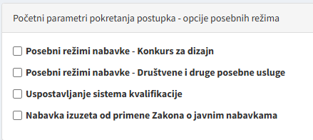

1. ***Duration of qualification system***

Contracting entity has to specify the duration of qualification system. There is no legal limit to the maximum duration of this system. It can even be established for an indefinite period of time. In section ‘Subject/Lots’ - ‘Description’, choose one of offered options for the validity of qualification system, such as: ‘Set by start and end dates’ or ‘Valid indefinitely’.

*Display on the Portal*

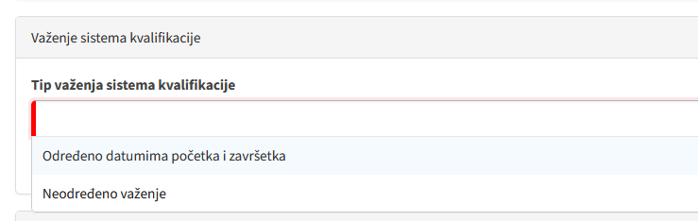

Where contracting entity opts for a limited duration, it has to set the system’s exact start and end dates. Having that said, it is free to change duration (extend it, or end it before the preset date) at any time of the system’s duration. In the case of extending the system’s duration, this information must be published in the notice on the existence of a qualification system, whereas information on system’s early ending must be published in the notices on contract award, on suspension, or on cancellation of the procedure.

The procedure for correcting the notice on the existence of a qualification system is identical to the procedure for correcting data in other published notices. Namely, where contracting entity wishes to extend system’s duration, it publishes this information on the Portal, by choosing option ‘Correction in procedure’ in section ‘Processes of procedure’, then ‘Change of data from the original notice’ and further on, following the Portal’s functionalities, enters relevant data, and the modified duration of the system gets published through notice ‘Correction - notice on changes or additional information’.

Where contracting entity wishes to end qualification system before the expiry of time for which it was established, it has to publish this information in the form ‘Notice on contract award, suspension, or cancellation of the procedure’. System ends upon selecting option ‘End system’ in section ‘Processes of procedure', and information on its ending is published in 'Notice on contract award, suspension, or cancellation of the procedure - sectoral procurement', which will be published on the day following the chosen date, and immediately after this notice is published, all applicants will be notified thereon.

1. ***Documents required with application***

Having in mind the provisions of the PPL and the purpose of qualification system, a mandatory part of application is the completed statement on fulfillment of Criteria for the qualitative selection of economic operators. Applicant may also be required to supply technical solution, where criteria and rules for functioning of the qualification system include technical specifications[7], or required to submit other documents, as the case may be. Required parts of application, as stated therein, are listed in section ‘Subject/Lots’ - ‘Parts of application required in application’.

*Display on the Portal*

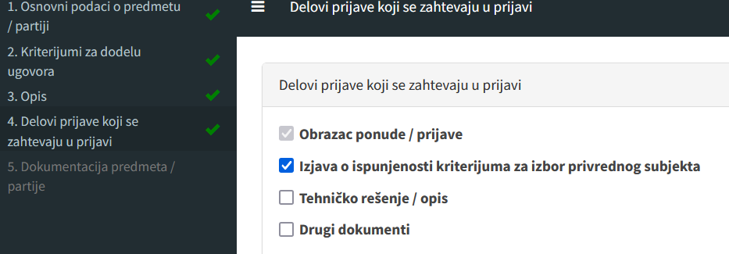

1. ***Defining the criteria for the qualitative selection of economic operators***

Contracting entity defines criteria for the qualitative selection, that economic operators/applicants have to fulfill to be admitted (entered) into the system, whereby such criteria may be updated from time to time, and the updating rules must be stated in advance.

Criteria for the qualitative selection are key requirements in the qualification system, given that economic operators are only admitted to the system if they meet the set criteria. This is why these are so important in the qualification system, as important as in the initial phases of the multi-phase procedures (restricted procedure, competitive dialog, negotiated procedure with prior publication, innovation partnership).

Criteria for the qualitative selection of economic operators are determined, and their fulfillment is evidenced, fully in line with the provisions of Articles 111 through 131 of the PPL. Further, the defining of these criteria and the manner of proving them within the establishing of qualification system on the Portal, are completely the same as when preparing tender documents in public procurement procedures.

1. ***Criteria and rules for the functioning of the qualification system***

Contracting entity also sets the rules for admittance into the system and its functioning, and may update them throughout the system’s duration, whereby criteria and rules for functioning of the system may include technical specifications, as well. Criteria and rules, and any updating thereof, are published on the Portal.

The PPL does not specify all that may be considered as criteria and rules for the functioning of qualification system, but one may surmise these include: description of all relevant requirements that economic operators must fulfill to make their tenders acceptable; manner of awarding contracts under qualification system if the notice on the existence of a qualification system was also used as a public call; and any other data concerning the nature of the procurement subject and contract award that contracting entity deems relevant for the qualification system. These may be as follows: Technical and procedural rules and information related to admittance to qualification system, criteria for qualifying, rules for the functioning of the system, method of conducting the second phase of given procedure and, where necessary, technical specifications (technical requirements), etc.

To sum it up, rules for the functioning of, and information for admittance into, the qualification system, should provide the description of procedure for submitting application for qualification, plus the description of deadlines for reviewing applications and making decision. Objective criteria for qualification are the minimum requirements that economic operators must fulfill, such as technical competence, previous experience, financial stability, human resources, etc.; but, since the notice is drafted together with ‘Criteria for the qualitative selection of economic operators’, the above rules may only offer brief descriptions of such requirements and refer to the cited document. Rules for the functioning of the system should provide additional information about the system itself, such as: defining the qualification phases; method of updating criteria and rules; system’s duration; deadlines for deciding on qualification; etc. It may also offer data about the way of awarding individual contracts within the qualification system if the notice on the existence of a qualification system was used as a public call, such as the type of procedure, that is, the specific public procurement procedure whose second phase will be applied. Lastly, since technical specifications[8] can be a part of qualification, especially where is required to prove compliance with technical requirements (e.g., certain quality standards, certificates, methods), fulfillment of such requirements can be an integral part of criteria and rules for the functioning of the system qualification.

Criteria and rules for functioning of the system are uploaded as a separate, previously drafted document, on the Portal, in the section ‘Tender documents’.

*Display on the Portal*

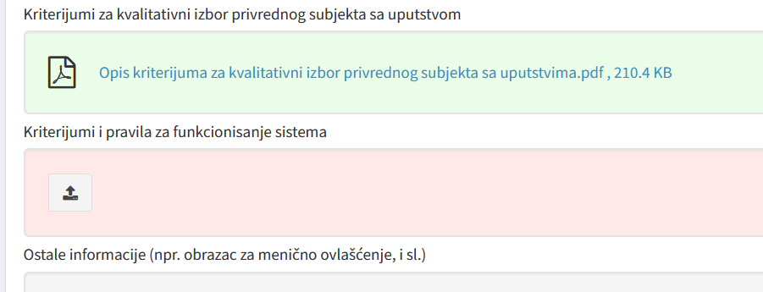

1. ***Opening of applications***

Qualification system is not a procedure to select a contractor/supplier/executor, but one to establish whether an economic operator fulfills certain eligibility requirements for participation in future procurements. Therefore, the focus is on establishing qualifications, rather than on competitive bidding.

*Display on the Portal*****

## **Application for Qualification**

Qualification system must remain open **throughout its duration,** thus enabling economic operators to apply for qualification at any time. The PPL does not know of any minimum deadlines for submission of applications in qualification system, hence, since the moment of publishing notice on the existence of a qualification system, any economic operator can apply.

Application is submitted similarly to a tender; the difference is that economic operators do not prepare and do not submit elements of tender (price, price structure, commercial terms of tender such as deadline for execution, warranty period, terms of payment, etc.), only documents evidencing their qualification in accordance with the above-stated possible requirements of procurers.

Once an economic operator submits application for qualification, contracting entity is notified of an executed opening of application via its email and its inbox on the Portal.

Contracting entity can see all submitted applications through option ‘Applications’ - ‘Opening tenders/applications’ on the procedure’s navigation line, together with created reports on opening of applications. Upon each newly submitted application, contracting entity receives information about executed opening of application, and each opening is followed by creation of a new report on opening of application. This report is not delivered to candidates, and is only visible to procurer. Just like the first one, each subsequent report created by the Portal immediately upon submission of any new application, remains visible only to the procurer.

Economic operators can see own submitted application in the navigation part, section ‘My tenders’ - ‘My tenders (submitted)’.

## **Expert Valuation of Applications and Deciding on Qualification**

* **Expert valuation of applications**

Expert valuation of applications includes review and evaluation of submitted applications. After each submitted application follows expert valuation pursuant to the provisions of Articles 141 through 150 of the PPL.

#### *****Deciding on qualification*****

Contracting entity makes decision on qualification and delivers it to the applicant **no later than 6 months** from the date the application was submitted. This is the final deadline within which decision must be delivered to the applicant, and decision itself should anyhow be taken in the shortest possible time.

Where contracting entity deems that making decision on qualification will take longer than four months from the date of submission of application, it has to notify the applicant of the reasons that justify this prolonged timeframe for deciding, within two months from the application date, as well as of the actual date by which it will decide of said requests; this other deadline cannot in any case be longer than six months from the date of the submission of application. Hence, in any event, the maximum deadline is six months since the opening of application, whereby, if contracting entity estimates this would take more than 4 months, it has to notify applicants thereon within 2 months since the opening.

This decision is not published, but instead delivered separately to each candidate through the Portal.

#### *****Rejecting application*****

Decision on rejecting application for qualification must contain reasoning and be delivered to the applicant immediately, and no later than within **15 days** from the day of decision.

The reasons for rejection must be based on previously defined criteria for qualification (criteria and rules for qualitative selection of economic operator, and objective criteria and rules for functioning of the qualification system) determined by contracting entity pursuant to Article 69, Paragraphs 8 and 9 of the PPL.

Upon expert evaluation of applications, and in order to make and deliver decision on qualification o decision on rejecting application for qualification, select option ‘Processes of procedure’ - ‘Qualification of candidates’ on the procedure’s navigation line.

*Display on the Portal*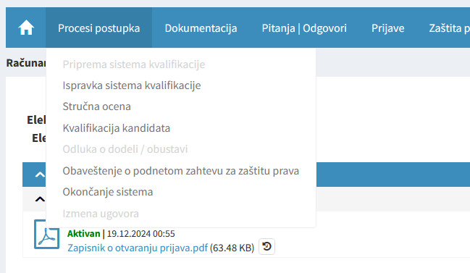

While working on the Portal, in the ‘Candidate qualification’ section, one can choose to either recognize, or decline to recognize, qualification.

*Display on the Portal*

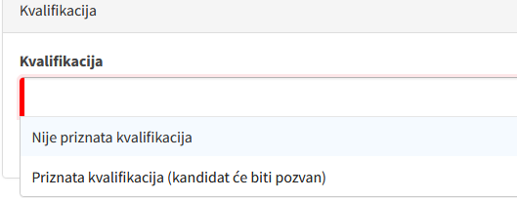

In addition, since the applicant may submit a new, updated application sometime after the submission of the initial one but before the procurer’s decision (a period that can take up to 6 months, as already stated), in this case contracting entity would mark the button ‘Application is NOT considered any longer (an updated application has been received).

*Display on the Portal*

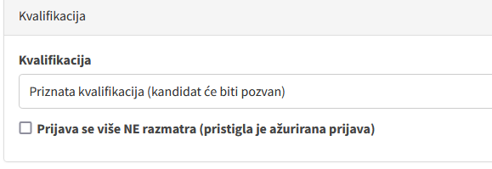

Lastly, upload the previously prepared document: Decision on qualification, or Decision on rejecting application for qualification, and then it is delivered to each applicant separately.

## **Record Keeping, and Exclusion of Candidates from the Qualification System**

***Records of qualified economic operators***

Contracting entity keeps written records of qualified economic operators. The records may be sorted into categories by type of contracts for which economic operators qualify.

**Exclusion from the system**

Throughout the qualification system duration, contracting entity may exclude a candidate from the system, if it no longer meets the qualification requirements. Even though it reads that, in this case, contracting entity may exclude a candidate, this should not be an alternative, but rather a candidate which ceases to meet qualification requirements should be excluded.

In this case, decision on exclusion must be delivered to the candidate it excludes no later than **15 days** before the qualification ending day, with the reasoning that justifies the exclusion. The decision should specify the date the candidate’s qualification ends, and decision itself must be served at least 15 days before the termination date of qualification specified therein.

Exclusion is executed by new expert valuation of application on the Portal (section ‘expert valuation of applications’), by taking and uploading decision on exclusion on the Portal (section ‘Candidate qualification’), thus delivering it to the excluded candidate on the Portal.

|  |
| --- |
| **Note:** The PPL prescribes that contracting entity has to notify interested economic operators on the qualification systems of other contracting entities, where the former finds that such system meets the latter’s requirements. |

## **Procedure for Awarding Contract**

As previously stated, where notice on existence of a system is used as a public call, contracts will be awarded by applying the rules for the second phase of:

* 1. Restricted procedure
  2. Negotiated procedure with prior publication
  3. Competitive dialog
  4. Innovation partnership

Procurer does not have to opt for one of the above procedures at the point of establishing a qualification system; it may choose any of those when initiating procedure for awarding the contract for which it is going to use the established qualification system, according to the rules of this particular system. The drafting of the call for tenders and related tender documents has to comply with the rules of the above procedures, in accordance with the PPL and the Regulation on the contents of tender documentation in public procurement procedures[9].

Regardless of the chosen procedure, contracting entity has to send calls for tenders to all qualified economic operators, or, as the case may be, only to those in certain categories, if it created separate categories within the system. The actual contract awarding procedure on the Portal is not conducted within the qualification system; instead, procurer initiates a new procedure (‘My procedures’ - ‘New procedure’) in section ‘Subject-matter and panel’, and, from the drop-down menu, selects Article 70, Paragraph 8, of the PPL as the legal basis.

*Display on the Portal*

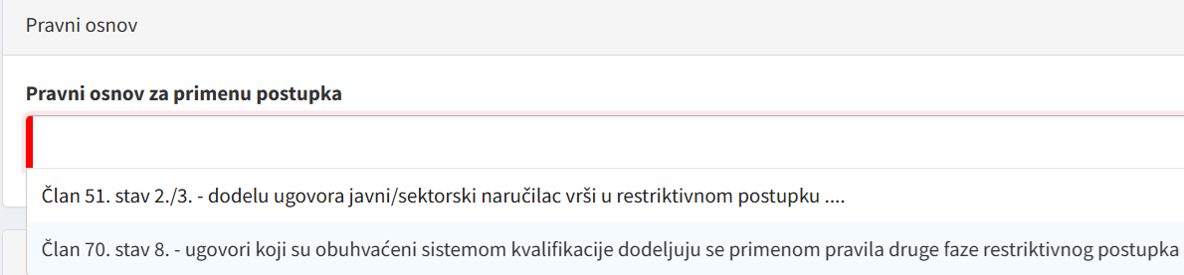

Then, in section ‘Selection of preliminary procedure’, from the drop-down menu containing all existing qualification systems, it marks the appropriate qualification system which will be used for the conducting of the second phase of the procedure.

*Display of example on the Portal*

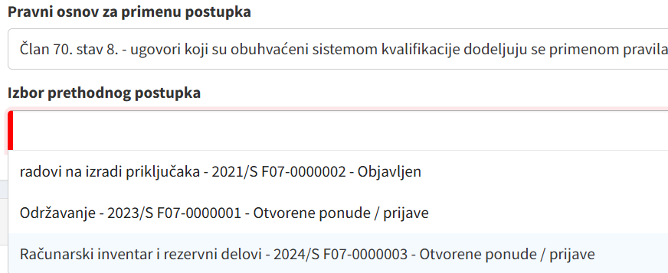

After that, in section ‘Continue procedure’, it selects option ‘by sending calls to qualified economic operators’.

Next, in line with the Portal's functionalities and by means of entering relevant data, the preconditions are created to conduct the second phase of the procedure and to invite economic operators with recognized qualification to submit tenders.

*Display of example on the Portal*

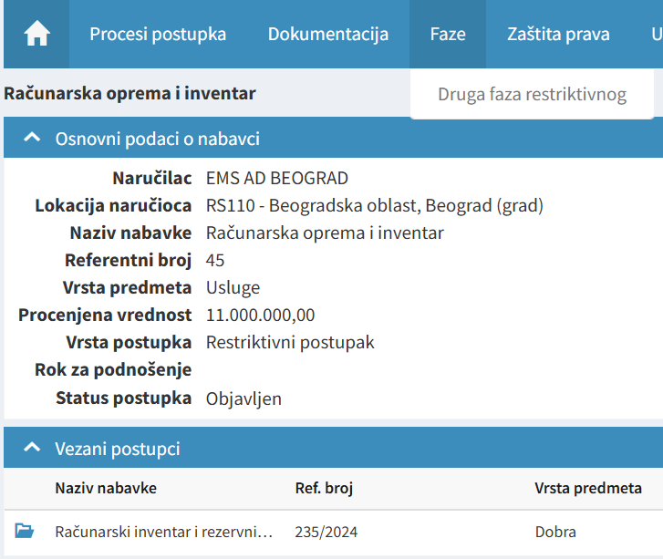

Having this done, contracting entity applies all rules of the second phase of the chosen procedure, including the expert valuation of tenders and the award of contract.

# The Guide to Electronic Auction

## **What is Electronic Auction?**

Electronic auction is a type of competition among tenderers in public procurement procedure, by means of electronically submitting new, more favorable tenders, which the procurer ranks using the automatic evaluation methods. Electronic auction is not a separate type of public procurement procedure, but rather a distinct manner, or instrument, to rank the tenders. The easiest way to define electronic auction is as a process of interactive auction after the tenders have already been opened. As such, the auction is a sort of an alternative to negotiations, once the tenderers have already presented their tenders, namely, the prices. The advantage this instrument affords to the procurer is the additional pressure on tenderers to lower their prices, which is the essence of auctioning.

The basic features of the advantage bestowed by electronic auction are transparency, increased competitiveness, participants’ anonymity, and flexibility among the competing economic operators. **Transparency** is ensured by keeping tenderers informed about the current ranking at all times during the actual auctioning. **Anonymity** is warranted by lack of Portal’s ability to reveal tenderer’s identity before the auction is completed, and the electronic process motivates tenderers to come up with more favorable tenders, which results in **increased competitiveness** in the procedure. **Flexibility** is brought about by the auction allowing subsequent modifying, or improving the tenders.

*Display of key steps in electronic auction*

## **Procurement Procedures and Procurement Subjects**

**Procedures suitable for electronic auction**

Electronic auction cannot be used in all public procurement procedures, only in the following:

* Open procedure
* Restricted procedure
* Competitive procedure with negotiation, and
* Negotiated procedure with prior publication

In other words, auctioning cannot be used in competitive dialog, innovation partnership, and negotiated procedure without prior publication.

Further, electronic auction can be used in:

* Re-opening of competition pursuant to framework agreement
* Awarding contract within dynamic procurement system

**Procurement subjects suitable for electronic auctioning**

In addition to not being suitable for all public procurement procedures, electronic auction cannot be used for all procurement subjects, too, only where the content of the procurement documentation, and in particular the technical specifications of the subject-matter, can be precisely determined.

Therefore, in terms of procurement subjects, electronic auction, in general, is suitable for all goods, and also for great many services and works. Exceptions cover such services and works whose subject-matter is the execution of intellectual work that cannot be ranked by automatic evaluation methods, whereby the PPL cites design services in construction as an example, but those could also be some other services, notably (consulting, engineering, translation...).

## **Drafting and Publishing Public Call and Tender Documents in Procedure Using Electronic Auction**

**Precondition for conducting electronic auction**

In order to conduct electronic auction, procurer must state its intention to use electronic auction as early as in its public call.

1. Marking a public procurement instrument – electronic auction

When initiating a procurement procedure, firstly mark button ‘Instruments (electronic auctions / electronic catalogs) in section ‘Basic parameters of procedure’, and upon the display of two options, select button ‘Electronic auction will be conducted’.

*Display on the Portal*

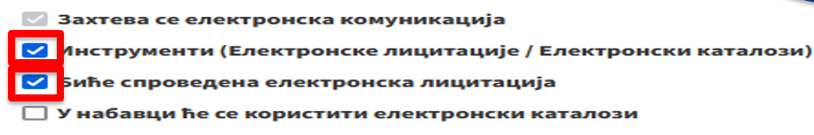

1. Procurement documentation

Pursuant to Annex 5 of the PPL, when intending to conduct electronic auction, procurer is obliged to state the following in its procurement documents:

|  |  |
| --- | --- |
| 1 | Elements whose values will be the subject of electronic auction |
| 2 | All limitations concerning the values that may be offered, which arise from the specifications related to the procurement subject |
| 3 | Information that will be made available to tenderers during electronic auction and, where necessary, information about the actual timing of making it available |
| 4 | Relevant information about the process of electronic auction |
| 5 | Conditions under which the tenderers will be competing and especially the minimum differences that will be required during the competition, as necessary |
| 6 | Relevant information about utilized electronic equipment and about modalities and technical specifications for connecting[10] |

Further, section ‘Other requirements’ in the field ‘Additional data on electronic auction’ contains information about the intended electronic auction.

|  |
| --- |
| **Example:** “Electronic auction will be conducted after expert valuation of tenders, with tenderers who have submitted acceptable tenders. This auction’s subject will be the price; within 60 minutes of the auction’s duration, tenderers will be allowed to offer still lower prices for an unlimited number of takes, in the manner determined by the invitation to electronic auctioning.” |

## **Expert Valuation of Tenders**

The process of electronic auction, i.e., using electronic system to rank tenders, is preceded by a segment of public procurement procedure in which procurer performs the usual process of expert valuation of tenders; however, the opening of tenders in case of electronic auction is not public. Namely, procurer carries out initial valuation of tenders in line with requirements per tender documents in terms of technical specifications, criteria for the qualitative selection of economic operator, etc., and compiles report on expert valuation of tenders. Thus, the actual auctioning is not conducted until the completion of expert valuation of tenders. This means that the subject of auctioning are only tenders that were not rejected. To this end, prior to electronic auction has to be compiled report on expert valuation of tenders but, logically, without decision on awarding contract. Hence, procurer firstly opens the tenders, establishes if those are acceptable in a usual way, and thereafter conducts electronic auction.

When drafting expert valuation on the Portal, select option ‘Conducting electronic auction to award the contract’ in section ‘Decision on the next phase’.

*Display on the Portal*

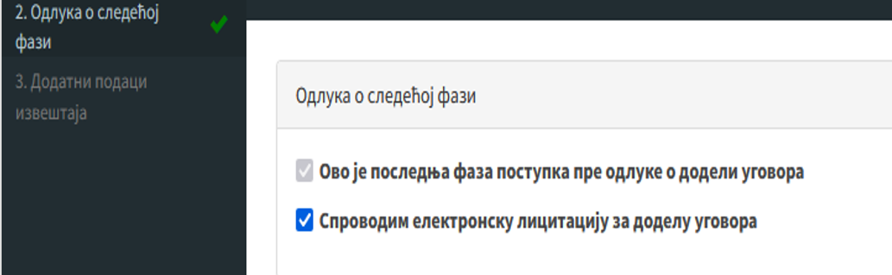

**Conducting and Ending the Auction**

**Method of using electronic auction**

Electronic auction is conducted as an iterative electronic process, whereby novel lower prices or novel values of specified elements of the award criterion are submitted, and the ranking of tenders by using automatic valuation methods is enabled. Where the price is the sole criterion, electronic auction is based on the price alone. Where the contract is awarded on the basis of the best price/quality ratio, or on the basis of the lowest costs by applying the principle of cost efficiency, electronic auction is based on the price and/or novel values of specified elements of the award criteria as set in the procurement documentation.

**Initiating electronic auction**

To initiate electronic auction, select option ‘Auctions’ - ‘New auction’ on the procedure’s navigation line.

*Display on the Portal*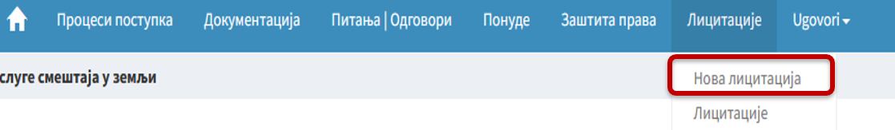Next, enter basic data about the auction (reference number and a short description of the auction subject), and then create a special sub-platform within the procedure in which will be conducted complete electronic auction, from sending invitations and up to its completion.

**Invitation to the auction**

Procurer invites simultaneously, through the Portal, all tenderers who have submitted acceptable tenders. In its invitation, it specifies the exact time of the start of auctioning and provides instructions on the way of its conducting.

Invitation is a particularly important document, especially the plan and mode of its conducting that specify:

* Date and time of the start of auctioning;
* Whether the auction is conducted in phases and (where the answer is YES) in how many phases;
* Duration of the auction in minutes;
* Whether the auction is automatically extended if, in a specified period prior to its closure, a new tender is submitted and (where the answer is YES) which period before the closure is considered as relevant, and how much will be extended deadline for the auction closure. All above data are entered in the section ‘Plan and method of conducting’ in the appropriate fields on the Portal.

*Display on the Portal*

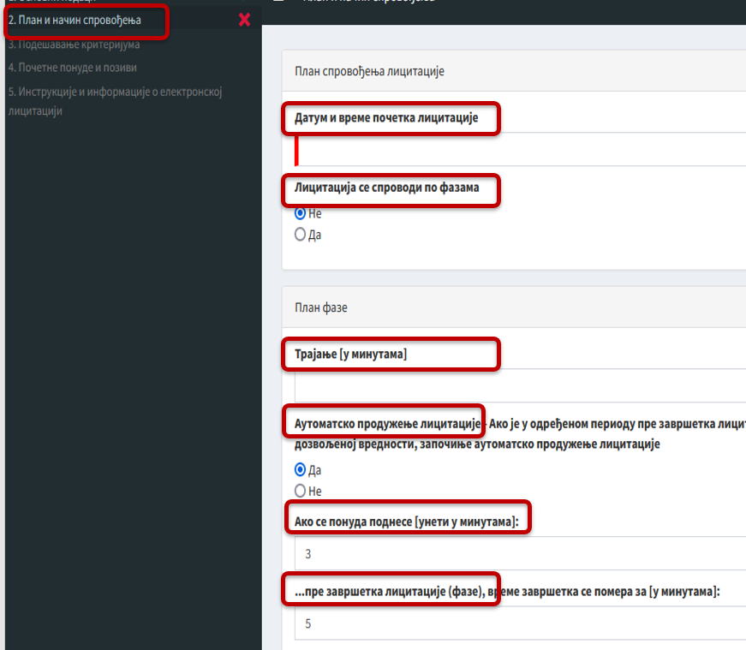

An equally important aspect is the setting of information visibility options during electronic auction, where procurer chooses one of the following options:

1. Participants see **only their own ranking**
2. Participants see **their own ranking and the total number of participants**
3. Participants see **their own ranking, the total number of participants, as well as offered prices** and other values of all **last tenders**
4. Participants see **their own ranking, the total number of participants, as well as offered prices** and other values of **the currently most advantageous tender**

It is further necessary to select on the Portal whether the auctioning participants see own potential ranking before submitting a novel value. If activated, this option will allow each auctioning participant to know which rank would its offered specific, lower price (or other value that is the subject of auctioning) take, whereas otherwise it will not have this information until after submitting new tender.

Lastly, in its invitation procurer defines parameters of criteria to be ranked in a way which enables it to determine minimum difference in value change during the submission of tenders.

This is crucial, since procurer makes the procedures more efficient by determining the optimal minimum difference. For example, in auctioning the price, where offered prices range around 50,000,000.00 dinars, to allow a tenderer to offer a merely few dinars lower price than the previously offered one may render the purpose of auctioning meaningless. In this case, the setting of the minimum difference of, say, 50,000.00 dinars between the previously and the newly offered prices of the same tenderer would be a better option.

**Anonymity of participants**

Unlike the standard public procurement procedure that does not involve electronic auction, in a procedure with electronic auction the opening of tenders is not public, for the sake of preserving anonymity among the tenderers. To this end, procurer delivers separate invitations to participate in electronic auction to each tenderer, together with results of the initial valuation of given tenderer’s tender, and nothing more. In other words, none among the tenderers will learn who are the competing tenderers, not only by the beginning, but rather until the end of electronic auction (per the above presented visibility options).

**Mathematical formula**

Invitation to take part in electronic auction must contain the mathematical formula which will be applied in auctioning. Thus, the tenderers know beforehand how the changes of tenders will be reflected in the number of weights and the rank. The above is relevant where the price is not the sole criterion, because if there is in place another criterion that is ranked but is not the subject of the auction, then it is vital for the auctioning participants to know and be able to monitor how the change in price is reflected in the total number of weights of each tender. Likewise, where tenders with variants are allowed, procurer has to provide a separate formula for each variant.

**The timing of the start of electronic auction**

Electronic auction starts at the earliest upon expiry of two working days from the day of sending invitations to tenderers whose tenders were evaluated as acceptable, to take part in electronic auction, i.e., bidding. It may be conducted in several consecutive phases. Procurer is obliged to send to all participating tenderers, immediately upon changes, any information exchanged during the course of electronic auction that is relevant for setting a tender’s current and final ranks relative to other tenderers; it may also send to them other information concerning other offered prices or values, but only if it stipulated such option in its tender documentation. Procurer may at any time declare the number of tenderers in a given phase of auctioning, but must not reveal identity of any of them prior to the closure of auctioning.

## **Conducting and ending electronic auction**

Electronic auction is conducted on the Portal. This is a dynamic process, with all the above stated advantages and specificities.

Electronic auction may end in three separate ways:

* At the predetermined time (date and hour)
* In case that no new prices or new values that meet requirements in terms of the predetermined minimum reducing have been submitted, provided that the preset period of time after the receipt of the last tender has actually elapsed.
* Upon ending the number of phases of electronic auction as foreseen in tender documents

**The first** way is to set, precisely and in advance, the timing of the closure of the auction, notably, to define date, hour, and minute of the end. This is the case of auctioning conducted in a single phase. A good practice to have it last no shorter than 30 and no longer than 120 minutes, whereby procurer may decide that any change of the offered element of the criterion that is the subject of auctioning near its closure (e.g., within the last two or three minutes) triggers an additional extension of deadline for several more (e.g., three or five) minutes.

**The second** moment where the tender documentation defines the end of electronic auction is the case where no new prices or new values that meet requirements in terms of the predetermined minimum reducing have been submitted, provided that the preset period of time after the receipt of the last tender has actually elapsed. Hence, procurer may set the auction’s duration to 120 minutes but with option of early ending when, for instance, 20 or 30 minutes elapse since the last change.

**The third** possibility provided for the closure of electronic auction under the PPL is where procurer chooses a multi-phase auctioning, and then the end of the last, say, third phase, is the end of the whole auction.

In addition, it is also possible to set the point of closure as a combination of the second and the third options, whereby procurer has to set the time that has to pass between the receipt of the last tender and the end of electronic auction in its invitation to take part in each individual phase of such electronic auction.

Each option has its own advantages and flaws. The first one does not motivate tenderers to bid vigorously and thus reveal their hand; instead, they will likely wait until the last minute. Its plus side is that tenderers will not speculate much, given that, as in an open procedure, they have to come up with their best tender which they will not be able to change later on, by a specified time (deadline). The second option offers the possibility of a genuine competing, whereby each tenderer can respond by its bid to another one’s bidding, within a specified time interval. Lacking response to the best tender within such specified time, electronic auction ends. In this case, procurers would have to set the optimal minimum values of reduction in each step (e.g., the price to be reduced in each subsequent step by at least 10,000 dinars), to avoid procrastination as under scenario where tenderers can reduce the price for one dinar and thus render the entire process meaningless. However, the downside is that tenderer can speculate relative to other tenderers’ bids, since it is not motivated to offer its best conditions from the outset; thus, where the competition is not strong enough, tenderer does not have to offer its otherwise best conditions. As for the third option, this would mean that tenderer gives its new offer in each phase, so that tenderers are likely to wait for the last phase to come up with their best tenders. Since it may be seen as similar to the first one, they share similar advantages and flaws.

Immediately upon the closure of electronic auction, the Portal automatically publishes names and ranks of all tenderers participating in the auction. Information about the auction’s closure arrives simultaneously into the inboxes of all participants and on the emails given at the registration/application on the Portal. After the auction, procurer takes decision on awarding public procurement contract on the basis of the award criteria and the results of the electronic auction.

|  |
| --- |
| Note: In the case of interruption due to technical reasons, procurer notifies all participants thereon, and may either conduct a new auction or cancel the procurement procedure. |

# The Guide to Electronic Catalog

### **Possibility to Submit Tender with E-Catalog**

Electronic catalogs are a special electronic instrument involving the submission of tenders in the form of electronic catalogs, or the submission of tenders that include electronic catalogs.

Submission of tenders with e-catalogs can be requested:

* In all public procurement procedures
* In cases of framework agreements with several tenderers, when reopening competition
* In dynamic procurement systems for individual contracts

When public procurement procedure uses e-catalog, there is no usual price structure form[11], given that the tenderers will offer (state) their prices in electronic catalog, so that the price structure form will, if necessary, only contain other costs included in the price. To this end, electronic catalog will have the following columns, designed by procurer: position number, position title, technical specifications (description of services or works), unit of measure, currency, and quantity (for a standardized electronic catalog) This is the minimum data, but, depending on the procurement subject, procurer can also define other elements it deems important for such procurement subject. After creating an e-catalog, procurer links it to the public procurement procedure for which it was created, and then conducts further procedure on the Portal as usual. Therefore, the point of distinction from a typical public procurement procedure (without electronic catalogs) is the creation of electronic catalog (the list of all goods, services, or works to be procured) and then its linking to the actual procedure.

**Framework agreements and e-catalogs**

Electronic catalogs are especially useful in framework agreements, both with single and with several tenderers. A simple yet very practical example is where procurer concludes framework agreement with the single provider, to be further executed based on the electronic catalog supplied by the tenderer with listed works, goods or services that are the subjects of procurement together with prices. For framework agreements with several tenderers, procurer can stipulate that reopening of competition for individual contracts is carried out on the basis of updated catalogs, and here procurer may apply one of two possible options. The first option implies that procurer invites tenderers to submit their electronic catalogs again, adjusted to the requirements of given contract. The second option implies that procurer informs tenderers of its intention to collect data necessary to compile tenders corresponding to the requirements of given contract from the already submitted electronic catalogs. The potential use of this method must be included in the tender documents for the framework agreement. In addition, in this case procurer has to notify all tenderers of the date and time it intends to collect data necessary to compile tenders that correspond to the requirements of this individual contract, whereby it has to allow the tenderers to refuse such collection of data. The period of time between the notification and the actual collection of data must be appropriate. Upon collecting data and compiling the tender, but before awarding the contract, procurer has to present the collected data to the tenderers and allow them to dispute or confirm that thus-compiled tender does not contain material errors.

**Dynamic procurement systems and e-catalogs**

The use of electronic catalogs in dynamic procurement system, which is also an electronic procurement system, features an especial practicality. Contracts based on dynamic procurement system may be awarded on the basis of a tender for individual contracts which, at the request of procurer, is separately submitted in the form of electronic catalog. In addition, as in the case of framework agreements with several tenderers, procurer may also award contracts after notifying tenderers of its intention to collect data necessary to compile tenders corresponding to the requirements of given contract from the already submitted electronic catalogs. The foregoing applies on the condition that the application for participation in dynamic procurement system has an electronic catalog attached to it, in accordance with technical specifications and in the form determined by procurer. In this case, candidates subsequently supplement electronic catalogs, upon being notified of procurer’s intention to compile tenders as described above.

**Creating and Filling In E-Catalogs**

**Creating e-catalogs by procurer**

Prior to initiating public procurement procedure in which tenders should be submitted as electronic catalogs, procurer creates this form on the Portal through the intended format and specifications.

By creating electronic catalog, procurer creates a document in which it defines the type of electronic catalog, as well as its basic and additional elements.

An e-catalog is created by choosing options ‘My e-catalogs (Procurer)’ - ‘New e-catalog’ from navigation on the Portal’s homepage.

*Display on the Portal*

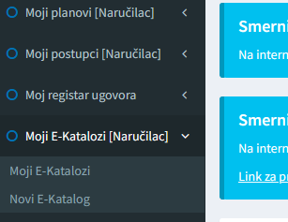

Then, basic data about e-catalog are defined: catalog’s label, title, and description. Basic elements of electronic catalog (those that procurer must define) are: position number, position title, technical specifications (description of services or works), unit of measure, currency, and quantity (for a standardized electronic catalog).

*Display on the Portal*

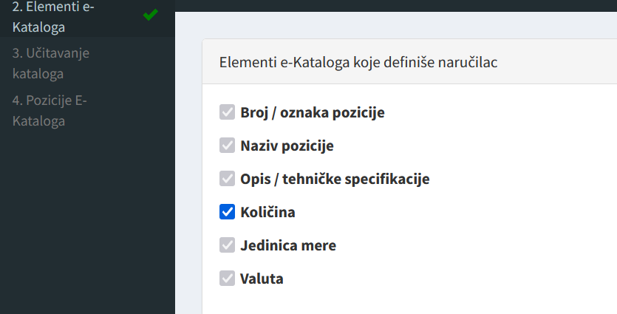

Additional elements of electronic catalog are those that procurer may opt for, if it wishes to provide additional information or set additional request to tenderers, after which it names each additional field and defines one of several offered options in which such element will be expressed: a brief wording (one line), an integer or decimal value, and whether this particular field will be entered for all positions, by applying the Portal’s functionalities.

While creating e-catalog, procurer also defines the data that tenderer will present. Some are mandatory, such as unit price and the total price with VAT and without VAT for requested positions, with possibility to also set as mandatory data (e.g., brief description - basic features of the offered product, producer’s name), or as optional (e.g., photo of the offered product).

*Display on the Portal*

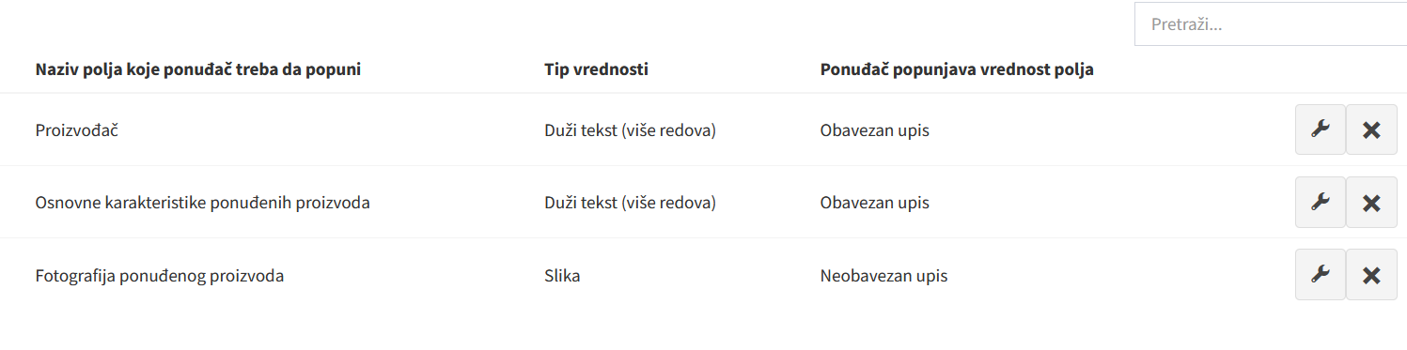

**Preparing e-catalog request by procurer**

Procurer prepares e-catalog either directly on the Portal or in an Excel template. Whichever way procurer chooses, e-catalog will be created so to represent the list of all goods/services or works it intends to procure.

If creating e-catalog on the Portal in section ‘E-catalog positions’, procurer enters the requirements it has already defined (position title, description, quantity...) separately for each position in accordance with the Portal’s functionalities.

*Display on the Portal*

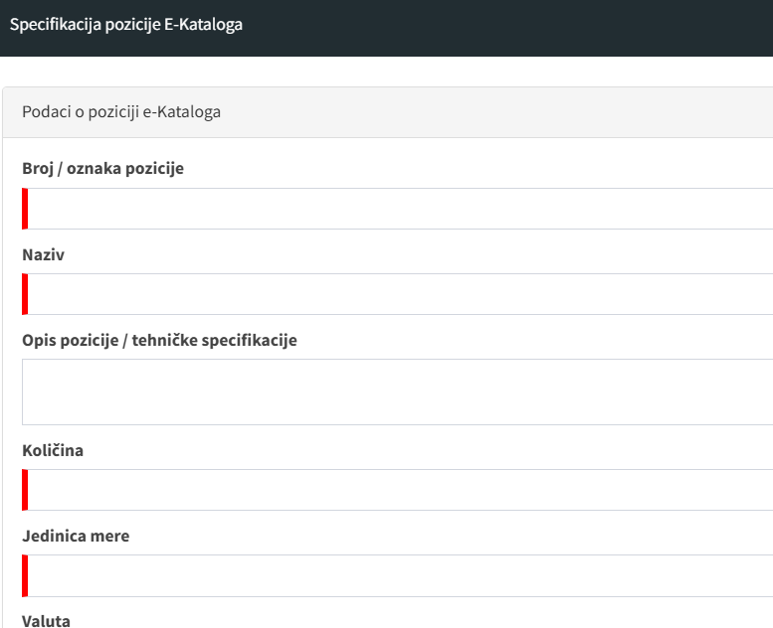

If using an Excel template, procurer downloads it in the Portal’s section ‘Catalog uploading’ - ‘E-catalog import template’, whereas the prepared catalog is uploaded in section ‘Catalog uploading’ - ‘E-catalog in Excel template format’

*Display on the Portal*

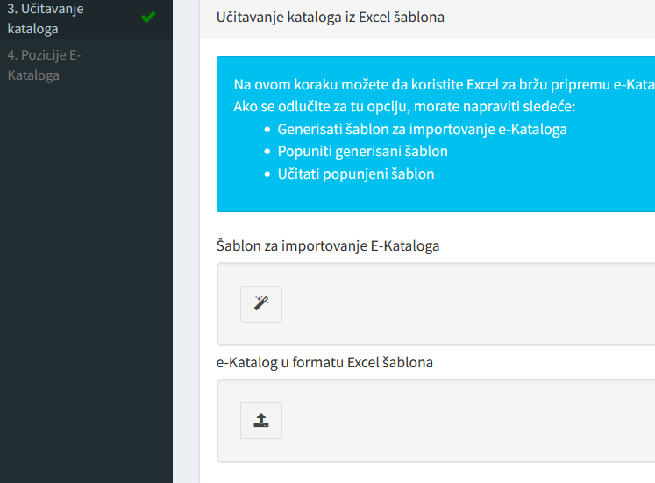

**Filling e-catalog in by procurer**

Tenderer can access e-catalog either by choosing option ‘E-catalog’ - ‘defined e-catalogs’ on the navigation menu, or by choosing option ‘Fill in’ below the navigation line ‘E-catalogs’ on the procedure’s intro page.

*Display on the Portal*

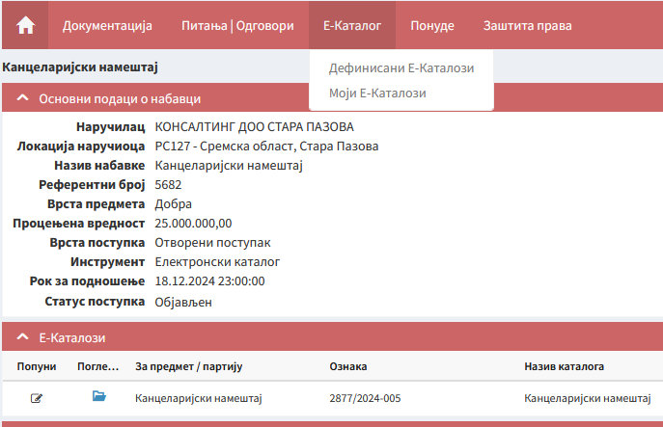

Then, tenderer accesses e-catalog defined by procurer and, just like the two options that are available to procurer, those being: either completing e-catalog by Excel template or directly on the Portal, tenderer can also either fill in e-catalog directly on the Portal, or export an e-catalog’s Excel template (fill it in and then upload it to the Portal).

And all the filled in positions from the template are entered in e-catalog on the Portal, and thereafter tenderer can also upload requested documents (which of course cannot be done in Excel), such as in this case are photos of offered products.

*Display on the Portal (an example of completed e-catalog)*

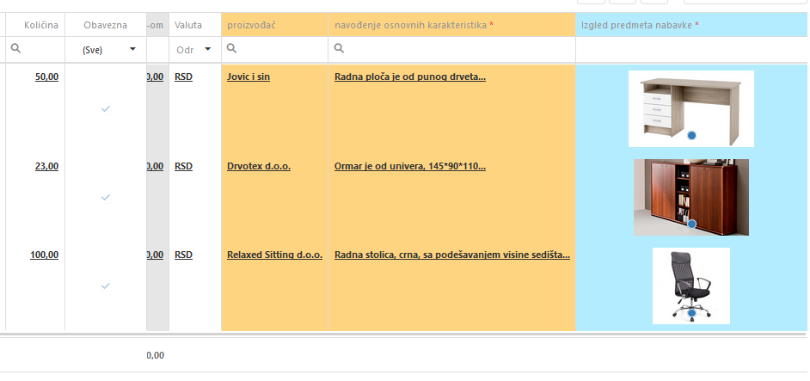

**Drvotex doo**

### **Preparing Tender Documentation and Submitting Tender with E-Catalog**

**Preparing tender documentation with e-catalog**

If procurer requests the tenders to be submitted in the form of electronic catalog, it has to state this in its public call for tenders or invitation to submit application or, where the notice on the existence of a qualification system is used as public call, in its call for tenders or call to negotiate.

When initiating a procurement procedure, it is firstly needed to mark the field ‘Instruments (electronic auctions / electronic catalogs) in section ‘Basic parameters of procedure’, and upon the display of two options, to select field ‘Procurement will use electronic catalogs’.

*Display on the Portal*

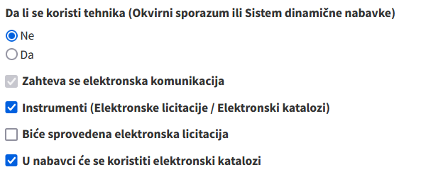

Then, in section ‘Subject/Lots’ - ‘Description’, mark field ‘Tenders must either be submitted in the form of electronic catalog or contain an electronic catalog’, after which procurer chooses link to E-catalog that is included in the procurement at hand.

*Display on the Portal*

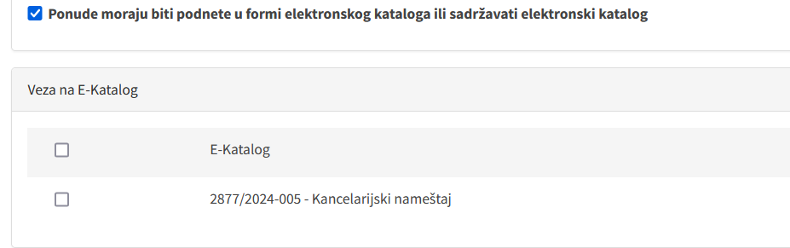

The remaining parts in preparing public call (invitation to submit applications / notice on the existence of a qualification system) and in designing tender documents on the Portal do not differ from the standard ones.

**Submitting tender with e-catalog**

Submission of tender with e-catalog is very similar to the standard submission of tender on the Portal. The difference is that instead of the filled-in form of the price structure (and maybe the filled-in technical specifications tables) and catalog delivery (depending on procurer’s requests in given procurement), here the completed e-catalog is uploaded (attached to the tender).

In this case, additional advantage is that the Portal, given the ‘processable’ data on price from e-catalogs, can compute the total price and enter it in the field for offered prices in the Tender Form.

Thus, there is not even a theoretical possibility of a calculating error since, firstly, the system (Portal) from the e-catalog itself calculates the total price for each position (by multiplying entered unit prices by specified quantities), and thereafter calculates the total price of all positions.



1. Article 77 of Directive 2014/25/EU.
2. Article 35 of Directive 2014/24/EU and Article 53 of Directive 2014/25/EU.
3. Article 36 of Directive 2014/24/EU and Article 54 of Directive 2014/25/EU.
4. Contracting entities are defined in Article 4 of the PPL
5. Article 105, Paragraph 1, Point 4) of the PPL.
6. From Article 75, Paragraph 3, of the PPL.
7. Article 69, Paragraph 9, of the PPL.
8. Technical specifications are set in accordance with the rule provided for under Articles 98 - 101 of the PPL.
9. “Official Gazette of the RS”, No. 21/2021.
10. The utilized electronic equipment and modalities and technical specifications for connecting are the minimum technical requirements for the use of the Portal, in line with the Instruction on using the Public Procurement Portal (“Official Gazette of the RS”, Nos. 93/20 and 96/23
11. Article 13, Paragraph 3, of the Regulation on the contents of tender documentation in public procurement procedures (“Official Gazette of the RS”, No. 21/2021)