Dopunski prevodi uz Vodič za instrumente u JN

1. Naslovna i završna stranica: (važi i za Smernice o zelenim JN)

|  |  |
| --- | --- |
| Održivo  Savesno  Efikasno  Projekat za odgovorno upravljanje | Sustainable  Conscientious  Efficient  Project for responsible management |

1. Strana 8

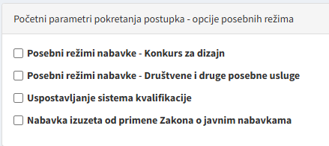

Initial parameters for initiating a procedure – options of special regimes

* Special procurement regimes – Design competition
* Special procurement regimes – Socia and other special services
* Establishing qualification system
* Procurement exempt from applying the Public Procurement Law

1. Strana 8

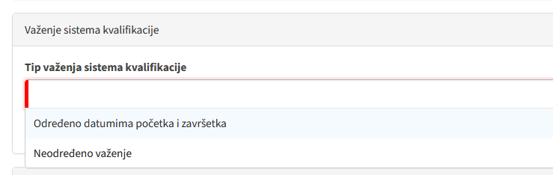

Duration of qualification system

Type of qualification system validity

Set by start and end dates

Valid indefinitely

1. Strana 9

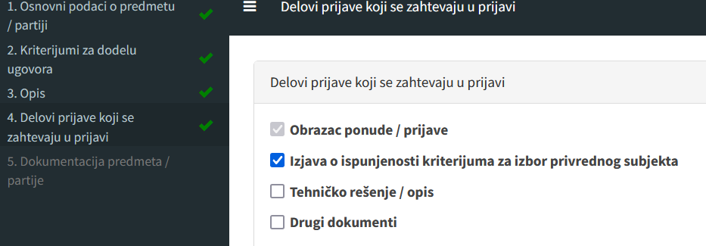

|  |  |
| --- | --- |
| 1. Basic data about subject / lots 2. Criteria for awarding contract 3. Description 4. Parts of application required in the application 5. Documentation for the subject / lots | Parts of application required in the application    Parts of application required in the application  Tender / application form  Declaration on meeting criteria for the selection of economic operator  Technical solution / description  Other documents |

1. Strana 11:

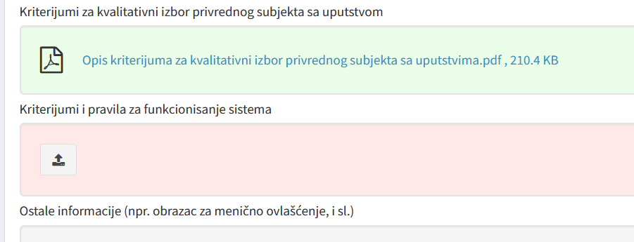

Criteria for qualitative selection of economic operator with instructions

Description of criteria for qualitative selection of economic operator with instructions.pdf

Criteria and rules for the functioning of the system

Other information (e.g., bill of exchange authorization form, etc.)

1. Strana 11:

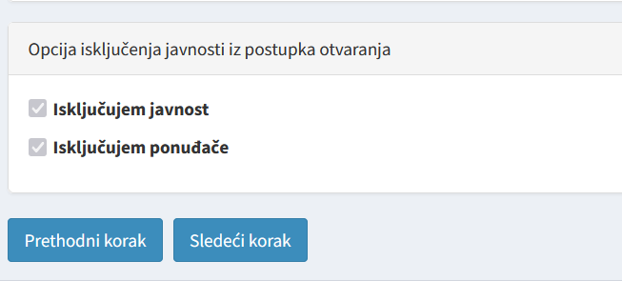

Option of excluding the public from the procedure of opening

Excluding the public

Excluding the tenderers

1. Strana 13:

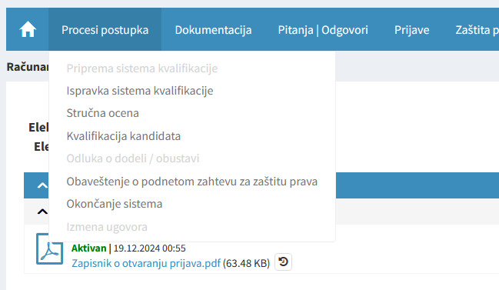

|  |  |  |  |  |
| --- | --- | --- | --- | --- |
| Processes of procedure | Documentation | Questions & Answers | Applications | Protection of rights |

Preparing qualification system

Correcting qualification system

Expert valuation

Qualification of candidates

Decision on awarding / canceling

Notice on filed request for the protection of rights

Ending system

1. Strana 14:

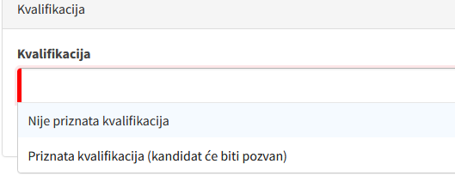

**Qualification**

Qualification not recognized

Qualification recognized (candidate will be invited)

1. Strana 14:

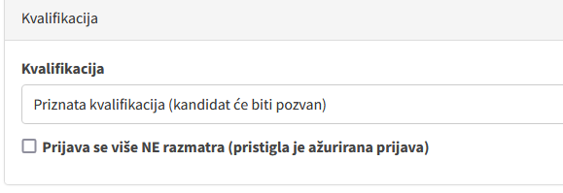

**Qualification**

Qualification recognized (candidate will be invited)

Application is NOT considered any longer (an updated application has been received)

1. Strana 16:

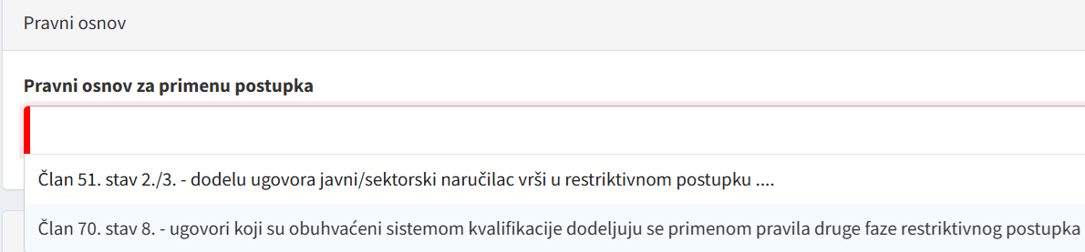

Legal basis

Article 51, Paras 2/3 – contracting entity awards contract in restricted procedure

Article 70, Para 8 – contracts to be covered by qualification system will be awarded by applying the rules of the second phase of restricted procedure

1. Strana 16:

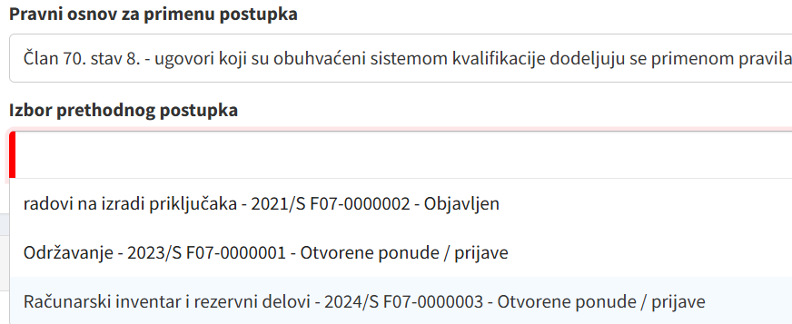

Legal basis for applying procedure

Article 70, Para 8 – contracts to be covered by qualification system will be awarded by rules

**Selecting preliminary procedure**

Construction connection works - 2021/S F07-0000002 – Published

Maintenance - 2023/S F07-0000001 – Opened tenders / applications

Computer inventory and spare parts - 2024/S F07-0000003 Opened tenders / applications

1. Strana 17:

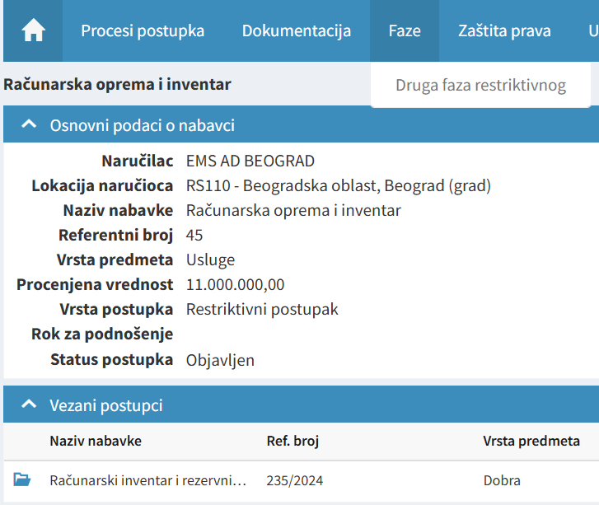

|  |  |  |  |
| --- | --- | --- | --- |
| Processes of procedure | Documentation | Phases | Protection of rights |
| Computer inventory and spare parts | | Second phase of restr. procedure | |
| Basic data on procurement | | | |
| Procurer | EMS AD BEOGRAD | | |
| Procurer’s location | RS110 – Belgrade region, Belgrade (City) | | |
| Procurement title | Computer inventory and spare parts | | |
| Reference number | 45 | | |
| Type of subject | Services | | |
| Estimated value | 11,000,000.00 | | |
| Type of procedure | Restricted procedure | | |
| Deadline for submission |  | | |
| Status of the procedure | published | | |
| Related procedures | | | |
| Procurement title | Reference number | | Type of subject |

1. Strana 20:

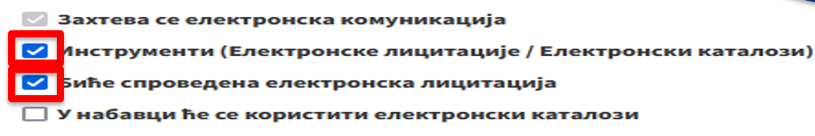

* Electronic communication is required
* Instruments (Electronic auctions / Electronic catalogs)
* Electronic auction will be conducted
* Procurement will use electronic catalogs

1. Strana 21:

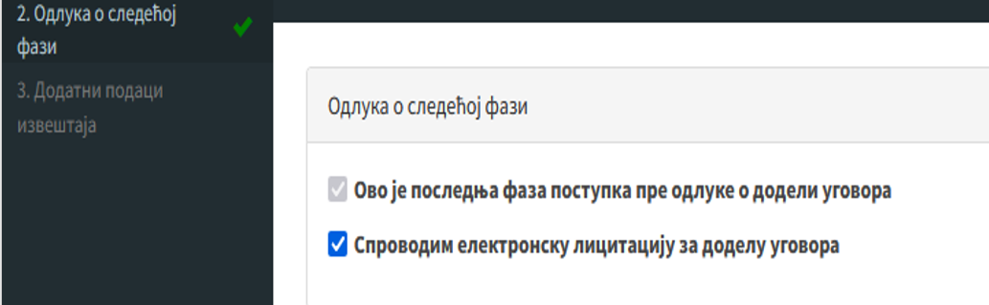

|  |  |
| --- | --- |
| 2. Decision on the next phase |  |
| 3. Additional data from the report | Decision on the next phase |
|  | This is the last stage in the procedure before the contract award |
|  | Conducting electronic auction to award the contract |

1. Strana 22:

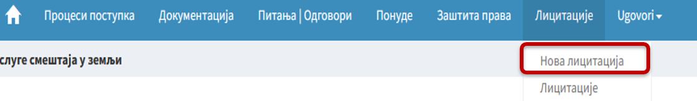

|  |  |  |  |  |  |  |
| --- | --- | --- | --- | --- | --- | --- |
| Processes of procedure | Documentation | Questions & Answers | Tenders | Protection of rights | Auctions | Contracts |
|  |  |  |  |  | New auction |  |
|  |  |  |  |  | Auctions |  |

1. Strana 22:

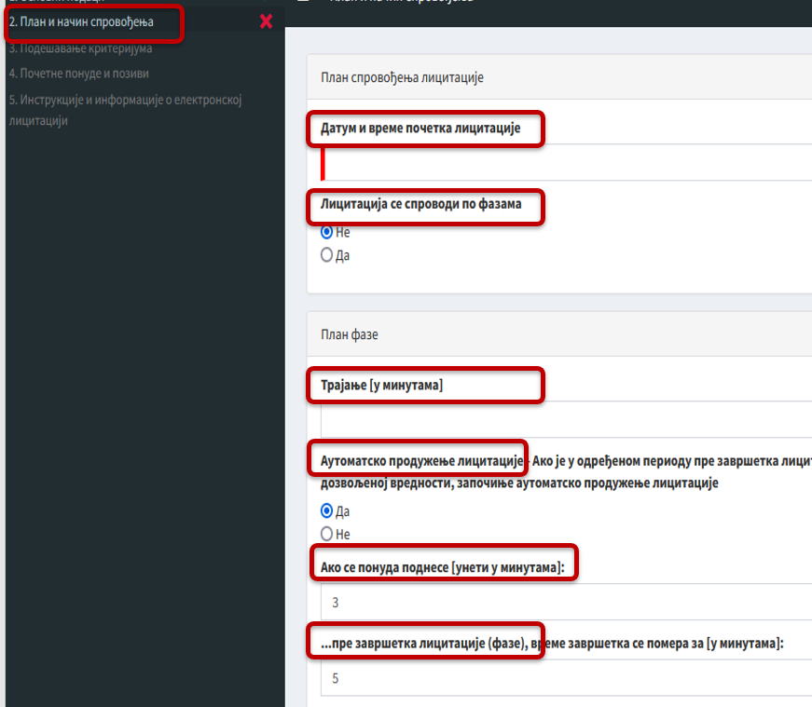

|  |  |
| --- | --- |
| Plan and method of conducting |  |
|  | Plan of conducting the auction |
|  | Date and time of the start of auctioning |
|  | The auction is conducted in phases |
|  | No  Yes |
|  | The phase’s plan |
|  | Duration (in minutes) |
|  | Automatic extending of auctioning. If in a specified period prior to the closure (…), starts an automatic extension of auctioning |
|  | Yes  No |
|  | If a tender is submitted (enter within how many minutes) |
|  | …prior to the closure of the auction (phase), the closure time is pushed for (specify minutes) |

1. Strana 28:

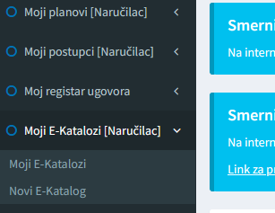

* My plans [procurer]
* My procedures [procurer]
* My register of contracts
* My E-catalogs [procurer]

My E-catalogs

New E-catalog

1. Strana 28:

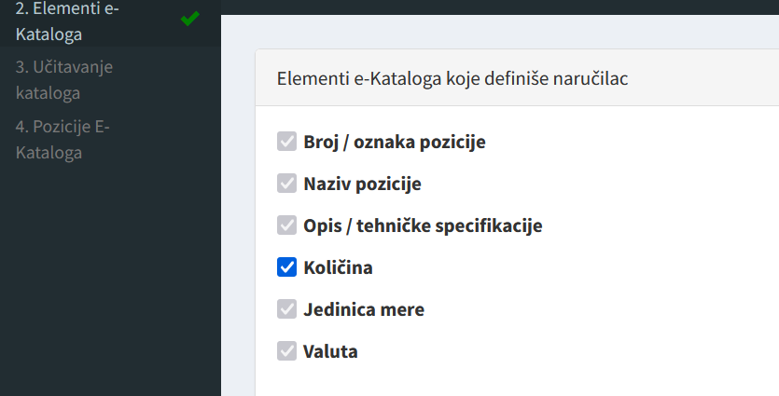

|  |  |
| --- | --- |
| 2. Elements of e-catalog  3. Uploading the catalog  4. Position of e-catalog | Elements of e-catalog defined by procurer   * Position number / marking * Position title * Description / technical specifications * Quantity * Unit of measure * Currency |

1. Strana 29:

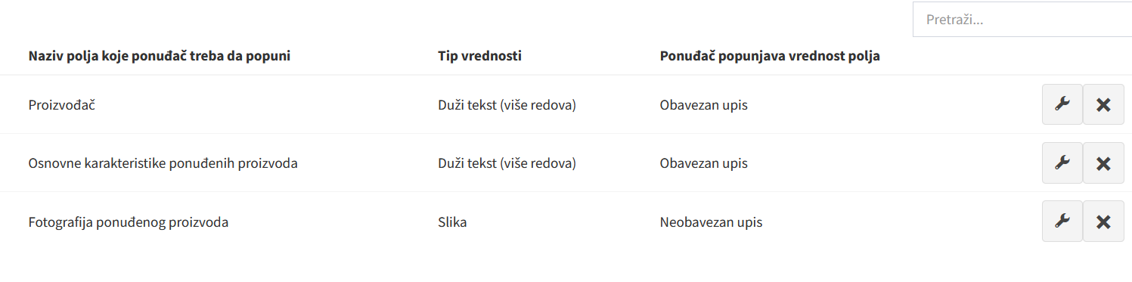

|  |  |  |
| --- | --- | --- |
| Title of field tenderer has to fill in  Tenderer  Basic features of offered products  Photo of offered product | Type of value  Longer text (several lines)  Longer text (several lines)  Photo | Tenderer enters values of the field  Mandatory entry  Mandatory entry  Optional entry |

1. Strana 29:

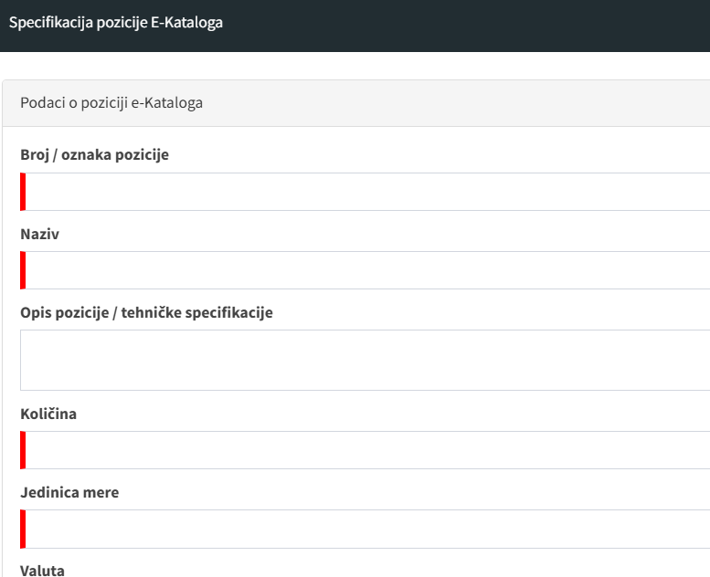

Specification of e-catalog’s position

Data on e-catalog’s position

Position number / marking

Title

Position description / technical specifications

Quantity

Unit of measure

Currency

1. Strana 30:

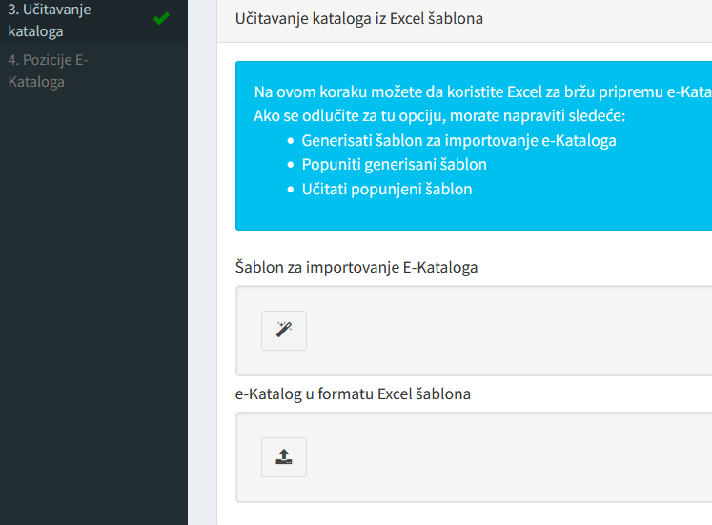

|  |  |
| --- | --- |
| 3. Uploading catalog  4. Position of e-catalog | Uploading catalog from Excel template  At this step, you may use Excel for quicker preparation of e-catalog. If you opt for it, you must do the following:   * Generate a template to import e-catalog * Fill in generated template * Upload the filled-in template   Template for importing e-catalog  E-catalog in the form of Excel template |

1. Strana 30:

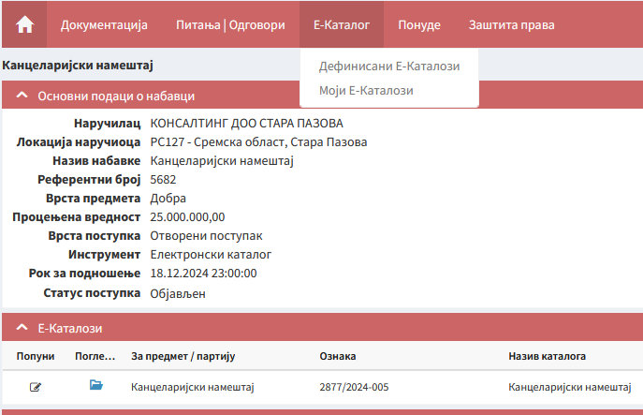

|  |  |  |  |  |  |  |
| --- | --- | --- | --- | --- | --- | --- |
| Documentation | | Questions & Answers | E-catalog | | Tenders | Protection of rights |
| Office furniture | | | | | Defined E-catalogs  My E-catalogs | |
| Basic data on procurement | | | | | | |
| Procurer | | | CONSULTING DOO STARA PAZOVA | | | |
| Procurer’s location | | | RS127 – Srem region, Stara Pazova | | | |
| Procurement title | | | Office furniture | | | |
| Reference number | | | 5682 | | | |
| Type of subject | | | Goods | | | |
| Estimated value | | | 25,000,000.00 | | | |
| Type of procedure | | | Open procedure | | | |
| Instrument | | | Electronic catalog | | | |
| Deadline for submission | | | 18.12.2024 at 23:00:00 | | | |
| Status of the procedure | | | Published | | | |
| E-catalogs | | | | | | |
| Fill in | Take a look | | For subject / lot | Marking | | Catalog title |
|  |  | | Office furniture | 2877/2024-005 | | Office furniture |

1. Strana 31:

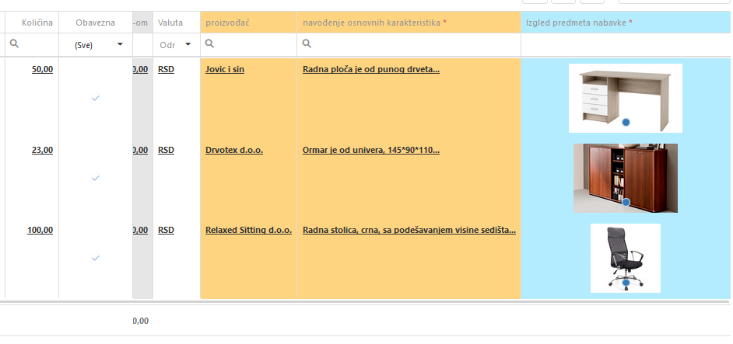

**Drvotex doo**

|  |  |  |  |  |  |  |
| --- | --- | --- | --- | --- | --- | --- |
| quantity | mandatory |  | currency | producer | stating basic features | appearance of the procurement subject |
|  | (all) |  | set |  |  |  |
| 50.00  23.00  100.00 |  | 0.00  0.00  0.00 | RSD  RSD  RSD | Drvotex doo  Drvotex doo  Relaxed sitting doo | worktop is made of solid wood  filing cabinet is made of univer  work chair, black, with seat height adjustment |  |

1. Strana 32:

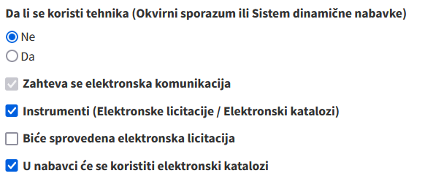

Is a technique being used (Framework agreement or Dynamic procurement system)

* No
* Yes
* Electronic communication is required
* Instruments (Electronic auctions / Electronic catalogs)

Electronic auction will be used

* Procurement will use electronic catalogs

1. Strana 32:

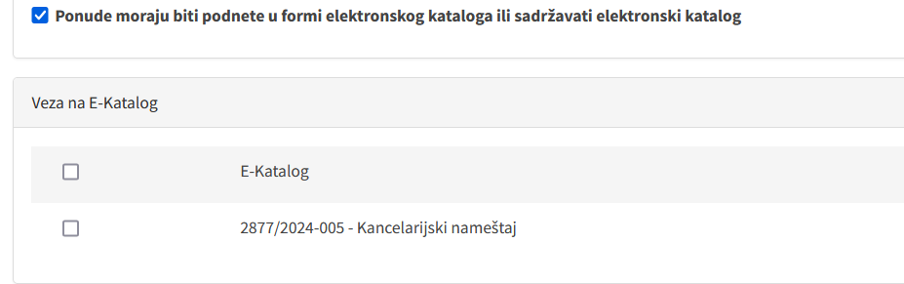

* Tenders must either be submitted in the form of electronic catalog or contain an electronic catalog

Link to E-Catalog

* E-Catalog
* 2877/2024-005 – Office furniture