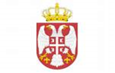

# **REPUBLIC OF SERBIA PUBLIC PROCUREMENT OFFICE**

**REPORT ON IMPLEMENTATION OF THE ACTION PLAN FOR IMPLEMENTATION OF THE**

**OF THE PUBLIC PROCUREMENT DEVELOPLMENT PROGRAMME IN THE REPUBLIC OF SERBIA**

**FOR 2022**

Belgrade, 13 April 2023

# **INTRODUCTION**

The Government of the Republic of Serbia on 13 November 2019 adopted the **Public Procurement Development Programme in the Republic of Serbia for the period 2019-2023** (“Official Gazette of the Republic of Serbia”, No. 82/19, hereinafter referred to as: the Programme).

In order to continue with the reform of the public procurement system in the Republic of Serbia, the Government has established a goal "Further development of a modern and efficient public procurement system" and several objectives:

1. Increasing the efficiency and economy of public procurement procedures,
2. Strengthening competition in the public procurement market,
3. Reduction of the risk of irregularities in the public procurement system,
4. Promotion and encouragement of environmental and social aspects in public procurement and innovations.

The programme determined that the measures whose implementation will directly affect the fulfillment of the above objectives, will relate to the following priority areas:

1. improving the legal framework;
2. Strengthening the institutional framework;
3. improvement of electronic public procurement
4. strengthening administrative capacities and education.

The Public Procurement Office (hereinafter referred to as: the PPO), in accordance with the Programme, is obliged to prepare a proposal of action plans for the Government of the Republic of Serbia for a period of one year in order to achieve the determined strategic goals and improve the above-mentioned priority areas in the Programme. Accompanying the Action Plan for the implementation of the Public Procurement Development Programme in the Republic of Serbia for 2019 and 2020, which was adopted together with the Programme, referred to a period of two years, given the late adoption of this public policy document in November 2019. The upcoming Action Plans were adopted on an annual basis (2021, 2022). **Action plan for 2022 for the implementation of the Public Procurement Development Programme in the Republic of Serbia for the period 2019-2023** (hereinafter referred to as: Action Plan), adopted, at the proposal of the PPO, the Government of the Republic of Serbia, and it was published in the “Official Gazette of the Republic of Serbia”, No. 66 on 10 June 2022.

The implementation of this Programme is monitored by the PPO as a coordinating body, while measures to achieve the objectives of the Programme are carried out in cooperation with the relevant institutions. Based on the collected information on the execution of the Action Plan, the PPO is obliged to prepare a Report on the implementation of the Action Plan and submit it to the Government for information.

Reporting on the implementation of the Programme and accompanying action plans will be carried out in accordance with Article 43 of the Law on Planning System of the Republic of Serbia ("Official Gazette of the Republic of Serbia", No. 30/18) which stipulates that the party proposing a public policy document is a state administration body, that body reports to the Government, through the state administration body responsible for the coordination of public policies, on the results of the implementation of that document, i.e., on the ex-post analysis of the effects of public policy determined by that document.

In accordance with the above, the PPO has prepared a **Report on the implementation of the Action Plan for the implementation of the Public Procurement Development Program in the Republic of Serbia for 2022** (hereinafter referred to as: the Report). Considering the above-mentioned strategic goals, ie priority areas of public procurement system reform, all activities within the Action Plan are grouped into four areas, i.e., measures, according to which its implementation is monitored:

1. Improving the legal framework;
2. Strengthening the institutional framework;
3. Improvement of electronic public procurement
4. Strengthening administrative capacities and education.

The following will show the activities and the degree of their implementation, the impact on the fulfillment of measures and indicators (result indicators) at the level of the measure, as well as indicators at the level of specific objectives (outcome indicators) and goal (effect indicators) during 2022.

# **I. IMPROVING THE LEGAL FRAMEWORK**

In the period covered by the Program, the harmonisation of national regulations with directives and other acts of the European Union in the field of public procurement will be carried out. Within the process of accession of the Republic of Serbia to the European Union, harmonisation with the acquis communautaire in the field of public procurement is envisaged in the negotiating chapter 5 - Public Procurement. The Republic of Serbia, as a candidate country, is obliged to fully harmonise its legislation in the field of public procurement, including concessions and public-private partnerships, before joining the European Union. Further full harmonisation of legislation must be carried out in good time before the accession of the Republic of Serbia to the European Union, in order to ensure its full implementation at all levels, from national to local.

In 2021, the Republic of Serbia started applying the new methodology for the accession of the Republic of Serbia to the European Union, and in this regard, the negotiating groups are grouped by clusters. The Negotiating Cluster "Basics" was formed for negotiating chapters 5 - Public Procurement, 18 - Statistics, 23 - Justice and Fundamental Rights, 24 - Justice, Freedom and Security and 32 - Financial Control. It is a cluster of core values that includes chapters on the rule of law, economic criteria, the functioning of democratic institutions, public administration reform, public procurement, statistics and financial control.

The following activities are defined within this measure:

• Proposing amendments to the Law on Public-Private Partnerships and Concessions (hereinafter referred to as: LPPPC)

The deadline for the implementation of the above activity was the 4th quarter of 2022.

# **1.Proposing amendments to the LPPPC**

Amendments to the legislative framework in the field of public-private partnerships and concessions are planned to be implemented in the 4th quarter of 2022. The deadline for the implementation of this activity will be rescheduled for the 4th quarter of 2023, given that the amendments to the Law on Public-Private Partnerships and Concessions were not adopted.

The indicator for the implementation of the measure "Amendments to the PPLO in implementation", i.e., the target value of the result indicator in 2022 has not been met, given that amendments to the PPLO were not adopted.

# **II. STRENGTHENING THE INSTITUTIONAL FRAMEWORK**

The basic institutions whose activities, manner of work and form of organisation are regulated by the Law on Public Procurement (“Official Gazette of the Republic of Serbia”, No. 91/19, hereinafter referred to as: PPL) and whose strengthening is necessary to raise the quality of the public procurement system are: PPO and the National Commission for Protection of Rights in Public Procurement Procedures (NC). The State Audit Institution (SAI), the Ministry of Finance (MFIN), the Ministry of Economy, the Commission for Public-Private Partnership, the Agency for Prevention of Corruption, the Commission for Protection of Competition and the Administrative Court also have a significant role in the field of public procurement. The Republic of Serbia has established an institutional framework that ensures the implementation of a unified policy in all areas related to public procurement, including the areas of concessions, public-private partnerships and defence. Bearing in mind that certain issues of public procurement are related to numerous other so-called In the sectoral areas, special attention is paid to the coordination of the work of institutions, establishing a system of regular organisation of meetings and workshops in order to harmonise positions regarding the application of the PPL, exchange of information, lectures and trainings, as well as improvement of measures of control of legal and purposeful spending of public funds in public procurement.

In connection with the foregoing, the Action Plan defines the following activities are defined within this measure:

* Organising the examination for Public Procurement Officers
* Training for preparation of taking the examination for Public Procurement Officers
* Organising workshops to harmonise the positions of the PPO, NC, MFIN and SAI regarding the new PPL
* The deadline for the implementation of the above activities was the 4th quarter of 2022, although these activities are being implemented “continuously", i.e., are being carried out during the term of the Action Plan and the Programme.

# **1.Organising the examination for Public Procurement Officers**

The PPO continued with the organisation of the exam for public procurement officers in the 1st

quarter of 2022. During 2022, a total of 22 exams were organised. In this period, a total of 358 candidates applied to take the exam for public procurement officer, of whom 315 candidates took the exam, while 181 candidates passed the exam, compared to 118 candidates in 2021. The candidate success rate was still somewhere above 50%.

# **2.Training for preparation of taking the examination for Public Procurement Officers**

The PPO, in cooperation with the United States Agency for International Development (USAID) and the Public Procurement Improvement Project, organised two trainings for representatives of contracting authorities and bidders (November and December) to help them prepare for the public procurement officer exam. All 193 participants had the opportunity to improve their knowledge of the legal and institutional framework in the field of public procurement, the role of institutions responsible for regulation, monitoring and supervision of public procurement, types of public procurement procedures, determining deadlines, criteria for quality selection of a business entity, criteria for awarding contracts, rights protection and other important topics in the field of public procurement.

# **3.Organising workshops to harmonise the positions of the PPO, NC, MFIN and SAI regarding the new PPL**

In this regard, during the months of November and December 2022, with the support of the USAID Project for the Improvement of Public Procurement, two workshops were held where experiences were exchanged regarding issues that are important for the proper application of regulations in the field of public procurement. Held workshops contributed to better cooperation and coordination of authorities responsible for regulating and monitoring public procurement, supported the exchange of knowledge and experience and enabled common understanding and a unified approach in applying the provisions of the Law on Public Procurement.

# **4.Training of the Police, Public Prosecutor’s Office, SAI and other institutions in the field of public procurements**

[1}Representatives of the PPO held a lecture at the workshop entitled "Public procurement for judges and judicial assistants of special departments for combating corruption of higher courts" which was organised in Belgrade on 21 and 22 March 2022, organised by the National Alliance for local economic development (NALED) and the Swedish Agency for International Development and Cooperation (SIDA). Representatives of the PPO presented the Public Procurement Portal (hereinafter referred to as: the Portal) and its functionality and spoke about the availability of information on public procurement procedures and access to the Portal, and new solutions of the Public Procurement Agency were also presented. Also, representatives of the PPO, with the support of SIDA and NALED, held a lecture at the workshop entitled "Public procurement for deputy senior public prosecutors and assistant prosecutors of the special anti-corruption departments of the Higher Prosecutor's Offices" in Belgrade on May 24, 2022. The PPO spoke about the work performed by the PPO, as well as the role and importance of the liaison officer who performs this duty in front of the PPO.

Within this measure, two result indicators have been defined. The first indicator of the implementation of the measure "Number of persons employed in the PPO", i.e., the target value of the result indicator in 2022 of 46 persons has been partially fulfilled, bearing in mind that the structure of employees shows that on 31 December 2022, the total number of employees in thirty-three (33) permanent and fixed-term employees, of which twenty-nine (29) are permanent employees and four (4) civil servants, while the total number of non-employment employees is based on contracts for temporary and casual jobs as of 31 December 2022, 9, which is a total of 42 persons employed (Chart 1). The second indicator for this measure, ie the target value of the result indicator "Number of certified officials" is fully met, bearing in mind that the target value of a total of 4950 certified public procurement officers (under the old and new PPL) has been reached and amounts to 5026 Register of Public Procurement Officers maintained by the PPO) (Chart 2).

*(*

*Graph*

*1)*

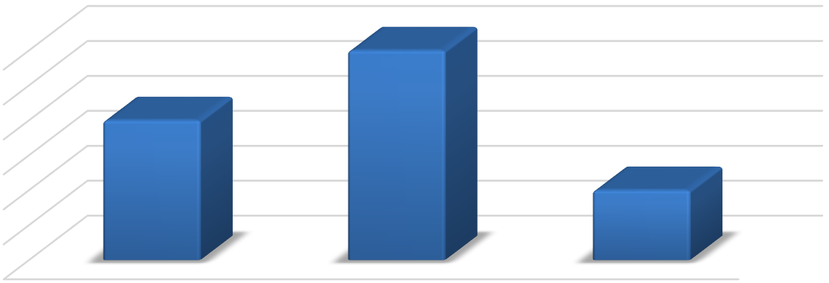

40

41

42

43

44

45

46

Baseline value (2021)

Target value (2022)

Achieved value in 2022

44

46

42

**Number of employed persons in the PPO**



Values expressed in numbers

Values expressed in numbers

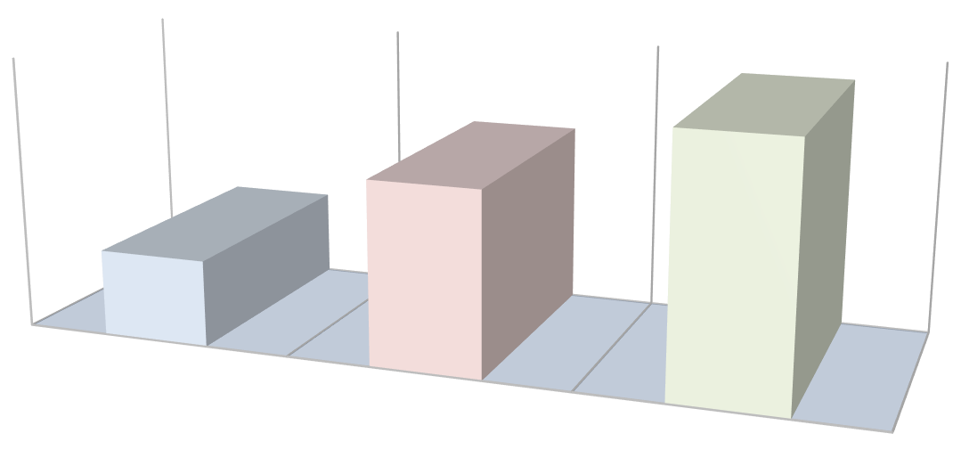

4750

4800

4850

4900

4950

5000

5050

BASELINE

VALUE (2021)

TARGET

VALUE (2022)

ACHIEVED

VALUE (2022)

4845

4950

5026

**Number of certified officers**

*(Graph 2)*

# **III.** **IMPROVEMENT OF ELECTRONIC PUBLIC PROCUREMENT**

The PPL introduced the obligation of electronic communication and electronic data exchange in public procurement procedures. Portal), which was set up on 1 July 2020, represents a significant step forward in the process of digitalisation of public procurement procedures. The Portal enables contracting authorities to compile and publish plans and notices on the Portal, publish tender documentation and decisions in public procurement procedures, as well as many other options and functionalities such as: e-submission of bids, e-tenders, dynamic procurement system, e-planning, e-complaints and e-catalogue.

In connection with the foregoing, and in order to further improve the new functionalities on the Portal, the Action Plan defines the following activities within this measure:

* Development of technical specification for the development of new functionalities on the Public Procurement Portal
* English translation of video instructions for users of the Public Procurement Portal
* Development of the mobile application of the Procurement Portal for iOS and Android mobile platforms

The deadline for the implementation of the activity was the 4th quarter of 2022.

# **1.Development of technical specification for the development of new functionalities on the Public Procurement Portal**

With the support of the United Nations Development Program (UNDP), NALED and SIDA, PPO developed technical specifications and launched several versions of the Portal during 2022, which further facilitate the work of Portal users. From March to December 2022, three new versions of the Portal were developed and published, and each of them brings some new opportunities to contracting authorities and bidders. These technical improvements to the Portal refer to all contracts assigned to a specific bidder, search optimisation, authorisations for administrative users, as well as a series of records for exporting content to Excel or JSON format. Also, some improvements are related to rights protection, quarterly reports and advance notices.

# **2.English translation of video instructions for users of the Public Procurement Portal**

The PPO, with the support of USAID and the Public Procurement Improvement Project, translated the following video instructions into English for users of the Portal: 1) registration on the Public Procurement Portal, 2) public procurement plan, 3) preparation and publication of the public procurement procedure, 4) submission of e-offers. The aforementioned video instructions with English subtitles are available on the Public Procurement Portal.

# **3.Development of the mobile application of the Procurement Portal for iOS and Android mobile platforms**

A mobile application has been developed for Android and iOS devices. The mobile app can be downloaded from the Google play store as well as the Apple store. On the mobile application, all the options that are available on the web application of the Portal are available.

Within this measure, one output indicator has been defined. The indicator of the implementation of the measure "Increased number of new functionalities on the Public Procurement Portal", i.e. the target value of the result indicator in 2022 was fully met, considering that the target value of 13 versions of the Portal was achieved (Graph 3).

**Increased number of new functionalities on**

# **Public Procurement Portal**

Achieved value in 2022

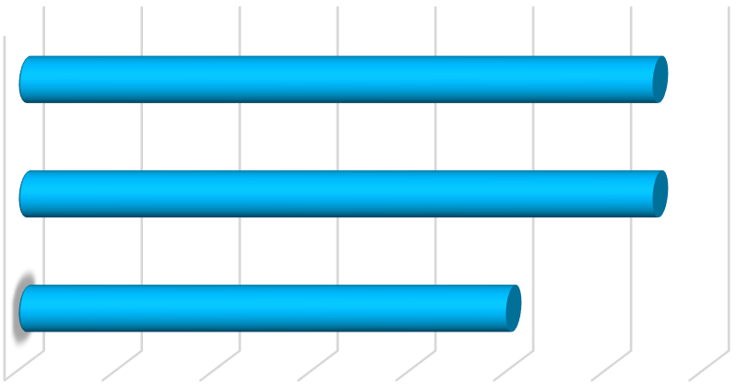

10

13

13

Target value (2022)

Baseline value (2021)

0 2 4 6 8 10 12 14

 Values expressed in numbers

*(Graph 3)*

## **IV.STRENGTHENING ADMINISTRATIVE CAPACITIES AND EDUCATION**

In order to enable the proper application of regulations in the field of public procurement, it is necessary to ensure adequate administrative capacity at all levels. To this end, it is necessary to continue all activities related to training, primarily of contracting authorities and bidders, preparation of all necessary supporting materials such as manuals, guidelines, instructions, etc., which were one of the activities during the implementation of the Public Prourement System Development Strategy in the Republic of Serbia for the period from 2014 to 2018. Development of the above mentioned institutional capacities through the continuation of the process of certification of public procurement officers, as well as strengthening of administrative capacities through strengthening of professional capacities of employees in PPL and other institutions, through development of auxiliary and practical tools important for proper application of PPL (manuals, guidelines, instructions) and through the organisation of trainings for procuring entities and bidders, micro, small and medium enterprises, will facilitate the proper application of the PPL by the participants in public procurement procedures.

In connection with the foregoing, Action Plan for the implementation of the Program, the following activities are defined within this measure:

* Development of new models of the documentation in accordance with the PPL
* Promotion of the tender documentation model
* Development of a model of internal acts of the contracting authority
* Development of methodology on the basis of which execution of public procurement contract will be monitored
* Organising training for contracting authorities and bidders
* Organizing a seminar on the application of environmental aspects in public procurement procedures • Organizing a seminar on the application of social aspects in public procurement procedures
* Organising trainings for micro, small and medium-sized enterprises

All the above activities had a deadline of the 4th quarter of 2022.

## **1.Development of new models of the documentation in accordance with the PPL**

The tender documentation model for the public procurement of paper haberdashery for maintaining personal hygiene, using the dynamic procurement system, was created within the project "Platform for Responsible Management of Public Finances", financed by SIDA and implemented by UNDP.

Also, with the support of NALED, models of tender documents for green public procurement (office supplies and communal electric vehicle) were prepared. The prepared tender documents contain examples of the application of ecological aspects within the framework of technical specifications and/or criteria for the qualitative selection of a business entity and/or criteria for the award of contracts and/or special conditions for contract execution. **2.Promotion of the tender documentation model**

In cooperation with UNDP, a webinar was held themed: "Dynamic procurement system - presentation of tender documents", on 23 September 2022. The PPO presented to the webinar participants the basic features of the dynamic procurement system, the method of establishing the system and awarding contracts, the similarities and differences between the dynamic procurement system and the framework agreement, as well as examples of good practice. In the second part of the webinar, the tender documentation for the public procurement of paper goods for maintaining personal hygiene, using the dynamic procurement system, was presented.

## **3.Development of a model of internal acts of the contracting authority**

In cooperation with NALED, a model of a special act was created that regulates the way of planning, implementation of public procurement procedures and monitoring the execution of contracts on public procurement (method of communication, rules, obligations and responsibilities of persons and organisational units), the way of planning and implementation of procurement exempted from the law and procurement of social and other specific services, which is prescribed by Article 49, paragraph 2. PPL.

## **4.Development of methodology on the basis of which execution of public procurement contract will be monitored**

[The methodology for supervising the execution of public procurement contracts has been adopted by the Ministry of Finance and can be found at the following link:](https://www.mfin.gov.rs/kontrola-javnih-sredstava/metodologija-za-vrenje-nadzora-nad-izvrenjem-ugovora-o-javnim-nabavkama)

[https://mfin.gov.rs/kontrola-javnih-sredstava/metodologija-za-vrenje-nadzora-nad-izvrenjemugovora-o-javnim-nabavkama.](https://mfin.gov.rs/kontrola-javnih-sredstava/metodologija-za-vrenje-nadzora-nad-izvrenjem-ugovora-o-javnim-nabavkama)

**5.Organisation of trainings for contracting authorities and bidders** **6.** **Organisation of a seminar on the application of environmental aspects in public procurement procedures.** **7.** **Organisation of a seminar on the application of social aspects in public procurement procedures** **8.**

## **Organising trainings for micro, small and medium-sized enterprises**

* The PPO, in order to strengthen the capacities of economic entities, organised trainings for contracting authorities and other economic entities on various topics. Representatives of the PPO held a lecture at the workshop entitled "Public procurement for judges and judicial assistants of special departments for combating corruption of higher courts", which was organised in Belgrade on 21 and 22 March 2022, organised by SIDA and NALED. Representatives of the PPO presented the Portal and its functionalities and spoke about the availability of information on public procurement procedures and access to the Portal, and new PPL solutions were also presented.
* The PPO representative participated as a lecturer in the workshop entitled "Partnership for Innovation as a Public Procurement Procedure" organised by SIDA and NALED in the premises of the National Academy for Public Administration on 15 April 2022. The participants got acquainted with the concept and procedure of Partnership for Innovation as a (new) procedure of public procurement, with EU practice in this area, then about challenges, opportunities and alternatives when it comes to the use of Partnership for Innovation in practice.
* At the proposal of the Ministry of Defence, the PPO empoyees held a training on 27 April 2022 for employees of the Ministry of Defence and the Serbian Armed Forces on the topic of implementing procedures for issuing individual purchase orders based on framework agreements for the procurement of services for providing airline tickets and hotel accommodation for official trips abroad, which are of exceptional importance for the functioning and execution of tasks under the Ministry's competence of Defence and the Serbian Armed Forces.
* [1}PPO representatives, with the support of SIDA and NALED, held a lecture at the workshop entitled "Public Procurement for Deputy Senior Public Prosecutors and Assistant Prosecutors of Special Anti-Corruption Departments of Higher Prosecutor's Offices" in Belgrade on May 24, 2022. The PPO spoke about the work performed by the PPO, as well as the role and importance of the liaison officer who performs this duty in front of the PPO.
* In cooperation with UNDP, a webinar was held on the topic: "Dynamic procurement system - presentation of tender documents", on 23 September 2022. The PPO presented to the webinar participants the basic features of the dynamic procurement system, the method of establishing the system and awarding contracts, the similarities and differences between the dynamic procurement system and the framework agreement, as well as examples of good practice. In the second part of the webinar, the tender documentation for the public procurement of paper goods for maintaining personal hygiene, using the dynamic procurement system, was presented.
* The PPO, in cooperation with USAID, organised two trainings for representatives of contracting authorities and bidders (November and December) to help them prepare for the public procurement officer exam. All 193 participants had the opportunity to improve their knowledge of the legal and institutional framework in the field of public procurement, the role of institutions responsible for regulation, monitoring and supervision of public procurement, types of public procurement procedures, determining deadlines, criteria for quality selection of a business entity, criteria for awarding contracts, rights protection and other important topics in the field of public procurement.
* In December, the PPO, in cooperation with the Serbian Chamber of Commerce (PKS), organised a seminar for contracting authorities and bidders on the topic "Environmental and social elements in public procurement procedures, the impact of changes in the market on the actions and attitudes and opinions of the PPO " in order to improve knowledge about environmental and social procurement in Serbia. The seminar was intended for contracting authorities and bidders in order to eliminate doubts that arise in practice when defining environmental and social elements in tender documents, as well as the method of proving them by bidders. One part of the seminar was devoted to current issues faced by participants in public procurement procedures during the implementation of concluded contracts, as well as to the views and opinions of the Public Procurement Law relating to the application of certain provisions of the Public Procurement Law and other regulations in the field of public procurement.
* The PPO, in cooperation with USAID, organised training for police officers in connection with the monitoring of public procurement and the most common irregularities in practice in Serbia. The "Guide to monitoring the implementation of regulations in the field of public procurement" was also presented.

Within this measure, one output indicator has been defined. Indicator of the implementation of the measure "Number of organised trainings during the year", i.e., the target value of the result indicator in 2022 has been fully met, bearing in mind that during 2022 8 trainings were organised for contracting authorities and bidders related to the implementation of the new legislative framework, which represents 4 more trainings compared to 2020 (Chart 4).

# **Number of organised trainings during the year**

8

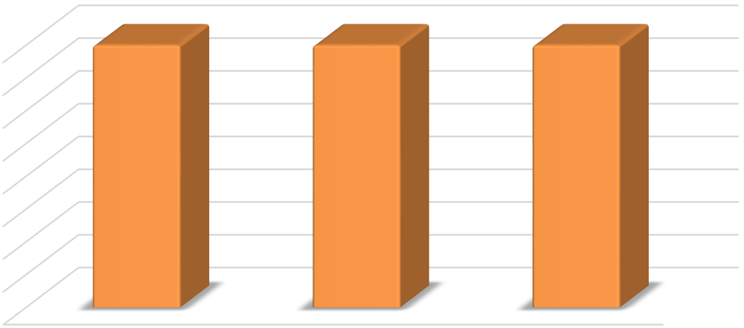

8

8

8

7

6

5 4 3

2

1

0 Baseline value (2020) Target value (2030) Achieved value in 2022)

 Values expressed in numbers

*(Graph 4)*

## **V. IMPLEMENTATION OF INDICATORS OF GOALS (OUTCOME INDICATOR) AND OBJECTIVE (EFFECT INDICATOR)**

The action plan defines the following indicators as outcome indicators:

* Average duration of the open procedure (Objective 1 “Increasing the efficiency and economy of public procurement procedures”); • Average duration of the open procedure (Objective 1 “Increasing the efficiency and economy of public procurement procedures”);
* The number of procedures over which monitoring was carried out (objective 3.
* The number of implemented public procurement procedures with the application of ecological aspects and the number of implemented public procurement procedures with the application of social aspects (objective 4. “Promotion and encouragement of environmental and social aspects in public procurement and innovations”).

**Objective 1** and outcome indicator “Share of conducted public procurements with electronic submission of bids in the total number of public procurement” was fully completed. The initial value of the indicator was 48 in 2021, while as of 31 December 2022, the target value for 2022 was 47(Chart

5).

*(*

*5)*

*Graph*



46.4

46.6

46.8

47

47.2

47.4

47.6

47.8

48

48.2

Baseline value (2021)

Target value (2022)

Achieved value in 2022

**Average duration of an open procedure (in days)**

Values expressed in numbers

**Objective 2** and the outcome indicator "Average number of bids under the public procurement procedure", was not met, bearing in mind that the initial value of the indicator was 2.5 in 2021, that the target value for 2022 was 2.6, and that during 2022 the average number of bids under the public procurement procedure was 2.5. The average number of offers is, among other things, a consequence of the frequent participation of groups of bidders in public procurement procedures. Namely, in more than 15% of the total number of public procurement procedures, groups of economic operators also submitted bids, of which in 7% of public procurement procedures the group of economic operators was the only bidder. Therefore, the number of economic entities that participated in the public procurement procedure is much higher than the number of bids submitted (Graph 6)[1].

# **Average number of bids under the public procurement procedure**

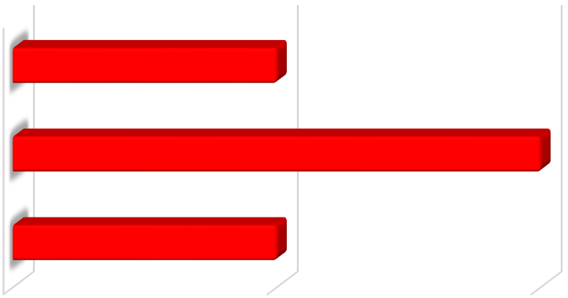 Achieved value in 2022

Target value (2022)

Baseline value (2021)

2.4 2.5 2.6

 Values expressed in numbers

*(Graph 6)*

**Objective 3** andoutcome indicator “Number of monitored procedures” has been fully fulfilled. The initial value of the indicator was 258 in 2021, while as of December 31, 2022, the target value for 2022 is

500 exceeded and amounts to 630 (Chart 7).

# **Number of procedures over which the monitoring was conducted**

Achieved value in 2022

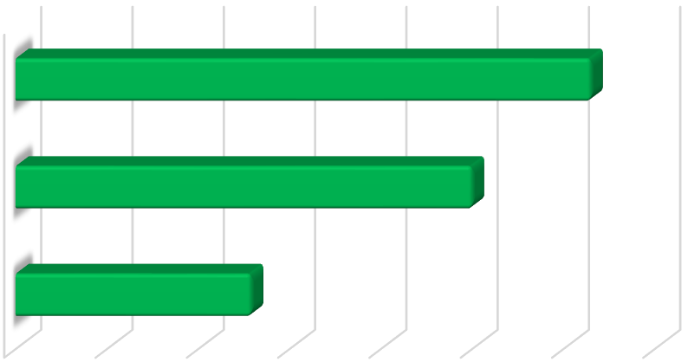

258

500

630

Target value (2022)

Baseline value (2021)

0 100 200 300 400 500 600 700

 Values expressed in numbers

*(Graph 7)*

**Objective 4** andOutcome indicator “Number of conducted public procurements with the application of environmental criteria” and “Number of conducted public procurements with the application of social aspects” was fully fulfilled. The initial value in terms of "green public procurement" was 650 in 2021, while as of 31 December 2022, the target value for 2022 of 700 was exceeded and amounted to 1,111. In relation to other

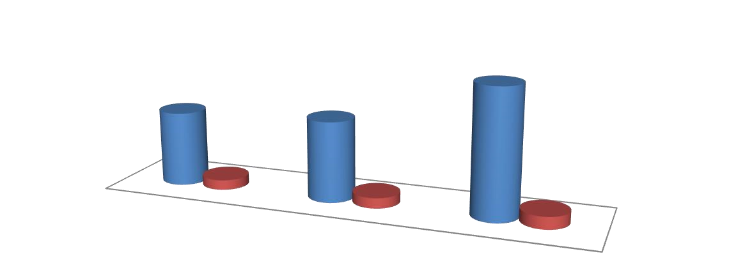

Baseline value

(2021)

Target value

(2022)

Achieved

VALUE (2022)

650

700

1111

86

90

106

**Promotion and encouragement of environmental and**

**social aspects in public procurement and**

**innovations**

Number of conducted public procurements with the application of environmental aspects

aspects

Number of conducted public procurements with the application of social aspects

by this indicator the initial value of this goal was 86 in 2021, while as of 31 December 2022, the target value for 2022 of 90 was exceeded and amounted to 106 (Chart 8).

*(Graph 8)*

The action plan defines the following indicators as effect indicators:

• Annual Progress Report of the European Commission for the Republic of Serbia

With regard to the general goal "Further development of a modern and efficient public procurement system", and the above-mentioned indicator, the PPO did not fully fulfill the planned indicator, bearing in mind the Progress Report of the Republic of Serbia, which shows that the Republic of Serbia in the part related to Chapter 5 - public procurement was moderately prepared and did not make progress compared to the previous year (2021).[2]

## **VI.** **CONCLUSION**

Based on the analysis of the success of the implementation of the Action Plan for 2022, it can be concluded that 94% of the defined activities were implemented in full in the established manner and within the set deadline (Chart 9). Activities that have not been implemented through this Action Plan, such as the activity "Proposing amendments to the Law on Public Procurement", will be proposed as an integral part of the Action Plan for 2023.

*(*

*Graphics*

*on 9*

*)*

94

%

6

%

**Percentage of implemented activities at**

**level of measures**

Implemented activities

Activities not implemented

In terms of outcome indicators at the level of special goals, as well as result indicators at the level of measures, the PPO has achieved most of the planned result indicators, while those that have not been met, bearing in mind that this is a public policy document for the period 2019-2023, the PPO will strive to fulfill completely by the end of the implementation of this programme.

**Annex 1** **Implementation of the Action Plan in 2022**

|  |  |  |  |  |
| --- | --- | --- | --- | --- |
| **Annual report for:** | **Action plan for 2022 for the implementation of the Public Procurement Development Programme in the Republic of Serbia** | | | |
| **Institution responsible for monitoring and control of implementation:** | **PUBLIC PROCUREMENT OFFICE** | | | |
| **Public policy document for which the action plan is determined:** | **Public Procurement Development Programme in the Republic of Serbia for the period from 2019 to 2023** | | | |
|  | | | | |
| Goal: Further development of a modern and efficient public procurement system | | | | |
| Institution responsible for monitoring and control of implementation: PPO | | | | |
| **Name of the indicator** | **Baseline value and year** | **Target value**  **in the year**  **2022** | **Implemented**  **value in the year:**  **2022** | **Comment on progress towards the target value of the indicator**  **(optional)** |
| Annual Progress Report of the European Commission for the Republic of Serbia | Partial progress (2021) | Progress has been made | No progress | The report on the progress of the Republic of Serbia shows that the Republic of Serbia, in the part related to Chapter 5 - public procurement, is moderately prepared and has not achieved progress compared to the previous year[3]. |
|  | | | | |
| Specific objective 1: Increasing the efficiency and cost-effectiveness of public procurement procedures | | | | |
| Goal holder: PPO | | | | |
| **Name of the indicator** | **Baseline value and year** | **Target value in 2022** | **Implemented**  **value**  **in 2022** | **Explanation of deviations from the target value of the indicator** |
| Average duration of an open procedure (in days) | 48 (2021) | 47 | 47[4] | Indicator fulfilled, no deviation. |
|  | | | | |

|  |  |  |  |  |
| --- | --- | --- | --- | --- |
| Specific objective 2: Strengthening competition in the public procurement market | | | | |
| Goal holder: PPO | | | | |
| **Name of the indicator** | **Initial value and year** | **Target value in 2022** | **Implemented**  **value**  **in 2022** | **Explanation of deviations from the target value of the indicator** |
| Average number of bids under the public procurement procedure | 2.5 (2021) | 2.6 | 2.5[5] | The average number of offers is, among other things, a consequence of the frequent participation of groups of bidders in public procurement procedures. Namely, in more than 15% of the total number of public procurement procedures, groups of economic operators also submitted bids, of which in 7% of public procurement procedures the group of economic operators was the only bidder. Therefore, the number of economic entities that participated in the public procurement procedure is much higher than the number of bids submitted.  The PPO plans to continue with the organisation of trainings to improve the public procurement system with a special focus on encouraging competition, strengthening the capacity of bidders, small and medium-sized enterprises. |
|  | | | | |
| Specific objective 3: Reduction of the risk of irregularities in the public procurement system | | | | |
| Goal holder: PPO | | | | |
| **Name of the indicator** | **Baseline value and year** | **Target value in 2022** | **Implemented**  **value**  **in 2022** | **Explanation of deviations from the target value of the indicator** |
| Number of procedures over which the monitoring was conducted | 258 (2021) | 500 | 6306 | The indicator is fully fulfilled. The initial value of the indicator was 258 in 2021, while as of 31 December 2022, the target value for 2022 of 500 was exceeded and amounts to 630. |
|  | | | | |
| Specific objective 4: Promotion and encouragement of environmental and social aspects in public procurement and innovations | | | | |
| Goal holder: PPO | | | | |

|  |  |  |  |  |  |  |
| --- | --- | --- | --- | --- | --- | --- |
| **Name of the indicator** | | **Baseline value and year** | | **Target value in 2022** | **Implemented**  **value**  **in 2022** | **Explanation of deviations from the target value of the indicator** |
| Number of conducted public procurements with the application of environmental aspects  aspects | | 650 (2021) | | 700 | 1,111[6] | The indicator is fully achieved. The initial value of the indicator was 650 in 2021, while as of 31 December 2022, the target value for 2022 of 700 was exceeded and amounts to 1,111. |
| Number of conducted public procurements with the application of social  aspects | | 86 (2021) | | 90 | 106[7] | The indicator is fully fulfilled. The initial value of the indicator was 86 in 2021, while as of 31 December 2022, the target value for 2022 was 90 times exceeded and amounted to 106 (Chart 7). |
|  | |  | |  | |  |
| Measure 1: Improving the legal framework | |  | |  | |  |
| Item holder: ME | |  | |  | |  |
| **Name of the indicator** | | **Baseline value and year** | | **Target value in 2022** | **Implemented**  **value**  **in 2022** | **Explanation of deviations from the target value of the indicator** |
| Amendments to the LPPPC in application | | Under preparation (2021) | | applied | / | The indicator, i.e., the target value of the output indicator in 2022 has not been met, given that the amendments to the PPLO have not been adopted. |
|  | |  | |  | |  |
| **Activities for the implementation of the measure:**  **2022** | **Institution responsible for implementation** | **Deadline for implementation in 2022** | **Activity status** | **New deadline for implementation** | | **Description**  *(Explanation of derogation + Progress made + Future steps)* |
| 1.1. Proposing  amendment and supplement  LPPPC | ME | 4th quarter of 2022 | Underway | 4th quarter of 2023 | | Amendments to the legislative framework in the field of public-private partnerships and concessions are planned to be implemented in the 4th quarter of 2022. The deadline for the implementation of this activity will be postponed to 2023, given that the amendments to the LPPPC were not adopted. |

|  |  |  |  |  |  |  |
| --- | --- | --- | --- | --- | --- | --- |
|  | | | |  | |  |
| Measure 2: Strengthening the institutional framework | | | |  | |  |
| Item holder: PPO | | | |  | |  |
| **Name of the indicator** | | **Baseline value and year** | | **Target value in 2022** | **Implemented**  **value**  **in 2022** | **Explanation of deviations from the target value of the indicator** |
| Number of employed persons in the PPO[8] | | 44 (2021) | | 46 | 42 | The first indicator of the implementation of the measure "Number of persons employed in the PPO", i.e., the target value of the result indicator in 2022 of 46 persons has been partially fulfilled, bearing in mind that the structure of employees shows that on 31 December 2022, the total number of employees in thirty-three (33) permanent and fixed-term employees, of which twenty-nine (29) are permanent employees and four (4) civil servants, while the total number of non-employment employees is based on contracts for temporary and casual jobs as of 31 December 2022, 9, which is a total of 42 persons employed (Chart 1). |
| Number of certified officers | | 4845[9] (2021) | | 4950 | 502611 | The indicator fully met, bearing in mind that the target value of a total of 4,800 certified public procurement officers (according to the old and new PPL) has been reached and amounts to 4,845 (Data from the Register of Public Procurement Officers maintained by the PPO). |
|  | | | |  | |  |
| **Activities for the implementation of the measure:**  **2022** | **Institution responsible for implementation** | **Deadline for implementation in 2022** | **Activity status** | **New deadline for implementation** | | **Description**  *(Explanation of derogation + Progress made + Future steps)* |

|  |  |  |  |  |  |
| --- | --- | --- | --- | --- | --- |
| 2.1. Organising examinations for Public Procurement Officers | PPO | 4th quarter  2022 | Completed  [10] |  | The PPO continued with the organisation of the exam for public procurement officers in the 1st quarter of 2022. During 2022, a total of 22 exams were organised. In this period, a total of 358 candidates applied to take the exam for public procurement officer, of whom 315 candidates took the exam, while 181 candidates passed the exam, compared to 118 candidates in 2021. The candidate success rate was still somewhere above 50%.  The PPO will continue to organise examinations for public procurement officers in the coming period. |
| 2.2.Training for preparation of taking the examination for Public Procurement Officers | PPO  NALED | 4th quarter  2022 | Completed  [11] |  | The PPO, in cooperation with USAID, organised two trainings for representatives of contracting authorities and bidders (November and December) to help them prepare for the public procurement officer exam. All 193 participants had the opportunity to improve their knowledge of the legal and institutional framework in the field of public procurement, the role of institutions responsible for regulation, monitoring and supervision of public procurement, types of public procurement procedures, determining deadlines, criteria for quality selection of a business entity, criteria for awarding contracts, rights protection and other important topics in the field of public procurement.  The PPO will continue to organise examinations for public procurement officers in the coming period. |
| 2.3.Organising workshops to harmonise the positions of the PPO, NC,  MFIN in connection with  PPL | PPO  RC  MFIN  USAID | 4th quarter of 2022 | Completed  [12] |  | In this regard, during the months of November and December 2022, with the support of the USAID Project for the Improvement of Public Procurement, two workshops were held where experiences were exchanged regarding issues that are important for the proper application of regulations in the field of public procurement. Held workshops contributed to better cooperation and coordination of authorities responsible for regulating and monitoring public procurement, supported the exchange of knowledge and experience and enabled common understanding and a unified approach in applying the provisions of the Law on Public Procurement. |

|  |  |  |  |  |  |  |
| --- | --- | --- | --- | --- | --- | --- |
|  |  |  |  |  |  | The PPO will continue to organise examinations for public procurement officers in the coming period for the purpose of harmonising this activity. |
| 2.4. Training of the Police, Public Prosecutor’s Office, SAI and other institutions in the field of public procurements | PPO  USAID  UNDP | 4th quarter  2022 | Completed  [13] |  |  | Representatives of the PPO held a lecture at the workshop entitled "Public procurement for judges and judicial assistants of special departments for combating corruption of higher courts", which was organised in Belgrade on 21 and 22 March 2022, organised by SIDA and NALED. Representatives of the PPO presented the Portal and its functionalities and spoke about the availability of information on public procurement procedures and access to the Portal, and new PPL solutions were also presented. Also, representatives of the PPO, with the support of SIDA and NALED, held a lecture at the workshop entitled "Public procurement for deputy senior public prosecutors and assistant prosecutors of the special anti-corruption departments of the Higher Prosecutor's Offices" in Belgrade on 24 May 2022. The PPO spoke about the work performed by the PPO, as well as the role and importance of the liaison officer who performs this duty in front of the PPO.  The PPO will continue to organise examinations for public procurement officers in the coming period. |
|  | | | |  |  |  |
| Measure 3: Improvement of electronic public procurement | | | |  |  |  |
| Item holder: PPO | | | |  |  |  |
| **Name of the indicator** | | **Baseline value and year** | | **Target value in 2022** | **Implemented**  **value**  **in 2022** | **Explanation of deviations from the target value of the indicator** |
| Increased number of new ones  of functionalities of the Public Procurement Portal | | 10 (2021)[14] | | 13 | 13[15] | [The indicator, i.e., the target value of the result indicator in 2022, has been fully fulfilled, since as at 31 December 2022, a total of 13 versions of the Portal was published ( https://jnportal.ujn.gov.rs/](https://jnportal.ujn.gov.rs/)). |
|  | | | |  |  |  |

|  |  |  |  |  |  |
| --- | --- | --- | --- | --- | --- |
| **Activities for the implementation of the measure:**  **2022** | **Institution responsible for implementation** | **Deadline for implementation in 2022** | **Activity status** | **New deadline for implementation** | **Description**  *(Explanation of derogation + Progress made + Future steps)* |
| 3.1. Development of technical specification for the development of new functionalities on the Public Procurement Portal | PPO | 4th quarter of 2022 | Completed |  | With the support of UNDP, NALED and SIDA, the project "Effective public procurement in the service of economic growth" developed technical specifications and launched several versions of the Portal during 2022, which further facilitate the work of Portal users. From March to December 2022, three new versions of the Portal were developed and published, and each of them brings some new opportunities to contracting authorities and bidders. These technical improvements to the Portal refer to all contracts assigned to a specific bidder, search optimisation, authorisations for administrative users, as well as a series of records for exporting content to Excel or JSON format. Also, some improvements are related to rights protection, quarterly reports and advance notices.  In the coming period, the PPO will continue to improve the Public Procurement Portal, develop new modules, functionalities and options on the Portal. |
| 3.2. English translation of video instructions for users of the Public Procurement Portal | PPO | 4th quarter of 2022 | Completed |  | The PPO, with the support of USAID and the Public Procurement Improvement Project, translated the following video instructions into English for users of the Portal: 1) registration on the Public Procurement Portal, 2) public procurement plan, 3) preparation and publication of the public procurement procedure, 4) submission of e-offers. The aforementioned video instructions with English subtitles are available on the Public Procurement Portal. |
| 3.3. Development  development of the mobile application of the Procurement Portal for iOS and Android mobile platforms | PPO | 4th quarter of 2022 | Completed |  | A mobile application has been developed for Android and iOS devices. The mobile app can be downloaded from the Google play store as well as the Apple store. On the mobile application, all the options that are available on the web application of the Portal are available. |
|  | | | | | |
| Measure 4: Strengthening administrative capacities and education | | | | | |

|  |  |  |  |  |  |  |
| --- | --- | --- | --- | --- | --- | --- |
|  | |  | |  | |  |
| **Name of the indicator** | | **Baseline value and year** | | **Target value in 2022** | **Implemented**  **value**  **in 2022** | **Explanation of deviations from the target value of the indicator** |
| Number of organised trainings during the year | | 8 (2021)[16] | | 8 | 8 | The indicator, i.e., the target value of the output indicator in 2022, has been fully met, bearing in mind that during 2022, 8 trainings were organised for contracting authorities and bidders related to the implementation of the new legislative framework and the use of the Public Procurement Portal. |
|  | |  | |  | |  |
| **Activities for the implementation of the measure:**  **2022** | **Institution responsible for implementation** | **Deadline for implementation in 2022** | **Activity status** | **New deadline for implementation** | | **Description**  *(Explanation of derogation + Progress made + Future steps)* |
| 4.1. Development of new models of the documentation in accordance with the PPL | PPO NALED | 4th quarter of 2022 | Completed |  | | The tender documentation model for the public procurement of paper haberdashery for maintaining personal hygiene, using the dynamic procurement system, was created within the project "Platform for Responsible Management of Public Finances", financed by SIDA and implemented by UNDP.  Also, with the support of NALED, models of tender documents for green public procurement (office supplies and communal electric vehicle) were prepared. The prepared tender documents contain examples of the application of ecological aspects within the framework of technical specifications and/or criteria for the qualitative selection of a business entity and/or criteria for the award of contracts and/or special conditions for contract execution. |
| 4.2. Promotion of the tender documentation model | PPO  CCIS  NALED | 4th quarter of 2022 | completed  [17] |  | | In cooperation with UNDP, a webinar was held themed: "Dynamic procurement system - presentation of tender documents", on 23 September 2022. The PPO presented to the webinar participants the basic features of the dynamic procurement system, the method of establishing the system and awarding contracts, the similarities and differences between the dynamic procurement system and the framework agreement, as well as examples of good practice. In the second part of the webinar, the tender documents for |

|  |  |  |  |  |  |
| --- | --- | --- | --- | --- | --- |
|  |  |  |  |  | public procurement of paper haberdashery for maintaining personal hygiene, using a dynamic procurement system. |
| 4.3. Development of a model of internal acts of the contracting authority | PPO  NALED | 4th quarter of 2022 | Completed |  | In cooperation with NALED, a model of a special act was created that regulates the way of planning, implementation of public procurement procedures and monitoring the execution of contracts on public procurement (method of communication, rules, obligations and responsibilities of persons and organisational units), the way of planning and implementation of procurement exempted from the law and procurement of social and other specific services, which is prescribed by Article 49, paragraph 2. PPL. |
| 4.4. Development of methodology on the basis of which execution of public procurement contract will be monitored | MFIN  PPO  NALED | 4th quarter of 2022 | Completed |  | [The methodology for supervising the execution of public procurement contracts has been adopted by the Ministry of Finance and can be found at the following link:](https://www.mfin.gov.rs/kontrola-javnih-sredstava/metodologija-za-vrenje-nadzora-nad-izvrenjem-ugovora-o-javnim-nabavkama)  [https://mfin.gov.rs/kontrola-javnih-sredstava/metodologija-za-vrenje](https://mfin.gov.rs/kontrola-javnih-sredstava/metodologija-za-vrenje-nadzora-nad-izvrenjem-ugovora-o-javnim-nabavkama)[-](comments.xml)[nadzora-nad-izvrenjemugovora-o-javnim-nabavkama.](https://mfin.gov.rs/kontrola-javnih-sredstava/metodologija-za-vrenje-nadzora-nad-izvrenjem-ugovora-o-javnim-nabavkama) |
| 4.5. Organising training for contracting authorities and bidders | PPO  CCIS  UNDP | 4th quarter of 2022 | completed  [18] |  | The PPO, in order to strengthen the capacities of economic entities, organised trainings for contracting authorities and other economic entities on various topics. Representatives of the PPO held a lecture at the workshop entitled "Public procurement for judges and judicial assistants of special departments for combating corruption of higher courts", which was organised in Belgrade on 21 and 22 March 2022, organised by SIDA and NALED. Representatives of the PPO presented the Portal and its functionalities and spoke about the availability of information on public procurement procedures and access to the Portal, and new PPL solutions were also presented. The PPO representative participated as a lecturer in the workshop entitled "Partnership for Innovation as a Public Procurement Procedure" organised by SIDA and NALED in the premises of the National Academy for Public Administration on 15 April 2022. The participants were introduced to the term and procedure |
| 4.6. Organisation of a seminar on the application of environmental aspects in public procurement procedures | PPO  CCIS  UNDP  NALED | 4th quarter of 2022 | completed  [19] |  |
| 4.7. Organisation of a seminar on the application of social aspects in public procurement procedures | PPO  CCIS  NALED | 4th quarter of 2022 | completed  22 |  |

|  |  |  |  |  |  |
| --- | --- | --- | --- | --- | --- |
| public procurement procedures |  |  |  |  | Innovation Partnerships as a (new) public procurement procedure, with EU practice in this area, then challenges, opportunities and alternatives when it comes to the use of Innovation Partnerships in practice. Then, at the suggestion of the Ministry of Defense, the employees of the PPO held a meeting on 27 April  In 2022, training for employees of the Ministry of Defence and the Serbian Armed Forces on the topic of implementing procedures for issuing individual purchase orders based on framework agreements for the procurement of services for providing airline tickets and hotel accommodation for official trips abroad, which are of exceptional importance for the functioning and execution of tasks under the Ministry's competence of Defence and the Serbian Armed Forces. Representatives of the PPO, with the support of SIDA and NALED, held a lecture at the workshop entitled "Public procurement for deputy senior public prosecutors and assistant prosecutors of the special anti-corruption departments of the Higher Prosecutor's Offices" in Belgrade on 24 May 2022. Representatives |
|  |  |  |  |  |
| 4.8. Organising trainings for micro, small and medium-sized enterprises | PPO  CCIS  UNDP | 4th quarter of 2022 | completed  [20] |  | The PPO spoke about the work performed by the PPO, as well as the role and importance of the liaison officer who performs this duty in front of the PPO. In cooperation with UNDP, a webinar was held themed: "Dynamic procurement system - presentation of tender documents", on 23 September 2022. The PPO presented to the webinar participants the basic features of the dynamic procurement system, the method of establishing the system and awarding contracts, the similarities and differences between the dynamic procurement system and the framework agreement, as well as examples of good practice. In the second part of the webinar, the tender documentation for the public procurement of paper goods for maintaining personal hygiene, using the dynamic procurement system, was presented. The PPO, in cooperation with USAID, organised two trainings for representatives of contracting authorities and bidders (November and December) to help them prepare for the public procurement officer exam. All 193 participants had the opportunity to improve their knowledge of the legal and institutional framework in the field of public procurement, the role of institutions responsible for the regulation, monitoring and supervision of public procurement, types of public procurement procedures |
|  |  |  |  |  | procurements, determining deadlines, criteria for the quality selection of a business entity, criteria for awarding contracts, protection of rights and other important topics in the field of public procurement. In December, PPO, in cooperation with PKS, organised a seminar for contracting authorities and bidders on the topic "Environmental and social elements in public procurement procedures, the impact of changes in the market on procedures and attitudes and opinions of PPO" in order to improve knowledge about ecological and social procurement in Serbia. The seminar was intended for contracting authorities and bidders with the aim of eliminating doubts that arise in practice when defining environmental and social elements in tender documents, as well as the method of proving them by bidders.One part of the seminar was devoted to current issues faced by participants in public procurement procedures during the implementation of concluded contracts, as well as to the views and opinions of the Public Procurement Law relating to the application of certain provisions of the Public Procurement Law and other regulations in the field of public procurement. The PPO, in cooperation with USAID, organised training for police officers in connection with the monitoring of public procurement and the most common irregularities in practice in Serbia. The "Guide to monitoring the implementation of regulations in the field of public procurement" was also presented.  The PPO will continue in the coming period with the organisation of trainings and workshops for contracting authorities and bidders regarding the application of the Public Procurement Law and the use of the Public Procurement Portal. |

1. Regarding the type of public procurement subject, the largest number of bids was submitted in public works procurement procedures (average number of bids 3.03), then in public goods procurement procedures (average number of bids 2.58), and finally in public procurement procedures procurement of services (average number of bids 2.26). When it comes to public procurement items according to CPV designation, the largest number of bids was submitted in public procurement procedures for items within the group with CPV designation 33000000, Medical equipment, pharmaceutical products and personal care products (average number of bids 4.04). Annual Report on Public Procurements in the Republic of Serbia for the period 1 January 2022 – 31 December 2022 ([https://jnportal.ujn.gov.rs/annual-reports-ppo-public)](https://jnportal.ujn.gov.rs/annual-reports-ppo-public).
2. More information is available in the 2022 Annual Progress Report of the European Commission for the Republic of Serbia[(https://www.mei.gov.rs/upload/documents/eu_dokumenta/godisnji_izvestaji_ek_o_napretku/Serbia_Report_2022_SR.%5B1%5 D.pdf)](https://www.mei.gov.rs/upload/documents/eu_dokumenta/godisnji_izvestaji_ek_o_napretku/Serbia_Report_2022_SR.%5B1%5D.pdf).
3. <https://www.mei.gov.rs/upload/documents/eu_dokumenta/godisnji_izvestaji_ek_o_napretku/Serbia_Report_2022_SR.%5B1%5D.pdf>
4. Annual Report on Public Procurements in the Republic of Serbia for the period 1 January 2022 – 31 December 2022 ([https://jnportal.ujn.gov.rs/annual-reports-ppo-public)](https://jnportal.ujn.gov.rs/annual-reports-ppo-public).
5. Annual Report on Public Procurements in the Republic of Serbia for the period 1 January 2022 – 31 December 2022 ([https://jnportal.ujn.gov.rs/annual-reports-ppo-public)](https://jnportal.ujn.gov.rs/annual-reports-ppo-public). 6 Data of the PPO as of 31 December 2022.
6. Annual Report on Public Procurements in the Republic of Serbia for the period 1 January 2022 – 31 December 2022 ([https://jnportal.ujn.gov.rs/annual-reports-ppo-public)](https://jnportal.ujn.gov.rs/annual-reports-ppo-public).
7. Annual Report on Public Procurements in the Republic of Serbia for the period 1 January 2022 – 31 December 2022 ([https://jnportal.ujn.gov.rs/annual-reports-ppo-public)](https://jnportal.ujn.gov.rs/annual-reports-ppo-public).
8. The number of employees in the PPO includes permanent and fixed-term employees, as well as persons engaged through contracts (work outside the employment relationship) as of 31

   December 2022.
9. The data from the Register of Public Procurement Officers kept by the PPO as at 31 December 2021.11The data from the Register of Public Procurement Officers kept by the PPO as at 31 December 2022.
10. The indicator of the output results of this activity according to the Action Plan for 2022 is " Increased number of certified employees."
11. The indicator of the output results of this activity according to the Action Plan for 2022 is “Number of organised trainings - at least two per year”.
12. The indicator of the output results of this activity according to the Action Plan for 2022 is " Number of organised workshops - two per year ".
13. The indicator of the output results of this activity according to the Action Plan for 2022 is " At least two trainings were held."
14. The data from the Public Procurement Portal as of 31 December 2021 refers to the version of Public Procurement Portal which was released into operation.
15. The data from the Public Procurement Portal as of 31 December 2022 refers to the version of Public Procurement Portal which was released into operation.
16. Baseline value as of 31 December 2021.
17. The indicator of the output results of this activity according to the Action Plan for 2022 is " At least two trainings were held."
18. The indicator of the output results of this activity according to the Action Plan for 2022 is “Number of organised trainings - at least two per year”.
19. The indicator of the output results of this activity according to the Action Plan for 2022 is “Number of organised trainings - at least two per year”. 22 The indicator of the output results of this activity according to the Action Plan for 2022 is “Number of organised trainings - at least two per year”.
20. The indicator of the output results of this activity according to the Action Plan for 2022 is “Number of organised trainings - at least two per year”.