GUIDELINES FOR PREPARATION OF TENDER DOCUMENTATION AND PREPARATION OF E-BID ON THE PUBLIC PROCUREMENT PORTAL

August 2020
TABLE OF CONTENTS

- General part
- Criteria for qualitative selection of the economic operator
- Contract award criteria
- Bid form
- Offered price structure form
- Contract model
- Other documents
- Concluding remarks

- GENERAL PART
The Public Procurement Office (hereinafter referred to as: the Office), in accordance with authorisations regulated by Article 179 of the Law on Public Procurement (“Official Gazette of the Republic of Serbia”, No. 91/19, hereinafter referred to as: the Law), inter alia, also prepares guidelines in the field of public procurements.
These guidelines help contracting authorities in the preparation of tender documents, or economic entities in the preparation of e-bids in terms of the following documents and forms:
- Criteria for qualitative selection of the economic operator;
- Contract award criteria;
- Bid form;
- Offered price structure form;
- Contract model, and
- Other document.
The tender documentation prepared and published by the contracting authority on the Public Procurement Portal (hereinafter referred to as: the Portal) consists of several special parts, which together form the content of the tender documentation.
The process of preparation of tender documentation is not separate from the process of preparation of public invitation for a specific public procurement procedure, i.e., the preparation of public invitation and tender documentation are parts of a unique and inseparable process of preparation of these documents.
All parts of the tender documentation become visible only at the moment of publishing the public invitation on the Portal, i.e., the contracting authority does not publish the public invitation and tender documentation separately, but the process of publishing the said documents is unique and inseparable. Only after the announcement of the public invitation, interested persons can download the tender documentation.
In the process of preparation of the public invitation and tender documentation, the contracting authority enters data on the specific public procurement procedure through the Portal in a predetermined order. From the above data, the Portal automatically forms certain parts of the tender documentation (criteria for contract award only in the case of automatic ranking, criteria for qualitative selection of economic operators and instructions to bidders on how to make a bid), while other parts of the tender documentation in a predefined order (sample price structure, technical specifications, contract model, etc.).
When preparing the tender documentation, the contracting authority does not provide places for stamp and signature on the forms and documents it asks the bidder to submit within its e-bids, since the contracting authority cannot ask the bidder to sign and certify the forms and documents, and then to scan the signed and certified copies within the e-bids. Also, bidders are not obliged to sign and certify forms and documents, which they upload or create within their e-bids.
In addition to the above, in order to prepare the tender documentation and prepare the e-bid, in addition to these guidelines, it is necessary for contracting authorities and economic operators to familiarise themselves in detail with the Law, bylaws and user instructions on the Portal, accessed via icons marked with a question mark and located in the upper right corner of the platform.

- CRITERIA FOR QUALITATIVE SELECTION OF THE ECONOMIC OPERATOR

I. INTRODUCTION

The law stipulates that the contracting authority is obliged to exclude from the public procurement procedure an economic operator, if there are grounds for exclusion from Article 111 of the Law on Public Procurement, then the grounds for exclusion from Article 112 of the Law on Public Procurement, if the contracting authority stipulated them in the tender documentation, as well as if the economic operator does not meet the criteria for the selection of economic operator, that the contracting authority defined in the tender documentation, in accordance with Articles 114 - 117 of the Law on Public Procurement.

Article 118, paragraph 1 of the Law on Public Procurement stipulates that the economic operator in the bid or application submits a statement on the fulfilment of the criteria for qualitative selection of the economic operator on a standard form, confirming that there are no grounds for exclusion and meeting the required criteria for selecting the economic operator.

Article 119 of the Law on Public Procurement stipulates that before making a decision in the public procurement procedure, the contracting authority shall require the tenderer which has submitted the most economically advantageous bid, to submit evidence on fulfilment of the criteria for qualitative selection of economic operator, in the form of unverified copies, within an appropriate time limit not shorter than five working days. Therefore, the provisions of the Law on Public Procurement, as a rule, prescribe the obligation to request the above evidence only from the bidder who submitted the most economically advantageous bid, with the Law on Public Procurement prescribing in which cases the contracting authority is not obliged to request the same: if the estimated value of public procurement is equal to or lower than 5,000,000 dinars or if on the basis of the data stated in the statement on fulfilment of criteria it can obtain evidence, i.e., inspect the evidence on fulfilment of criteria for qualitative selection of economic operator or if the contracting authority already has valid relevant evidence.

The contracting authority does not require the bidder to submit evidence of fulfilment of the criteria for qualitative selection of the economic operator in the phase of submitting bids.
The contracting authority requires the bidder only to fill in an e-statement on the fulfilment of the criteria for qualitative selection of the economic operator.
Proof, if necessary, is done in the phase of expert evaluation of bids, by requesting evidence through the Portal and submitting evidence through the Portal, unless it is evidence that by its nature cannot be submitted through the Portal.

The contracting authority does not ask the bidder to download the e-statement form on the fulfilment of the criteria for qualitative selection of the economic operator, which is available on the website of the Office, nor does it load it as an integral part of the tender documentation.
The e-statement is integrated on the Portal and the bidders fill in the e-statement through the forms on the Portal when compiling the e-bid directly based on the data, ie criteria and conditions selected and defined by the contracting authority during the preparation of the procedure on the Portal.

II. PREPARATION OF CRITERIA FOR QUALITATIVE SELECTION OF ECONOMIC OPERATOR

Data related to the criteria for qualitative selection of a economic operator are entered during the preparation of tender documentation.

In this step, the Contracting authority enters the required data on the basis of which the Portal automatically forms part of the tender documentation, as follows:

- Criteria for qualitative selection of an economic operator and instructions on how to prove the fulfilment of these criteria, and
- Statement on fulfilment of criteria for qualitative selection of economic operator (SFC).
The statement on fulfilment of the criteria for qualitative selection of the economic operator, which is an integral part of this part of the tender documentation and which the bidder needs to fill in, is adjusted to the specific public procurement procedure in accordance with the standard form.
All grounds for exclusion from Article 111 of the Law on Public Procurement и Article 112 of the Law on Public Procurement defined by the contracting authority in the tender documentation, as well as criteria for selection of economic operator (ability to perform professional activities, economic and financial capacity, technical and professional capacity) will be stated in the document “e-statement on fulfilment of the criteria for qualitative selection of the economic operator”, which will be created from the entered data and which will be part of the tender documentation.
The process of preparation of criteria for qualitative selection of an economic operator consists of two parts: selection of criteria and determination of criteria and manner of proving them.

II. 1 SELECTION OF CRITERIA

- Grounds for exclusion from the public procurement procedure referred to in Article 111 of the Law on Public Procurement

All grounds for exclusion from the public procurement procedure referred to in Article 111 of the Law on Public Procurement are compulsory and automatically marked on the Portal, under the title “Compulsory Grounds for Exclusion”.

- Grounds for exclusion from the public procurement procedure referred to in Article 112 of the Law on Public Procurement

In this part, which is entitled “Other grounds for exclusion” on the Portal, the contracting authority may choose the grounds for exclusion from Article 112, paragraph 1 of the Law on Public Procurement, as follows:
- “ bankrupt, inability to pay, liquidity, etc.”, prescribed by Article 112, paragraph 1, item 1) of the Law on Public Procurement;
- “Grave professional misconduct”, prescribed by Article 112, paragraph 1, item 2) of the Law on Public Procurement;
- “Agreements aimed at distorting competition”, prescribed by Article 112, paragraph 1, item 3) of the Law on Public Procurement;
- “Prior involvement in the preparation of the procurement procedure”, prescribed by Article 112, paragraph 1, item 4) of the Law on Public Procurement;
- “Breaches of previously concluded contracts”, prescribed by Article 112, paragraph 1, item 5) of the Law on Public Procurement;
- “False information and failure to submit evidence”, prescribed by Article 112, paragraph 1, item 6) of the Law on Public Procurement.

The contracting authority may choose the basis for exclusion from Article 112 of the Law on Public Procurement, depending on the needs of a specific public procurement.

- Selection criteria

This part of the Portal is divided into three parts:

- Criterion entitled “Performing professional activity”, prescribed by Article 114, paragraph 1, item 1) of the Law on Public Procurement, within which the contracting authority chooses one or both criteria, as follows:
- “Entry in the register”, prescribed by Article 115, paragraph 1 of the Law on Public Procurement and
- “Authorisation, permit or membership”, prescribed by Article 115, paragraph 2 of the Law on Public Procurement.

- Criterion entitled “Financial and economic capacity”, prescribed by Article 114, paragraph 1, item 2) of the Law on Public Procurement, within which the contracting authority selects one, more or all criteria, as follows:
- “Total income”, prescribed by Article 116, paragraph 1, item 1) of the Law on Public Procurement;
- “Certain income”, prescribed by Article 116, paragraph 1, item 1) of the Law on Public Procurement;
- “Financial indicators”, prescribed by Article 116, paragraph 1, item 2) of the Law on Public Procurement;
- “Professional Liability Insurance", prescribed by Article 116, paragraph 1, item 3) of the Law on Public Procurement;
- “Other economic or financial conditions”. The Law on Public Procurement does not exclude the possibility that the contracting authority, in addition to the criteria provided for in Article 116, paragraph 1 of the Law on Public Procurement, envisages some other criteria related to financial and economic capacity.

- Criterion entitled "Technical and professional capacity, quality assurance standards and environmental management standards”, prescribed by Article 114, paragraph 1, item 3) of the Law on Public Procurement and Articles 126 and 127 of the Law on Public Procurement, within which the contracting authority selects one, more or all evidence, as follows:
- “List of delivered goods”, prescribed by Article 124, paragraph 1, items 1) and 2) of the Law on Public Procurement;
- “Technical persons or bodies - quality control”, prescribed by Article 124, paragraph 1, item 3) of the Law on Public Procurement;
- “Technical means and measures for quality assurance”, prescribed by Article 124, paragraph 1, item 4) of the Law on Public Procurement;
- “Funds for study and research”, prescribed by Article 124, paragraph 1, item 4) of the Law on Public Procurement;
- “Supply Chain Management and Monitoring Systems”, prescribed by Article 124, paragraph 1, item 6) of the Law on Public Procurement;
- “Quality control”, prescribed by Article 124, paragraph 1, item 6) of the Law on Public Procurement;
- “Educational and professional qualifications”, prescribed by Article 124, paragraph 1, item 5) of the Law on Public Procurement;
- “Environmental management measures”, prescribed by Article 124, paragraph 1, item 8) of the Law on Public Procurement;
- “Average annual number of employees”, prescribed by Article 124, paragraph 1, item 9) of the Law on Public Procurement;
- “Average annual number of managerial staff”, prescribed by Article 124, paragraph 1, item 9) of the Law on Public Procurement;
- “Samples, descriptions or photographs”, prescribed by Article 124, paragraph 1, item 12) sub-item (1) of the Law on Public Procurement;
- “Certificates of institutions or agencies for quality control”, prescribed by Article 124, paragraph 1, item 12) sub-item (2) of the Law on Public Procurement;
- “Quality assurance standards”, prescribed by Article 126 of the Law on Public Procurement;
- “Standards manage the environment", prescribed by Article 127 of the Law on Public Procurement.

The contracting authority may choose the criteria for the selection of the economic operator depending on the needs of the specific public procurement.

II. 2 DETERMINING CRITERIA AND THE WAY OF PROVING THEM

In this step, the contracting authority defines the details for each selected criterion, determines the method of proving the criteria and states the data required from the economic operator.

In this step, only the criteria selected by the contracting authority in the previous step will appear on the Portal.

The contracting authority can always return to the previous step if it failed to choose one of the criteria it wants to determine in a particular procedure.

The legal basis from the Law on Public Procurement, as well as the text of the provision of the Law on Public Procurement have already been entered on the Portal, so the contracting authority does not have to enter this information.

In the method of determining the evidence, the contracting authority has the possibility to either choose the already proposed text of the evidence that the contracting authority can adjust or to enter the data related to the evidence.

When the contracting authority uses the proposed text of the evidence, it should adjust it at least in the part where it is suggested * shall/must (is obliged) * / * may *. The contracting authority selects one of the offered options by deleting the option that does not correspond to the specific public procurement procedure.
If the contracting authority does not adjust the data specified in this part to the needs of its public procurement procedure, it will not be able to continue with the preparation of the tender documentation.

If the subject matter of procurement is formed into lots, the contracting authority may define different criteria for the selection of an economic operator for individual lots.

III. EXAMPLES OF CERTAIN CRITERIA

EXAMPLE 1 - Criterion: “Financial and economic capacity” - “Certain income”.
Subject matter of public procurement - Computers

Legal basis - Article 116, paragraph 1, item 1) of the Law on Public Procurement - the contracting authority does not enter this information in this step, since it was entered during the determination of the criteria, so that the Portal is now created by itself.

Provision - In this part, the Portal enters the text of the stated legal provision.

Method of proving the fulfilment of the criteria - the contracting authority can choose between the offered evidence or to enter the evidence proving the stated criterion.

Example when the contracting authority determines the proof itself:
The bidder proves the fulfilment of this criterion by submitting a statement.

Statement on fulfilment of criteria: question to the economic operator / requested data - in this part the Portal itself enters the question to the economic operator

Examples:
Certain income is considered to be income in the amount of at least 3,000,000 dinars in the field of computer sales, for the period of at most the last three financial years (2017, 2018 and 2019).

Criteria details - in this step the contracting authority states the data it requires from the bidder to meet this criterion.

Examples:
Number of previous years: 3
Area in which a certain income is required: Sale of computers
Minimum amount: 3,000,000 dinars
Currency: RSD

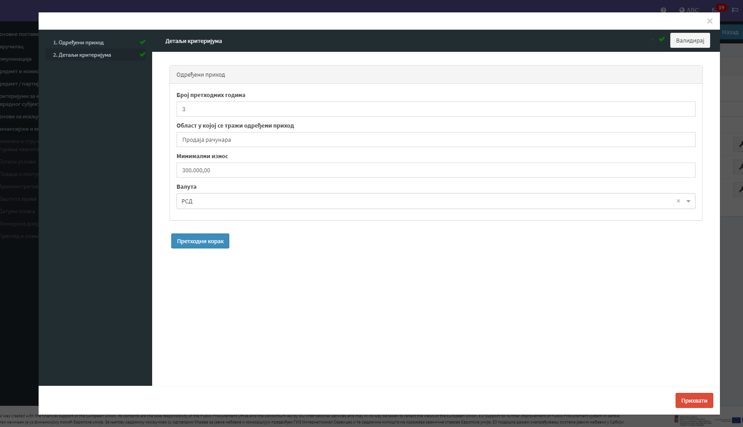

If used, the “Specific income” criterion must always be combined with the “Total income” criterion.

EXAMPLE 2 - Criterion entitled “Technical Persons or Bodies”
Subject matter of public procurement: Execution of works on the construction of the school building

Legal basis: Article 117 of the Law on Public Procurement - the contracting authority does not enter this information in this step, since it was entered during the determination of the criteria, so that the Portal is now created by itself.

Provision - In this part, the Portal enters the text of the stated legal provision.

Method of proving the fulfilment of the criteria - the contracting authority can choose between the offered evidence or to enter the evidence proving the stated criterion.

Example when the contracting authority determines the proof itself:
The bidder proves the fulfilment of this criterion by submitting licenses of responsible contractors and evidence in terms of experience (confirmations of contracting authorities, employment contracts, etc.)

Statement on fulfilment of criteria: question to the economic operator / requested data - in this part the Portal itself enters the question to the economic operator

Examples:
The stated criterion implies that the bidder has hired responsible contractors, holders of the following licences:
- Electrician, license XXX, with at least 5 years of experience in performing electrical work
- Plumber, YYY license, with at least 10 years of experience in performing plumbing work.

Criteria details - in this step the contracting authority states the data it requires from the bidder to meet this criterion. For each responsible contractor, the contracting authority enters the following data:

Examples:
Technical person: Responsible contractor
- Condition 1 - License XXX and at least 5 years of experience in performing electrical work
- Condition 2 - YYY licence and at least 10 years of experience in performing plumbing work

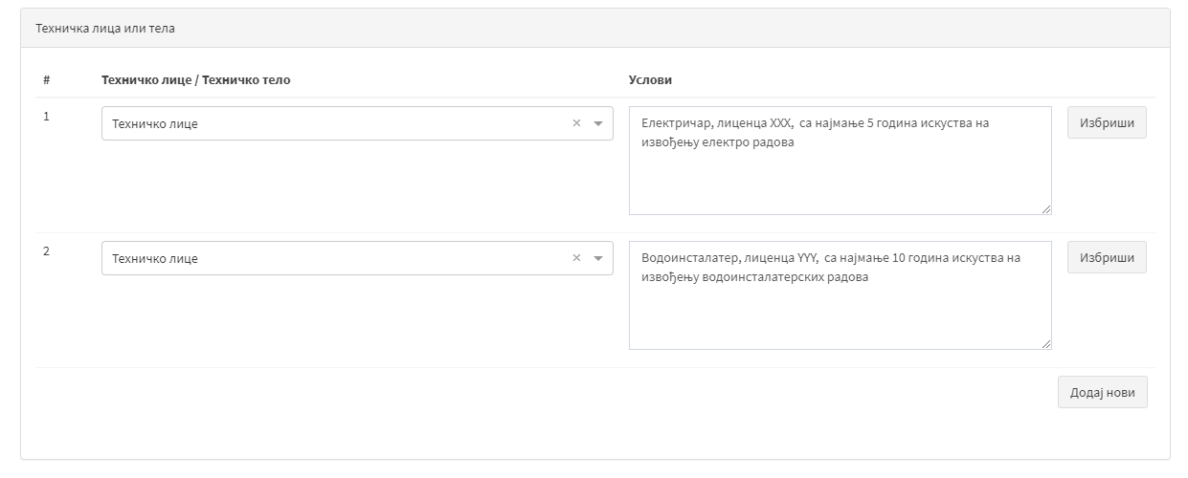

EXAMPLE 3 - The criterion “The bidder has not operated at a loss in the last 3 financial years”, is stated within the criterion “Financial indicators”, which is within the criterion “Financial and economic capacity”.

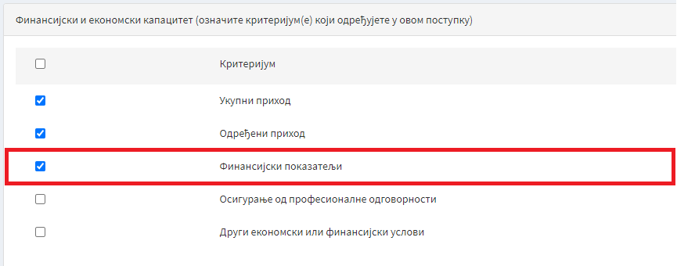

Legal basis - Article 116, paragraph 1, item 2) of the Law on Public Procurement - the contracting authority does not enter this information in this step, since it was entered during the determination of the criteria, so that the Portal is now created by itself.

Provision - In this part, the Portal enters the text of the stated legal provision.

Method of proving the fulfilment of the criteria - the contracting authority can choose between the offered evidence or to enter the evidence proving the stated criterion.

Example when the contracting authority determines the proof itself:
The bidder proves the fulfilment of this criterion by submitting financial statements for the period of the last 3 financial years for which the bidder submitted the final invoice or checking the fulfilment of the criteria by inspecting publicly published official data on the website of the Business Registers Agency.

Statement on fulfilment of criteria: question to the economic operator / requested data - in this part the Portal itself enters the question to the economic operator

Criteria details - in this step the contracting authority states the data it requires from the bidder to meet this criterion.

Examples:

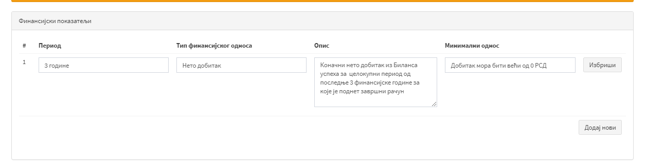

EXAMPLE 4 - The criterion “The bidder was not blocked in the last 6 months before the deadline for submission of bids” is stated within the criterion “Other economic or financial conditions”, which is within the criterion “Financial and economic capacity”.

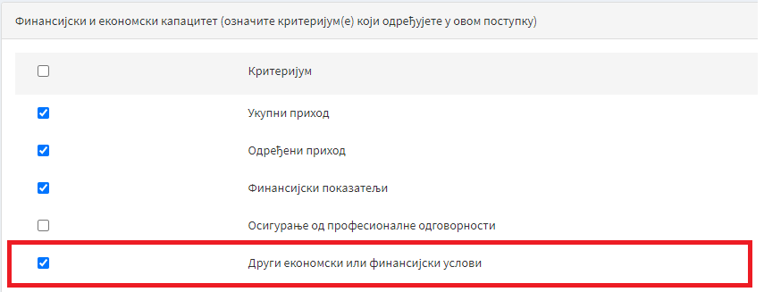

Legal basis: Article 116, paragraph 1 of the Law on Public Procurement - the contracting authority does not enter this information in this step, since it was entered during the determination of the criteria, so that the Portal is now created by itself.

Provision - In this part, the Portal enters the text of the stated legal provision.

Method of proving the fulfilment of the criteria - the contracting authority can choose between the offered evidence or to enter the evidence proving the stated criterion.

Example when the contracting authority determines the proof itself:
The bidder proves the fulfilment of this criterion by submitting the report of the National Bank of Serbia on account blockages or checking the fulfilment of the criteria by inspecting the publicly published official data on the website of the National Bank of Serbia.

Statement on fulfilment of criteria: question to the economic operator / requested data - in this part the Portal itself enters the question to the economic operator

Criteria details - in this step the contracting authority states the data it requires from the bidder to meet this criterion.

Examples:

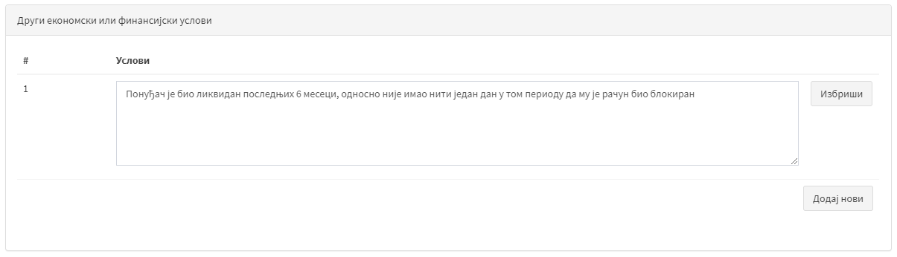

EXAMPLE 5 - Criterion: “Technical and professional capacity” - “Technical means and measures for quality assurance”.

Legal basis - Article 124, paragraph 1, item 4) of the Law on Public Procurement - the contracting authority does not enter this information in this step, since it was entered during the determination of the criteria, so that the Portal is now created by itself.

Provision - In this part, the Portal enters the text of the stated legal provision.

Method of proving the fulfilment of the criteria - the contracting authority can choose between the offered evidence or to enter the evidence proving the stated criterion.

Example when the contracting authority determines the proof itself:
The bidder proves the fulfilment of this criterion by submitting proof of the legal basis for the use of warehouse space (purchase agreement, lease agreement, cadastral excerpt or other appropriate evidence).

Statement on fulfilment of criteria: question to the economic operator / requested data - in this part the Portal itself enters the question to the economic operator

Examples:
The bidder meets this criterion if it has a warehouse space of at least 200 m2.

Details of the criteria - in this step the contracting authority states the data it requires from the economic operator within the specified criteria

Examples:

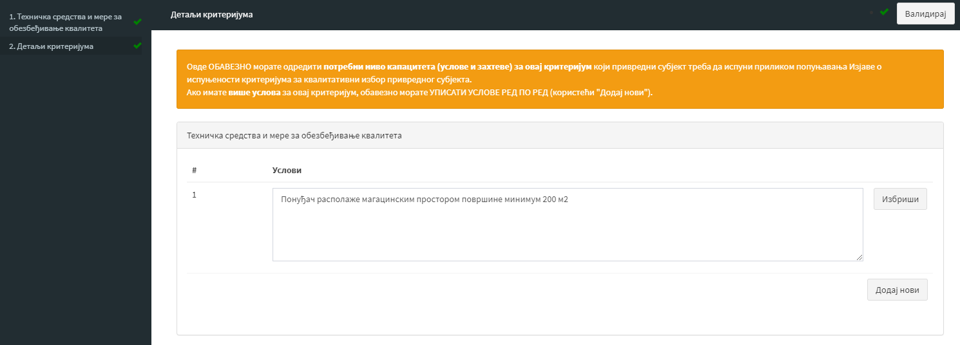

- CONTRACT AWARD CRITERIA

I. INTRODUCTION

In the public procurement procedure, the contracting authority awards the contract to the most economically advantageous bid, which it determines on the basis of one of the following criteria:
- prices or
- cost (applying the principle of cost efficiency) or
- price-quality ratio or
- cost-quality ratio.

The contracting authority is obliged to determine in the tender documentation the criteria for the award of the public procurement contract.

II. PREPARATION

During the preparation of the tender documentation for a specific public procurement procedure, the contracting authority on the Portal, in part 5 - Subject matter / lot, states the necessary data in five points, as follows:
- Basic information about the subject matter / lot.
- Contract award criteria
- Description
- Documents required in the bid / application
- Subject matter / lot documentation
Within point 2 - Criteria for contract award, the contracting authority through the Portal lists two groups of data, as follows:
- Award criteria,
- Procurement requirements, which the contracting authority may specify as reserve criteria.

A defined contract award criterion cannot be specified as a procurement request.

The procurement request is data that can be expressed numerically and which is important for the conclusion of the contract. For example, as a purchase request, a payment deadline, warranty period, etc. can be determined.

A defined award criterion cannot be specified as a reserve criterion.

The draw is not a reserve criterion and the contracting authority is not obliged to provide it with the tender documentation, but it is a way to award the contract pursuant to Article 144, paragraph 6 of the Law, if there are two or more bids that are equally ranked after applying the reserve criteria.

In the part of award criteria, the contracting authority selects the criteria according to the drop-down menu: price or cost by applying the principle of cost efficiency or price and quality criterion or cost criterion and quality criterion.
In case it has not determined exclusively the price as a criterion, the ordering party further expresses the numerical value of each individual element that values ​​(for example: price - 80 weights, warranty period - 20 weights).
After selecting the criteria for awarding the contract in a specific public procurement, the contracting authority shall also select the method of ranking acceptable bids (except for the price criterion), as follows:
- manual ranking or
- automatic ranking.

In case the contracting authority decides for “automatic ranking” as a way of ranking acceptable bids, the Portal will automatically create a part of the tender documentation called - the criteria for awarding the contract, based on data previously entered by the contracting authority. In case the contracting authority has decided on "manual ranking", it is necessary to previously independently prepare a part of the tender documentation called - the criteria for awarding the contract, and to read it in the prescribed order.
In the part Procurement requirements / reserve criteria, the contracting authority states the procurement requirements (one or more of them) and specifically states whether the stated procurement request will be used as a reserve criterion for contract award.

In the event that the contracting authority intends to use the bid validity period and the payment deadline and method of payment as reserve criteria, one or both data shall be stated in two places:
- in procurement requirements and
- in separate fields that will be presented in the next steps of preparation of tender documentation.
In this case, the contracting authority determines the manner of applying the reserve criteria in a situation where there are two or more bids that are equal after the application of the criteria.

The method of payment can be determined as a purchase request, and even as a reserve criterion, only if it can be expressed numerically. For example, the contracting authority has provided for payment in instillments, so it asks the bidder to state the number of instalments for the payment of the agreed value.

- BID FORM
I. INTRODUCTION
The bid form is one of the forms of documents that make up the bid.
The content of this form is prescribed by the Rulebook on the content of tender documentation in public procurement procedures (“Official Gazette of the Republic of Serbia”, No. 93/20, hereinafter referred to as: the Rulebook).
The contracting authority does not attach the bid form to the tender documentation and the said form does not represent a special part of the tender documentation. For this reason, interested parties cannot download the bid form as an integral part of the tender documentation.
When preparing the tender documentation and requesting certain data to be provided by the bidders (price, delivery deadline, etc.), the contracting authority automatically defines the content of the future bid form, which will thus be created by the bidder only during bid preparation. During the preparation of their bid, the bidders state the data requested from them by the ordering party (price, delivery deadline, etc.) and create a bid form that they submit within their e-bid.
II. COMPLETING THE FORM
- During the preparation of the tender documentation, the contracting authority does not compile a special bid form, but enters the data, which make up the content of the Bid Form, in the fields provided for that purpose on the Portal.

- In order to fill in the bid form, the bidder enters data on the Portal, based on the data defined by the contracting authority during the preparation of the public procurement procedure.
The bidder only enters the requested data on the Portal, and the bid form is not signed, verified or scanned.

- After entering the required data, the bidder creates a document of the bid form on the Portal as part of the preparation of the e-bid, based on the data entered by the contracting authority into the Portal.

The bidder creates the bid form by clicking on the field called “create”.

- The bid form thus created becomes an integral part of the e-bid and as such is submitted as an integral part of the bid that will be available to the contracting authority upon opening the bid.

- OFFERED PRICE STRUCTURE FORM
I. INTRODUCTION

The bid structure form is one of the sample bid documents.
The content of this form is prescribed by the Rulebook.
When preparing the tender documentation, the contracting authority also loads this form, which he previously prepared on his computer, i.e., the contracting authority does not prepare this form via the Portal.
The bidder fills in and loads the specified form within its e-bid.

II. PREPARATION AND PUBLICATION OF THE FORM

- The contracting authority prepares and publishes the form in WORD or EXCEL format, within the tender documentation.
It is recommended to use the EXCEL format for easier computational control.

If the EXCEL format is not used, for the purpose of calculation control, the contracting authority would have to rewrite all the data in the new EXCEL format, which may cause an error when copying or manually calculating, with the possibility of not noticing a calculation error.

The form does not contain a place for stamp and signature, since the contracting authority cannot ask the bidder to sign and certify the form, and to scan it signed and certified and load it as part of the bid.

- When preparing the procedure within the steps entitled “Documents required in the bid/application”, the contracting authority marks the field entitled “Offered price structure form”.
If the contracting authority does not mark the specified field, the bidders will not know that the form of the structure of the offered price is an integral part of the tender documentation, and they will neither fill in nor submit it within their e-bid.

The form of the structure of the offered price is not an obligatory part of the tender documentation only in two cases:
- If all elements of the form of the offered price structure are contained in the offer form (Article 12, paragraph 2 of the Rulebook) and
- If the contracting authority requires or allows tenders to be submitted in the form of electronic catalogues or that tenders contain electronic catalogues, and there are no other costs included in the price (Article 12, paragraph 3 of the Rulebook).

III. COMPLETING AND LOADING THE FORM

- The bidder fills in the prepared form.
The bidder only enters the required data in the form, and does not sign or certify the form.

- The bidder loads the completed form within the e-bid.
The bidder does not have to scan the completed form and load it, but only loads it.

- CONTRACT MODEL

I. INTRODUCTION
The model contract is an obligatory part of the tender documentation, prescribed by the Rulebook.
In this regard, these guidelines help contracting authorities to prepare and load the contract model in all respects in accordance with the Law on Public Procurement and the Rulebook.
Also, these guidelines provide an explanation of how bidders, when preparing bids, agree with the content of the contract model, which the contracting authority has envisaged as an integral part of the tender documentation.
These guidelines also apply to the framework agreement model.

II. PREPARATION AND PUBLICATION OF THE CONTRACT MODEL

- The contracting authority prepares a model contract on its computer.

- The contract model, which it prepared on its computer, is loaded by the contracting authority either within the step “Tender documentation” at the level of the entire procedure or within the step called “Subject matter / lot documents”.

- When preparing the public procurement procedure, in the section entitled “Documents required in the bid / application”, the contracting authority indicates the model contract only if it is necessary for bidders to fill in the contract model, after which bidders load it within their e-bid, or if there are data in the model contract for which the contracting authority expects the bidder to fill in, which will not be contained in other parts of the bid that the bidder will submit.

- In the instructions for compiling the bid, the contracting authority does not ask the bidder to sign the contract model, but, if necessary, to fill in the contract model and to load the completed contract model within its e-bid.

The contracting authority always downloads the model contract from its computer, i.e., this document cannot be created by the Portal.

III. ACCEPTANCE AND COMPLETION OF THE CONTRACT MODEL

- When entering data in order to create the Bid Form, the bidders mark the field entitled “We are familiar with the content and accept the contract model”.

- The bidder loads the completed model contract within its e-bid, only if the contracting authority has requested it in the tender documentation.

The bidder does not enter the date, stamp and signature in the model contract.

- OTHER DOCUMENTS
I. INTRODUCTION
Pursuant to the provisions of the Rulebook, the tender documentation may contain other information necessary for the preparation and submission of bids.
In this regard, these guidelines provide an explanation of how the contracting authority prepares and publishes other documents that make up the content of the tender documentation, as well as how bidders submit it within their e-bid.

II. PREPARATION AND PUBLICATION OF OTHER DOCUMENTS

- The contracting authority prepares another document on its computer.

- Within the steps entitled “Documents required in the bid/application”, the contracting authority marks the field entitled “Other document”.

- As part of the same step, in the section entitled “Description of other documents”, the contracting authority states exactly which other documents it requires bidders to submit as part of their e-bids.

Example: In this section, the contracting authority may ask the bidder to submit a Site Visit Statement as part of its e-tender.

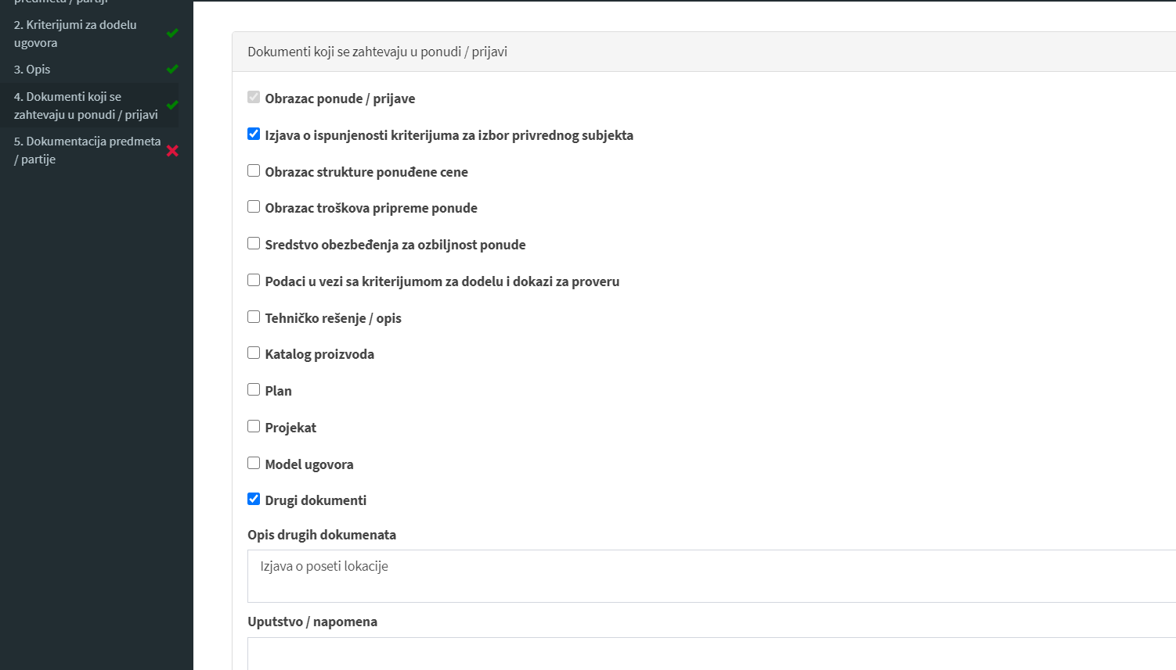

- As part of the tender documentation, within the part that best corresponds to the type of document required, the contracting authority loads the document he prepared on its computer.

Example: The statement on the site visit is loaded by the contracting authority within the part "General part - data on the subject matter of procurement".

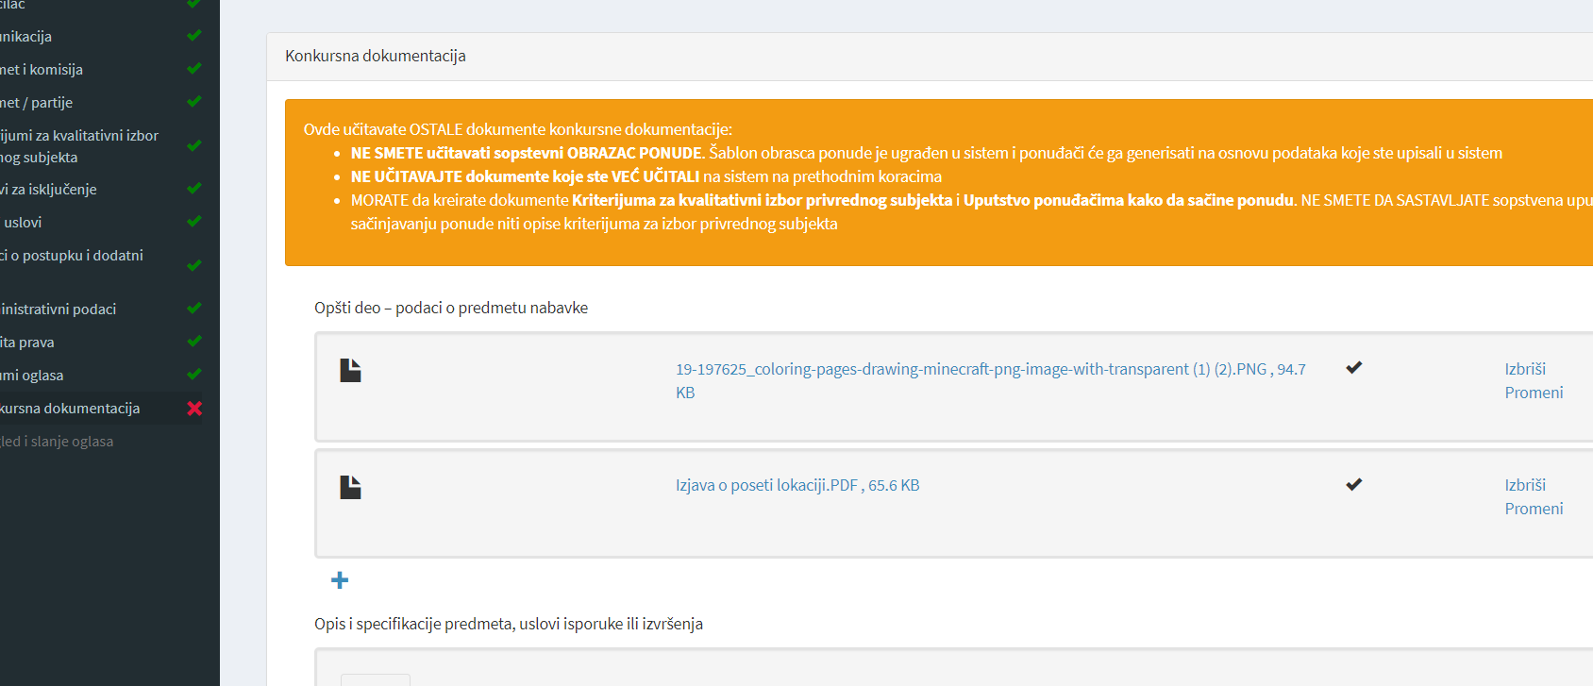

III. COMPLETING AND LOADING OTHER DOCUMENTS

- The bidder takes over another document published by the contracting authority within the tender documentation.

- The bidder fills in the downloaded document in the prescribed manner, and loads the completed document within his e-offer, in the section “Documents in the offer/application”.

The bidder only enters the requested data in another document, and it does not sign or certify.

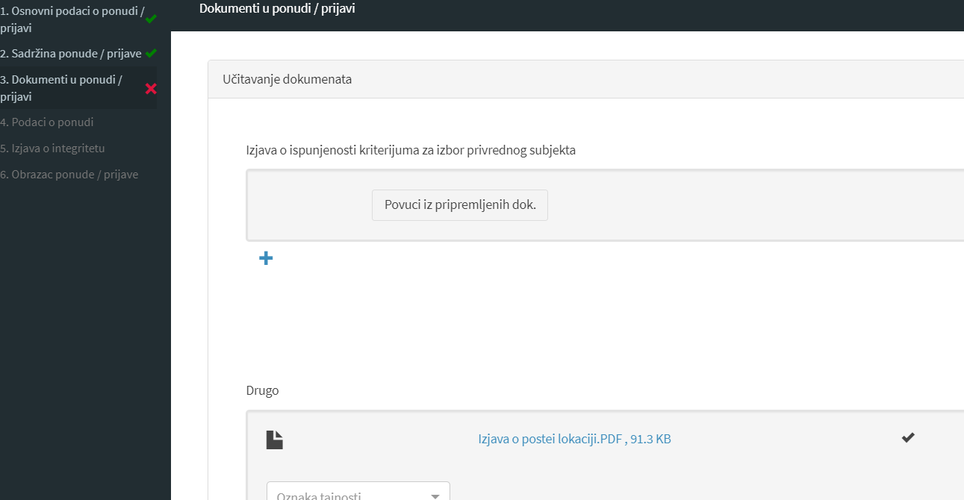

- CONCLUDING REMARKS

The law and bylaws for the implementation of this law have been in force since 1 July 2020. From that date, the contracting authorities are obliged to conduct all public procurement procedures in accordance with the provisions of the Law, through the new Portal. All bidders also submit their bids for participation in the above procedures electronically, i.e., through the Portal. Namely, Article 45 of the Law stipulates that communication and exchange of data in the public procurement procedure is performed by electronic means on the Public Procurement Portal, in accordance with this Article of the Law and Instruction for using the Public Procurement Portal (“Official Gazette”, No. 93/20, hereinafter referred to as: Instruction).
In this regard, the Office has prepared the Instruction, which is also published on the website of the Office in the section “regulations/bylaws”. This guide regulates issues related to, among other things, the forms of allowed files, how to create a user account, how to provide support to users of the Portal, technical conditions for using the Portal, dealing with the unavailability of the Portal and other issues related to using the Portal.
In addition to this manual, the Portal itself contains instructions for users of the Portal. In addition to general information about the Portal, this manual contains detailed instructions on how to work on the Portal, both on the part of the contracting authority and the bidder. It covers all areas from registration and public procurement plans, through the implementation of all phases of the public procurement procedure to statistical reports. The manual also contains video instructions, forms, as well as frequently asked questions.
Important information regarding the manner of work on the Portal, the Office will continue to publish on the front page of the Portal.
With this in mind, these guidelines were made in order to provide assistance to contracting authorities and economic operators in the implementation, i.e., participation in public procurement procedures.

