GUIDELINES FOR APPLYING THE NEGOTIATED PROCEDURE WITHOUT PUBLISHING A PUBLIC INVITATION

TABLE OF CONTENTS

INTRODUCTION 2
PREPARATION FOR THE NEGOTIATION PROCEDURE 3
PREPARATION OF THE NOTICE ON THE CONDUCT OF THE NEGOTIATED PROCEDURE 4
PREPARATION OF INVITATION FOR NEGOTIATIONS AND TENDER DOCUMENTATION 7
INVITATION OF ECONOMIC OPERATORS 9
SUBMITTING A BID 12
NEGOTIATION 13
PUBLICATION OF THE CONTRACT AWARD DECISION/SUSPENSION OF THE PROCEDURE 21
PUBLICATION OF NOTICE OF CONTRACT AWARD, SUSPENSION OF PROCEEDINGS OR ANNULMENT OF PROCEEDINGS 22

INTRODUCTION

The Public Procurement Office (hereinafter referred to as: the Office), in accordance with authorisations regulated by Article 179 of the Law on Public Procurement (“Official Gazette of the Republic of Serbia”, No. 91/19, hereinafter referred to as: the Law), inter alia, also prepares guidelines in the field of public procurements.

Article 61 of the Law prescribes the grounds, i.e., the conditions that must be met in order for the contracting authority to be able to conduct a negotiated procedure without publishing a public invitation.

Article 62 of the regulates the actions of the contracting authority during the implementation of this type of public procurement procedure.

Provisions of Article 62 of the Law stipulate that the minimum requirements from the tender documentation cannot be negotiated, that the contracting authority is obliged to keep a record of negotiations, and that the contracting authority is obliged to ensure equal treatment among all bidders, and must not provide information in a discriminatory manner, which certain tenderers might tend to make use of at the expense of the others.

The manner in which the contracting authority will conduct negotiations depends on a number of factors and circumstances of the specific case, such as circumstances related to the subject matter of public procurement, number of economic operators being negotiated, whether the bidder is a domestic or foreign economic operator, etc. In addition, conducting a negotiated procedure without publishing a public invitation by electronic means on the Public Procurement Portal is a great novelty for both contracting authorities and bidders and opens up a number of issues that need to be resolved in order for the public procurement procedure to be successfully conducted.

In view of the above, these guidelines aim to assist contracting authorities in creating good practice in conducting a negotiated procedure without publishing a public invitation.

PREPARATION FOR THE NEGOTIATION PROCEDURE

In preparation for the implementation of the negotiation procedure, the contracting authority undertakes two groups of activities. One group of activities takes place outside the Public Procurement Portal, while the other takes place on the Portal itself.

By the nature of things, before approaching the development of a public procurement plan and deciding to conduct a negotiated procedure for a particular public procurement without publishing a public invitation, the contracting authority conducts market research. Market research is not only aimed at collecting information that is important for determining the estimated value of public procurement and information about economic operators that could perform the public procurement, but during the same the contracting authority may find out that there are several solutions on the market that can to meet his needs for a particular subject of procurement, which represent an appropriate alternative or replacement, and in accordance with this knowledge will consider the possibility of planning that public procurement in some other type of procedure.

During the preparation, the contracting authority considers the existence of grounds for the application of the negotiated procedure, i.e., examines whether all the conditions prescribed by law for its application are met.

The second group of activities within the preparation for the implementation of the procedure takes place on the Public Procurement Portal itself. The contracting authority shall enter in the public procurement plan data on the public procurement that it will conduct in the negotiated procedure without publishing a public invitation.

Pursuant to Article 88, paragraph 7 of the Law, in exceptional cases, when public procurement cannot be planned in advance or due to urgency, the contracting authority may initiate a public procurement procedure even if the procurement is not provided in the public procurement plan.

During the preparation for the implementation of the negotiation procedure, the contracting authority shall make a decision on the implementation of the procedure, which shall contain the elements prescribed by Article 91 of the Law.

PREPARATION OF THE NOTICE ON THE CONDUCT OF THE NEGOTIATED PROCEDURE

In addition to the data that the contracting authority enters when conducting other types of public procurement procedures, in this type of procedure, the contracting authority on the Public Procurement Portal selects the legal basis for conducting the negotiation procedure from the offered bases. All grounds for the application of the negotiation procedure prescribed by Article 61 of the Law are contained on the Portal.

During the preparation of the notification on the implementation of the negotiated procedure without publishing a public invitation, the contracting authority shall enter the explanation of the application of the negotiated procedure in the appropriate field on the Public Procurement Portal. This explanation will be an integral part of the announcement, and it is very important that the contracting authority explains in a clear and understandable way the reasons for awarding the public procurement contract in the negotiated procedure without publishing a public invitation.

Based on the data entered on the Public Procurement Portal, a notification on the implementation of the negotiation procedure is created, which the contracting authority sends for publication.

After the publication of the notice on the implementation of the negotiation procedure without the publication of the public invitation, the contracting authority may correct the published announcement, if there is a need for that. The contracting authority may correct this advertisement until invitations to submit bids are sent to economic operators.

Also, after the publication of the notice on the implementation of the negotiation procedure without publishing a public invitation, and before the invitation for negotiations is sent to economic operators, the contracting authority may withdraw from the implementation of that procedure.

Submission of explanations and documentation to the Public Procurement Office

2) in the case of conducting a negotiated procedure without publishing a public invitation referred to in Article 61, paragraph 1, items 1) and 2) of the Law, the contracting authority at this step means that it submits to the Public Procurement Office an explanation and documentation regarding the reasons that justify the implementation of this type of procedure.
The contracting authority prepares documentation on its computer regarding the reasons that justify the application of this type of public procurement procedure, loads it and submits it to the Public Procurement Office via the Public Procurement Portal. (Figure 1)

(Figure 1)
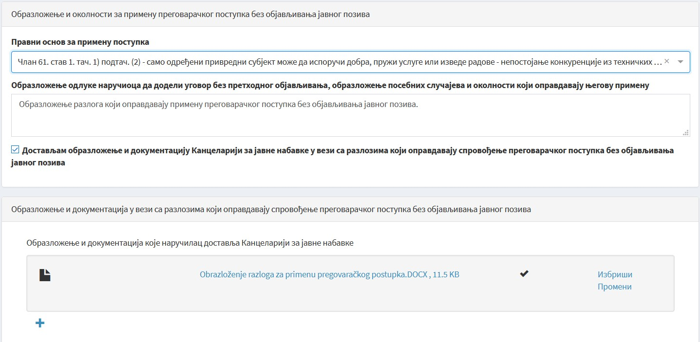

In accordance with Article 45, paragraph 2, item 9) of the Law, communication and exchange of data by electronic means on the Public Procurement Portal is considered to be communication between the Public Procurement Office and procuring entities in connection with Article 62, para. 2 and 3 of this law.
The contracting authority does not submit the explanation and documentation regarding the reasons that justify the application of this type of procedure to the Public Procurement Office by mail, i.e., by handing it over to the office of the Joint Services Administration, but exclusively through the Public Procurement Portal.

The Public Procurement Office is obliged to examine the validity of the application of the negotiated procedure within ten days from the day of receipt of the explanation and documentation and to submit an opinion to the contracting authority through the Public Procurement Portal.
If the submitted explanation and documentation do not contain all the data necessary to assess the merits of the negotiation procedure, the Public Procurement Office will request the contracting authority to submit additional documentation through the Portal.
The contracting authority receives a notification on the response of the Public Procurement Office in its mailbox on the Public Procurement Portal and takes over the opinion.

The provisions of the law do not stipulate that the examination of the existence of grounds for the application of the negotiated procedure retains further activities in the procedure. Therefore, the contracting authority is not obliged to wait for the submission of the opinion by the Public Procurement Office, but can continue with further activities in the public procurement procedure (inviting bidders, etc.). However, as the Public Procurement Office may give an opinion that in this case the application of the negotiated procedure without publishing a public invitation is not grounded, it is recommended that the contracting authority, if possible, wait for the Public Procurement Office’s opinion before proceeding with further activities.

PREPARATION OF INVITATION FOR NEGOTIATIONS AND TENDER DOCUMENTATION

The next step in conducting the negotiation procedure without announcing a public invitation is to invite economic operators.

Article 62, paragraph 4 of the Law stipulates that after the publication of the notice on the implementation of the negotiation procedure, the contracting authority is obliged to send a written invitation to negotiate to one or, if possible, to a larger number of economic operators.

Article 62, paragraph 5 of the Law stipulates that the contracting authority is obliged to submit tender documentation along with the invitation to negotiate, which determines the criteria for qualitative selection of economic operator and criteria for awarding the contract, the subject of procurement with a description of needs and required characteristics stating which elements of the description of needs and required characteristics of goods, services or works are the minimum requirements that bids need to meet, as well as elements of the contract to be negotiated and the manner of negotiation.

Inviting bidders and submitting tender documents is done through the Public Procurement Portal, in accordance with the provisions of Article 45 of the Law.

On the Public Procurement Portal, the contracting authority begins this step by selecting the field “Procedures” > “Invitation of economic operators”

The process of preparation and submission of invitations to negotiations is not separate from the process of preparation and submission of tender documentation. In the process of preparation of the invitation to negotiations and tender documentation, the contracting authority enters data on the specific public procurement procedure on the Public Procurement Portal in a predetermined order. Based on the entered data, the Public Procurement Portal automatically forms certain parts of the tender documentation (criteria for awarding contracts only in the case of automatic ranking, criteria for qualitative selection of economic operators and instructions to bidders on how to prepare a bid). Other parts of the tender documentation are previously prepared by the contracting authority and uploaded to the Public Procurement Portal in a predefined order.

Guidelines for the preparation of tender documentation and the preparation of e-bids on the Public Procurement Portal

When preparing the tender documentation for this type of public procurement procedure, the contracting authority should pay special attention to defining the elements of the contract to be negotiated and the manner of negotiation from Article 7 of the Rulebook on the content of tender documentation in public procurement procedures (“Official Gazette of the Republic of Serbia”, No. 21/21).

The elements of the contract to be negotiated will be determined by the contracting authority depending on the circumstances of the specific public procurement. The price is usually negotiated, but it can also be other elements of the future public procurement contract, such as the delivery deadline, i.e., the deadline for fulfilling the contractual obligation, the characteristics of goods, services or works above the minimum requirements, etc.

The provisions of the Law do not fully regulate the issues related to the manner in which the contracting authority will conduct the negotiation process.

The contracting authority will choose one of several possible ways to conduct negotiations, depending on the circumstances of the specific public procurement, i.e., depending on whether the invitation to negotiate is sent to one or more economic operators, depending on whether the bidder's representatives can attend negotiations at the premises of the contracting authority or not, as well as depending on a number of other circumstances of the case.

In this part of the tender documentation, the contracting authority will specifically regulate the following issues:

- whether the negotiations will be conducted through the Public Procurement Portal or outside the Portal;
- in case the negotiations take place outside the Public Procurement Portal, will it be conducted orally, i.e., will a meeting of the representatives of the contracting authority and the bidder be organised for that purpose, or will the negotiations take place in writing (e.g., by e-mail);
- how many phases, i.e., how many rounds of negotiations the contracting authority plans to conduct before inviting bidders to submit final bids;
- when several bidders participate in the negotiation procedure, whether the negotiations will take place with the simultaneous presence and participation of all bidders or with each bidder individually.

This part of the tender documentation should contain all the notes that are important for the actions of the contracting authority and the bidder during the negotiation procedure. In this part of the tender documentation, the contracting authority should indicate the following to the bidders:
- - that after the negotiations through the Public Procurement Portal, they will be invited to submit their final bids;
- - that they are obliged to submit their amended or final bids through the Public Procurement Portal;
- - that, if they do not enter into negotiations, their initial bids will be considered final;
- - that, if the bidder does not submit a new bid in the next phase of negotiations, the final bid will be considered the previously submitted bid through the Public Procurement Portal.

INVITATION OF ECONOMIC OPERATORS
SELECTION OF ECONOMIC OPERATORS AND SENDING INVITATIONS

After loading the parts of the tender documentation that he prepared on his computer, the contracting authority proceeds to the next step - Inviting economic operators (Figure 2)

Figure 2

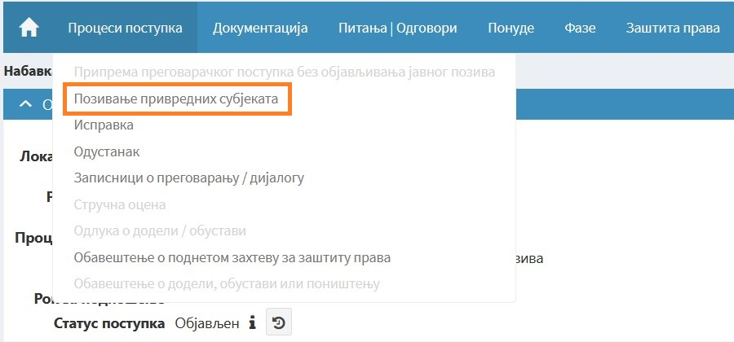

At this step, the contracting authority selects the economic operator/operators to which it will send invitations. The economic operator to which the invitation is addressed must first be registered on the Public Procurement Portal (Figures 3 and 4).
Figure 3
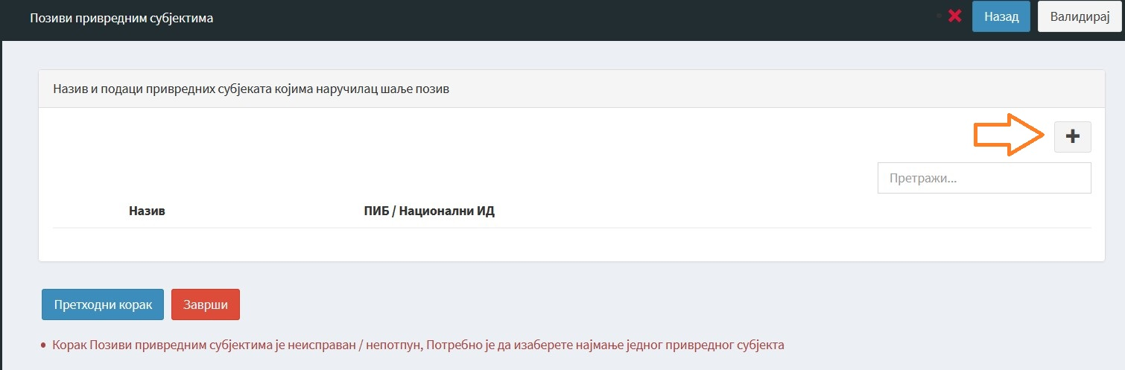
Figure 4
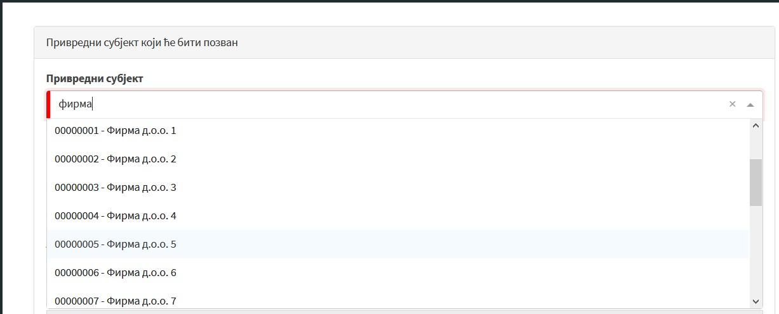

Based on the data entered on the Public Procurement Portal, a call for bids is created.

If the contracting authority invites more than one economic operator, the steps shown in Figures 3 and 4 must be repeated for each of the economic operators it invites.

In accordance with the provisions of the Law, the tender documentation in the negotiated procedure without publishing a public invitation is not published on the Public Procurement Portal. The contracting authority shall send invitations and tender documentation to the economic operator/operators through the Public Procurement Portal, so that the tender documentation is available only to economic operators to which the contracting authority sent invitations.

Economic operators to which invitations to submit bids have been sent will receive an invitation to submit bids and a link to the published procedure on which the tender documentation is located in their mailbox.

Note: In accordance with Article 91, paragraph 4 of the Law, the negotiated procedure without publishing a public invitation is considered initiated on the day of sending the invitation to tender. If the economic operator is not registered on the Public Procurement Portal, the contracting authority may invite it to register. If the economic operator is not registered on the Public Procurement Portal and does not want to register, and as a result the invitation cannot be sent, the contracting authority does not make a decision to suspend the procedure, because in that case the procedure is not considered initiated.
In such situations, the contracting authority on the Public Procurement Portal begins this step by selecting the field "Procedures", and then marks “Withdrawal”.

The contracting authority shall publish a Correction on the Public Procurement Portal - a notice of changes or additional information, stating the reason for withdrawing from the negotiation procedure.

An economic operator that is interested in participating in the negotiation procedure without publishing a public invitation, and to which no invitation has been sent by the contracting authority, may send a request for participation in the procedure to the contracting authority through the Public Procurement Portal.
In accordance with the principle of ensuring competition and non-discrimination, the contracting authority is obliged to enable participation in the negotiation procedure to any interested economic operator, and to send the invitation to submit bids in the manner described above to the economic operator that submitted a request to participate in the procedure.

After the invitation of economic operators, the contracting authority no longer has the opportunity to withdraw from the negotiation procedure without publishing a public invitation in the manner described above, by publishing a Correction - notice of changes or additional information.
Namely, in accordance with the provision of Article 91, paragraph 4 of the Law, the public procurement procedure is considered initiated on the day of sending the invitation to submit bids, and in case of withdrawal from further implementation of the procedure, the contracting authority should end it by issuing and publishing the conditions prescribed by Article 147 of the Law have been met.

SUBMITTING A BID

When preparing and sending a bid in a negotiated procedure without publishing a public invitation, the bidder acts in the same way as in other types of public procurement procedures.

Guidelines for the preparation of tender documentation and the preparation of e-bids on the Public Procurement Portal

PROCEDURE AFTER RECEIPT OF THE OFFER

After the deadline for submission of bids, the Public Procurement Portal opens the bids and creates the Minutes on the opening of bids.

On the Public Procurement Portal, contracting authorities are enabled to perform an expert evaluation of initial bids.
In the case when negotiations are conducted in several phases, the contracting authority is enabled to perform an expert evaluation of the bids received in that phase on the Public Procurement Portal, at the level of each phase.
If, after the conducted negotiations, the bidders submit their final bids through the Public Procurement Portal, the contracting authority will perform an expert evaluation of the final bids.

Based on the data from the submitted bids and in accordance with the instructions on the manner of negotiation contained in the tender documentation, the contracting authority decides whether to go to the next phase - Negotiation.

NEGOTIATION

As mentioned above, the negotiation process itself is not specifically regulated by the provisions of Article 62 of the Law, and the contracting authority is obliged to determine in the tender documentation the manner in which it will conduct the negotiation. In that sense, taking action on the Public Procurement Portal during the negotiation procedure differs depending on whether the negotiations are conducted through the Public Procurement Portal or outside the Portal.

Action in case of conducting negotiations outside the Public Procurement Portal

If the tender documentation stipulates that the negotiations will be conducted orally, i.e., that in order to negotiate the elements of the contract, one or more meetings of representatives of the contracting authority and bidders will be organised, after the opening of tenders and possible expert evaluation of initial tenders. to negotiations.

Invitation of bidders to negotiations is conducted through the Public Procurement Portal (Figure 5). The contracting authority will send an invitation for a meeting - negotiations, through its mailbox on the Public Procurement Portal, to the bidders who have submitted initial bids.

Figure 5
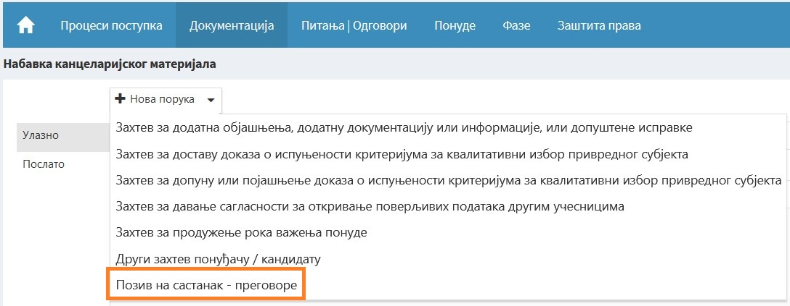

In the invitation to bidders, the contracting authority shall state the date and time of the negotiations.

Negotiation at the meeting is conducted in the manner specified in the tender documentation. During the negotiations, the contracting authority is obliged to ensure equal treatment of all bidders.

Also, in accordance with the provisions of Article 62, paragraph 7 of the Law, the contracting authority is obliged to keep a record of negotiations in which all data on the course of negotiations will be entered and state that the contracting authority informed the bidders that it will receive an invitation to submit a final bid. Although this is not explicitly prescribed by the provisions of the Law, the contracting authority shall submit a copy of the minutes of the negotiations to the present representatives of the bidders.

The contracting authority on the Public Procurement Portal within the field “Procedures” selects the field “Minutes of negotiations” and loads the minutes of negotiations that he prepared on its computer.
The minutes of the negotiations are not published.

When loading the minutes of negotiations, the contracting authority will enter data on the course of negotiations within the field “Brief description of the course of negotiations”, which will be an integral part of the Report on the procedure created on the Public Procurement Portal.

After the conducted negotiations, the contracting authority invites the bidder/bidders to submit their final bids through the Public Procurement Portal, i.e., bids that are the result of the conducted negotiations. (Figure 6)

Figure 6
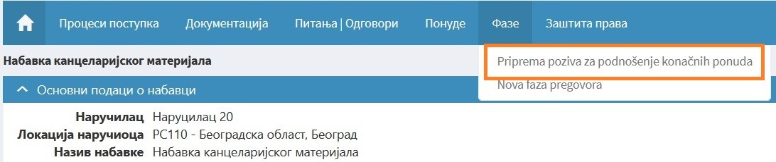

In order for the bids that were changed during the negotiations in relation to the initial ones to be taken into consideration and ranked, they must be sent through the Public Procurement Portal.

When inviting bidders to submit final bids, the contracting authority shall indicate which parts of the bid the bidders are submitting again.

After the expiration of the deadline for submission of final bids, the automatic opening of bids is carried out through the Public Procurement Portal and a record on the opening of final bids is formed.

Note:
The contracting authority on the Public Procurement Portal takes the same steps in the case when the negotiations were not conducted orally - at a meeting, for example if for the purpose of negotiations between the contracting authority and the bidder correspondence was conducted by e-mail.

After the expert evaluation of the bids, the contracting authority on the Public Procurement Portal in the navigation of the procedure, within the field “Procedure processes” selects the field “Decision on contract award” and makes a decision on contract award/termination of the procedure.

Acting in case of conducting negotiations through the Public Procurement Portal

If the tender documentation stipulates that negotiations will be conducted through the Public Procurement Portal, i.e., that one or more phases of negotiations will be conducted through the Public Procurement Portal in order to negotiate elements of the contract, the contracting authority will invite the bidder(s) to negotiate.

The contracting authority on the Public Procurement Portal in the navigation of the procedure selects the fields “Phases” > “New phase of negotiations” (Figure 7).

Figure 7
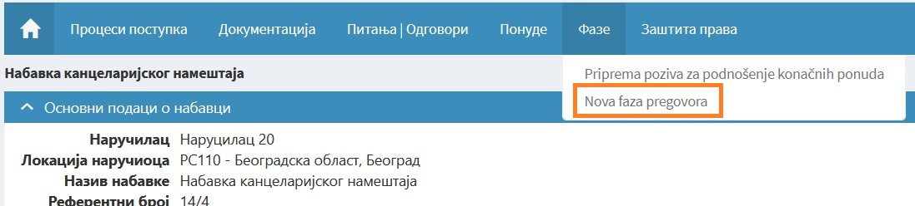

After that, a new workspace is opened on the Public Procurement Portal, at the level of the negotiation phase, and the contracting authority approaches the invitation of economic operators by inviting economic operators within that new workspace by selecting the fields “Procedures” > “Invitation of economic operators” (Figure 8).

Figure 8
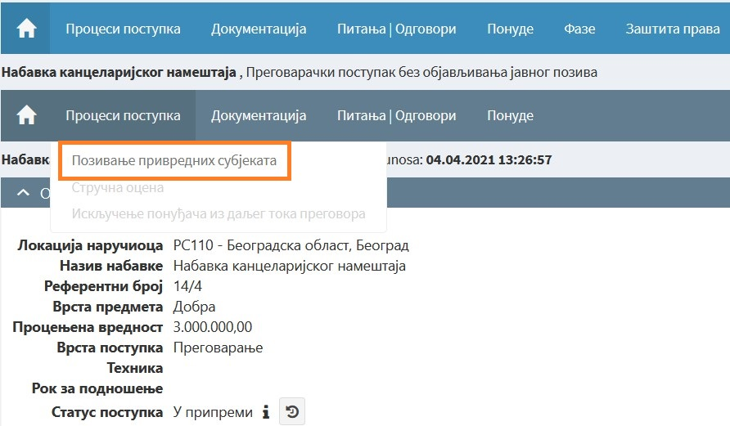

When inviting the bidder to the “New phase of negotiations”, the contracting authority requires the bidder to submit new bids and indicates which parts of the bid the bidders are submitting again.

The invitation should also contain a note that, if the bidders do not submit new bids, their previously submitted bids will be considered final.

Based on the received invitation, the bidders prepare new bids and send them through the Public Procurement Portal.

On the Public Procurement Portal, within the negotiation phase, the opening of new bids is carried out and a record on the opening of bids is created.

The bidder received a message that the opening of bids was carried out, with a link to the minutes of the opening of bids.

This part of the negotiation procedure - “New phase of negotiations” can be repeated several times, if the contracting authority has provided for it in the tender documentation.

When, after receiving new or amended bids, it finds that it has received a bid that meets its requirements and should be accepted, or when the number of negotiation phases specified in the tender documentation has been conducted, the contracting authority will perform an expert evaluation of bids at the phase level (Figure 9).

Figure 9
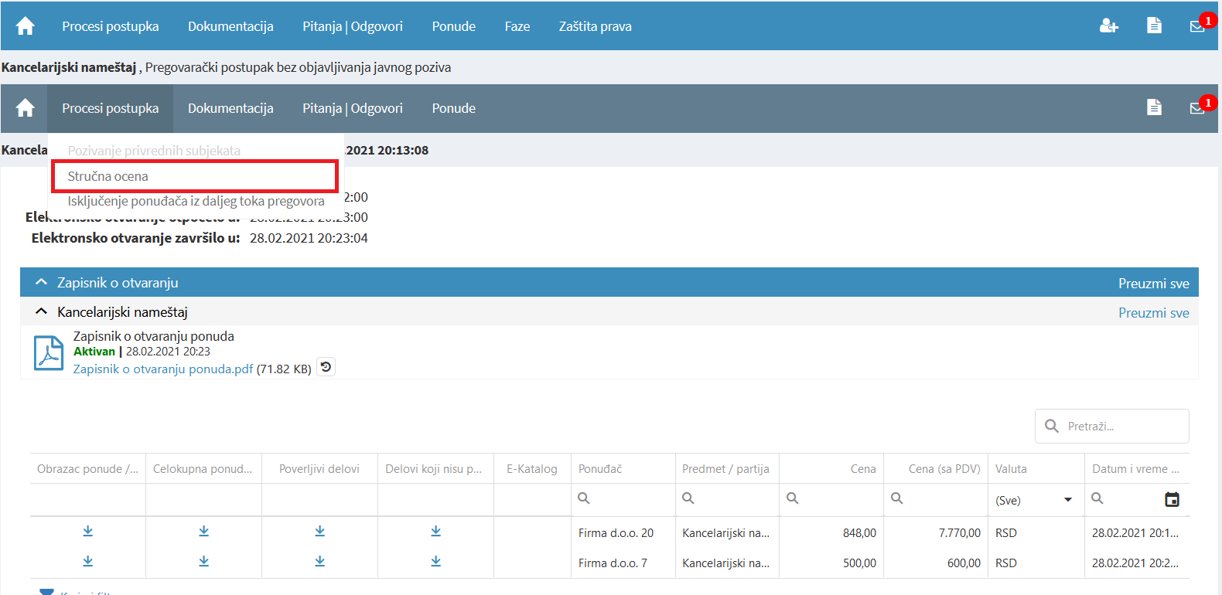

At the next step, the contracting authority on the Public Procurement Portal in the navigation of the procedure, within the field “Procedures”, selects the field “Minutes of negotiations” and loads the minutes of negotiations which it is obliged to keep in accordance with Article 62 of the Law and which it prepared on its computer (Figure 10).
The minutes of the negotiations are not published.

Figure 10
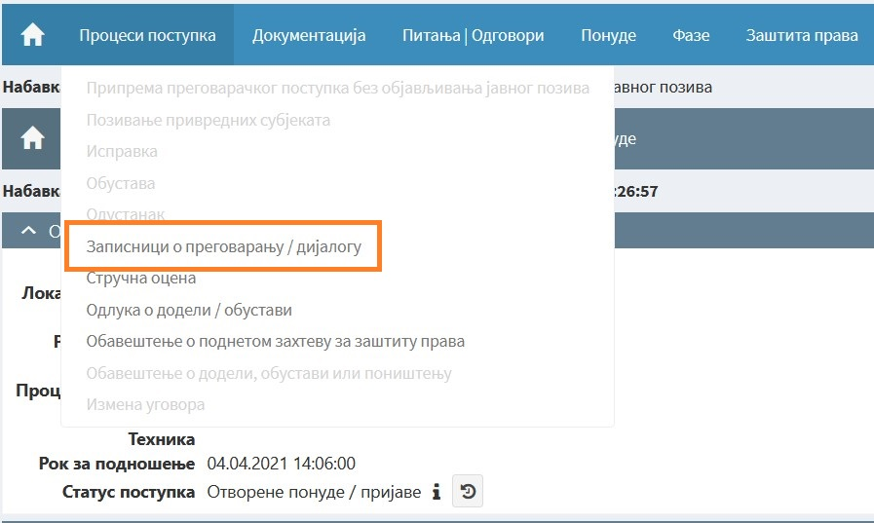

When loading the minutes of negotiations, the contracting authority will enter data on the course of negotiations within the field “Brief description of the course of negotiations”, which will be an integral part of the Report on the procedure created on the Public Procurement Portal (Figure 11).

Figure 11
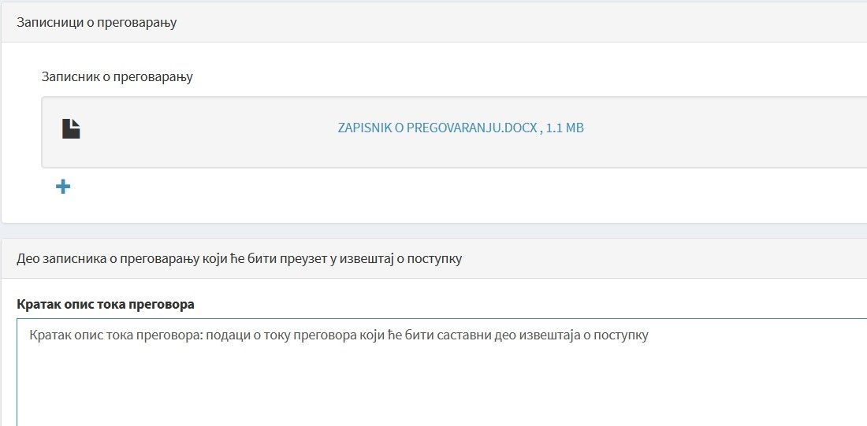
After that, the contracting authority on the Public Procurement Portal, also in the navigation of the procedure, within the field “Procedure processes” selects the field “Decision on contract award” and makes a decision on contract award/termination of the procedure. (Figure 12)

Figure 12
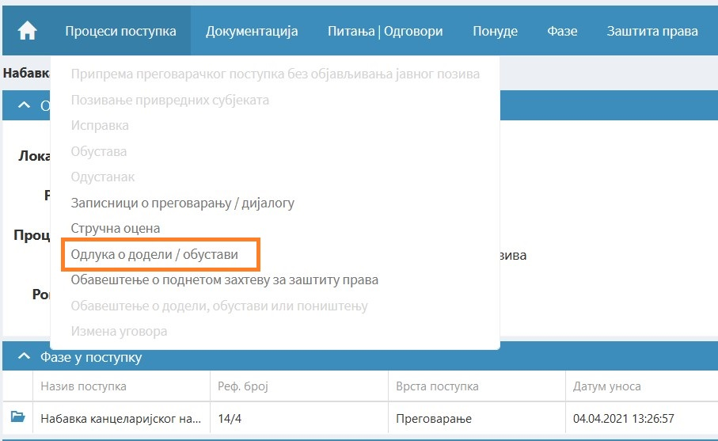
In the process of making a decision on awarding the contract, the Public Procurement Portal presents to the contracting authority the final bids of all bidders, i.e., the last bid of each of the bidders sent through the Public Procurement Portal, as well as the time of their receipt (Figure 13).

Figure 13
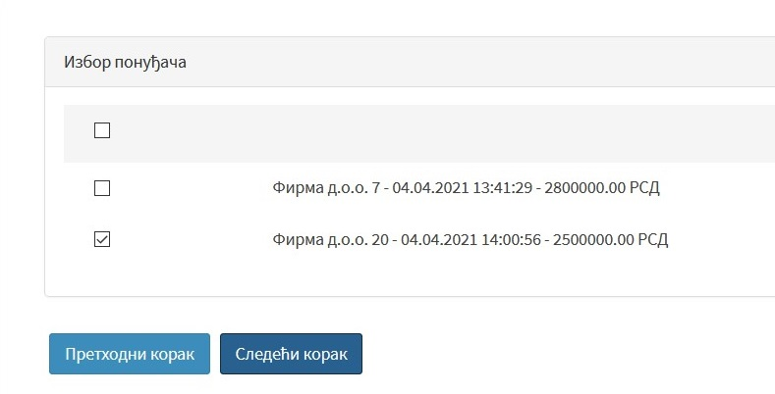

Action in case the bidder does not respond to the invitation to negotiate

If the bidder does not respond to the invitation to negotiate, as well as in the case when after the negotiations the bidder remains fully with his initial bid, the contracting authority after the expert evaluation of bids makes a decision on awarding/suspending the procedure based on the content of the submitted initial bid.
In such a case, the contracting authority on the Public Procurement Portal in the navigation of the procedure within the field “Procedures” selects the field “Decision on contract award”, then marks the field “This is the last phase of the procedure before contract award” and makes a decision on contract award/suspension procedure (Figure 14).
Figure 14
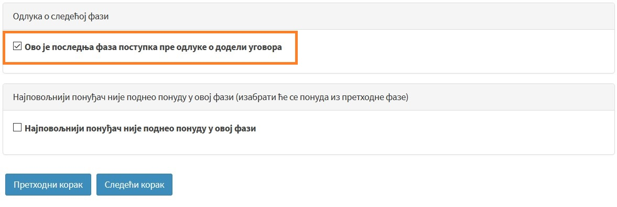

Is the contracting authority always obliged to negotiate?

Although the principle of economy of public procurement obliges the contracting authority to try to achieve better contract conditions whenever possible , e.g., to negotiate a lower price, a shorter performance deadline or a better quality above a predetermined minimum, there are situations in which it is known in advance that the bidder will remain with its initial bid and will not be ready for any favours regarding contract elements given in the bid. In such cases, the contracting authority could, after opening the bid, perform an expert evaluation of the bid, depending on whether the bid is acceptable or not, to make a decision on awarding the contract, or a decision to suspend the public procurement procedure. This procedure is justified in cases when the procurement can be performed only by a certain bidder, and the public procurement contract, by its nature, represents a kind of contract upon accession. In any case, the contracting authority is obliged to try whenever possible to reach the highest value for money and the most favourable terms of the contract through negotiations.

In such a situation, the contracting authority does not send an invitation to the bidder/bidders to submit new bids, but on the Public Procurement Portal within the expert evaluation of bids indicates that this is the last phase, after which it approaches the decision on awarding/suspending the procedure.

PUBLICATION OF THE CONTRACT AWARD DECISION/SUSPENSION OF THE PROCEDURE

The decision on awarding the contract in the negotiated procedure without announcing a public invitation, i.e., the decision to suspend the procedure, is made by the contracting authority within 30 days from the expiration of the deadline for submission of bids, unless it has specified a longer deadline in the tender documentation.

The decision on awarding the contract, i.e., the decision on termination of the procedure must be specially reasoned and must contain special data from the report on the public procurement procedure.
Pursuant to the provisions of Article 143, paragraph 2 of the Law, in the decision on awarding a contract in a negotiated procedure without publishing a public invitation, the contracting authority is obliged to state the circumstances that justify the application of this type of public procurement procedure.

PUBLICATION OF NOTICE OF CONTRACT AWARD, SUSPENSION OF PROCEEDINGS OR ANNULMENT OF PROCEEDINGS

As with other types of public procurement procedures, the contracting authority is obliged to send a contract award notice for publication within 30 days from the day of concluding the public procurement contract.

In case of suspension or annulment of the negotiation procedure without publishing a public invitation, the contracting authority is obliged to send a notice of suspension or annulment of the procedure within 30 days from the day the decision on suspension or annulment of the procedure is final. The data on the suspension or annulment of the procedure are published in the form of the contract award notice.

