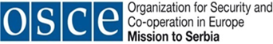
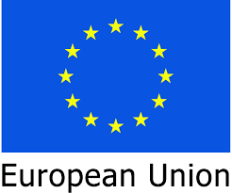

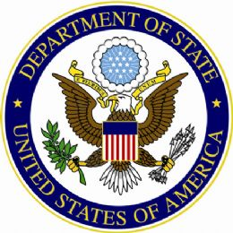
Republic of Serbia
Public Procurement
Office

Conference
Changing paradigm in public procurement:
Towards Value for Money and Higher Efficiency

June 1-2, 2016
Klub poslanika, Tolstojeva 2, Belgrade

Wednesday, June 1

9:00 – 9:15 Registration

9:15 – 10:15 Opening Session and Welcome Address

Željko Ožegović, State Secretaries,
Ministry of Public Administration and Local Self-Government
Kyle Scott, Ambassador, U.S. Embassy
Michael Uyehara, Deputy Head of Mission, OSCE Mission to Serbia
Steliana Nedera, Deputy Resident Representative at UNDP
Tony Verheijen, Country Manager for Serbia, Europe and Central Asia, World Bank
Steffen Hudolin, Head of Operations – Section II, Delegation of EU

Preparatory Activities and Planning in Public Procurement

10:15 – 11:25 Acquisition Planning – Defining the Need and Conducting Market Research -
Professor Steven Schooner, Nash & Cibinic Professor of Government Procurement Law and Co-Director of the Government Procurement Law Program

11:25 – 11:45 Q&A

11:45 – 12:05 Coffee break

12:05 – 12:35 Challenge of Deciding What Procurement Method to Use - Natascha B.F. Graff, Procurement Analyst in the Security Division, European Central Bank

12:35 – 12:45 Q&A

Selection Process and Award of the Contract

Writing Specifications and Selecting and Crafting Evaluation Criteria:
The Challenge of How to Assess Cost or Price (1st part)

12:45 – 13:30 Why Should You Use Best Value - Professor Joshua Schwartz, E.K. Guvin
Professor of Government Contracts Law and Co-Director of the Government
Procurement Law Program

13:30 – 13:45 Q&A

13:45 – 14:45 Lunch

14:45 – 15:30 Use of Non-Price Criteria as Evaluation Factors - Professor Joshua Schwartz,

15:30 – 15:45 Q&A

15:45 – 17:00 Panel Discussion on Good Practice

- CEE IBM Transformation & Operations, Mirela Senica, Procurement Manager
- Siemens d.o.o., Marko Nikolić, Project Manager
- BUCK d.o.o., Darko Budeč, President of the Company
- Merck Sharp & Dohme, Miha Božič, Tender and Pricing Lead for the Balkan region
- Johnson & Johnson, Ratko Štimac
- Bexing d.o.o., Aleksandra Bogunović, Director

Thursday, June 2

Selection Process and Award of the Contract (cont’d)

9:30 – 10:10 Conducting Negotiations - Professor Joshua Schwartz

10:10 – 10:25 Q&A

10:25 – 10:45 International Experience on Ways to Evaluate Tenders and Make the Source Selection Decision - Natascha B.F. Graff

10:45 – 11:00 Q&A

11:00 – 11:20 Coffee break

11:20 – 12:00 Framework Agreements and E-Procurement - Professor Steven Schooner

12:00 – 12:15 Q&A

12:15 – 13:00 Contract Management - Marcel Stuijts, CEO, Bizob - Public Agency for
structural collaborative procurement in the South-East of the Netherlands

13:00 – 13:15 Q&A

13:15 – 14:00 Panel discussion: Towards higher standards in compliance with the
regulation and future role of civil society organizations

- Association of Professionals in Public Procurement, Stevan Radunović,
President of Association
- Transparency Serbia, Rade Djurić, Associate

14:00 Lunch

- Material from the Conference can be downloaded via this link:
http://www.ujn.gov.rs/ci/news/story/322/Конференција%3A+Вредност+за+новац+и+повећање+економичности+у+јавним+набавкама+.html

